Computer Science

Project

[Hugo Legrand]

**Contents**

1.1 Description of the problem and stakeholders 3

1.2 features that make the problem solvable by computational methods 4

1.3 Research 5

1.4 Essential features 12

1. 5 Limitations 13

1.6 Requirements 14

1.6.1 Hardware requirements 15

1.6.2 Software requirements 15

1. 7 Success Criteria 16

2.1 Top - down design 18

2.2 Detailed breakdown of each part of the system 19

2.3 Key variables and data structures and classes 33

2.5 Usability Features 56

2.6 Test data to be used during iterative development 56

2.7 Further data to be used in post development 62

2.8 Validation 63

2.9 Videos 64

3.1 Iterative Development of the coded solution 65

3.1.1 Prototyping 65

3.1.2 Development and testing 66

4.1 Testing to inform evaluation 140

4.1.1 Post development testing 140

4.2 Evaluation of the Solution 141

4.2.1 Evaluating against the Success Criteria 141

4.2.2 Evaluating usability features 143

4.2.3 Maintenance issues 146

4.2.4 Potential Improvements and changes 147

**Section One: Analysis**

**Max marks 10**

# 1.1 Description of the problem and stakeholders

The project I am intending to undertake is a space themed retro style 2D platformer / adventure game. I spend most of my free on video games, therefore I have experience in this field, which shall help me solve problems during this project and has increased my interest in the gaming industry. The game will target an audience of gamers who also have a love for retro style platformers. I have chosen a space theme as I find it extremely interesting, and it is one of the many things I am interested in life. Space is also very complex and has a lot of different features, which I hope to include most of them in this game, including planets, asteroids, stars (which will mostly feature in a background), galaxies and more. The main character of this game will be an astronaut who in on the search of minerals and treasures. Different planets will hold different minerals and rocks, and some will be inspired by real-life planets and will keep their real-life features, including their gravitational force and atmosphere. The aim of the game is to collect, fight, kill but mostly, survive. I would like to include many enemies, which will be alien-like. These enemies will interact with the player and the player’s aim would be to kill them before they kill the player.

The stakeholders of this project will be anyone that is interested in learning about space, as I intend on including information and facts, with the intention on educating people about the wonders of space. For example, for every new mineral collected, the player will receive information about it. Some will help with the game, while some will educate them about these types of minerals. I do not intend on basing the game just on education, but more on exploration and survival. I will work with students appropriately aged to ask them what they would like to know about space, and how they would like to see this information presented in-game. I will be able to know the important and necessary features to add to this game by working with them.

The purpose for which I have decided to make this project is to give people a fun interactive and different way of learning about the forever expanding universe and what lies inside, all while playing a game on their screen, rather than being taught about it in class. I feel as if teaching about the basics of this topic through a game will attract more people than if it was to be through a lesson.

# 1.2 features that make the problem solvable by computational methods

There are many different parts to this project, and to make it easier I will make use of **decomposition** by breaking down the project into more manageable chunks, such as the tittle screen, the information screens, the statistics of the player window, the enemies, the background, etc. This will save me a lot of time as my work will be organized and I will only focus on small problems one at a time. After these smaller problems have been programmed, I am able to join them together to create a working program.

Space is huge topic that includes a lot of different parts, and some are going to be unnecessary for my project. Therefore, I will use **abstraction** when developing this project to reduce the amount of content that will be included, such concepts as accurate size of planets, or their shape and colors will be ignored as they are not as important as other concepts of space, such as gravitational force.

The program will be able to **accept inputs** to create movement for the main player. In a 2D space, this is much easier than a 3D space, as the only movements are to the left or right. Some other inputs will include jumping, possibly crouching, firing and more. The system will be able to read these inputs and move the character appropriately.

As well as accepting inputs, the system will be able to **output data** such as text on the screen or a death animation. For some data to appear such as the player’s score or the amount of each mineral obtained, the system will need to **store data**. This process is quite simple as it makes use of variables and/or functions/procedures. The act of storing data to then output it means the player has no need to write down any data they think is useful to remember as it will be shown on the screen (depending on which input as given for some).

One of the most complicated concepts in this projects that will help massively to create it is **enemy AI**. Without his concept, the game would not feel alive or real, as the enemies would have the inability to attack, move and react to any ongoing action, whether it would be on them or others. This will also increase the difficulty of the game, which would turn the interesting and fun game into an easy and boring one. As hard as this concept is to create, it will give me a new challenge that I am looking forward to undertaking.

# 

# 1.3 Research

To get some ideas for this project, I will need to conduct some research on games that include themes I intend on focusing on for this project. I have played many video games in the past and will use my experience in these games to help me in my research. As the game is aimed at any person interested in space, I intend on interviewing these people to get ideas as to what they would like to have inside the game. This game will have to include space facts, so the audience receives what they were promised. In order for me to learn about space, I will research the subject through websites, books, and documentaries.

**Terraria**

Terraria is a 2D sandbox adventure game developed by Re-Logic that originally came out in 2011 while development seemed to have stopped in late March 2021, with Re-Logic announcing a new crossover update for November 2021. The game has sold over 35 million copies to date, spread across a lot of different platforms, including Steam, Xbox, PlayStation, Nintendo 3DS/Switch and on mobile devices. Andrew Spinks, CEO of Re-logic, made this game with inspiration from his favorite games (Metroid, Minecraft, Castlevania), and I intend on doing the same. The game includes loads of different main genres such as survival, building, fighting, exploring and most importantly, action. I have chosen this game due to these genres that I would like to work on and add to my project, along with some other small features. It will be my main inspiration for this project.

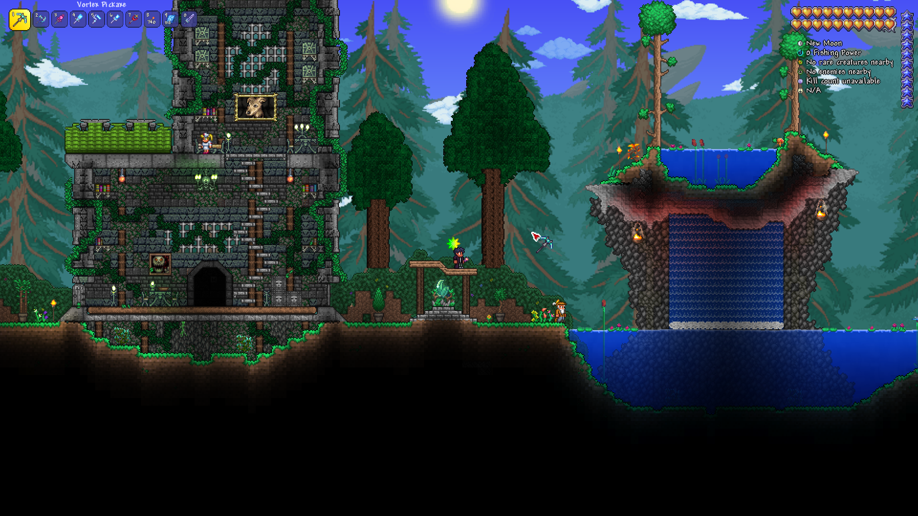

In this picture, we can see the main player, centered on the screen. Some features are noticeable, like the hot bar, in the top left, or the health ui in the top right. This picture also shows the capability and options a player has when building in Terraria.

The aim of Terraria is mostly seen as beating all 30 bosses the game has to offer, with the ability to fight them again for more rewards, and to explore the entire world. Throughout the journey, the player will be able to adventure out for treasure, and gain new weapons, tools, and items, while fighting enemies and dodging traps to access them. This is an aspect of the game I would very much like to add in my project as having a range of items to choose from and find allows for a more enjoyable game and gives the players are a chance of re-playability. As previously said, the player will fight enemies with the huge range of weapons that they acquire through exploration and fighting and build houses to guest NPCs, who (most) are crucial for progression in the game.

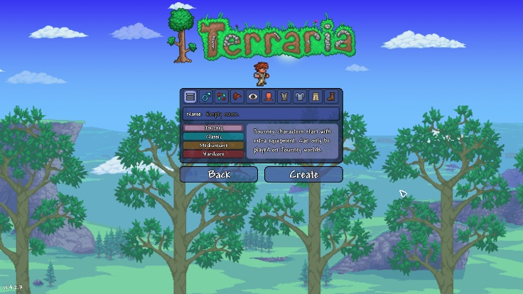When creating a character, the player has many different options for customization. As seen in the picture on the right, the UI includes different sections (hair, eyes, shirt, etc…), all used for the customization of a character. A noticeable feature is the different difficulties, character-wise (journey, classic, mediumcore and hardcore). These difficulties change how the game is played. For example, a character made using the ‘hardcore’ option has only has one life, while a ‘classic’ character has an infinite amount, and a journey character has more abilities, giving a chance for new players to experience the game without trouble. This is a feature I will take in mind when creating my project, as it will allow to make it more enjoyable and give it more re-playability. Including this feature in my project will also allow it to get more attention to any players that find the game too simple and would like to add some difficulty to it. The picture below gives another idea as to how this can be achieved, through the world creation menu. I do not intend for my worlds to be any different from the other, but it doesn’t stop me from adding the world difficulties feature, which in Terraria are: Journey. Classic, Expert and Master. These modes increase in difficulty. The enemies deal more damage and have more health, new de-buffs are introduced, new enemy AI and to counter some difficulties, exclusive rewards, from new weapons and accessories to decorations are also introduced in these higher difficulties. This again allows more re-playability within the game, with the many combinations of player difficulty and world difficulty. These different ideas on increasing difficulty and re-playability will be taken into mind when programming the project.

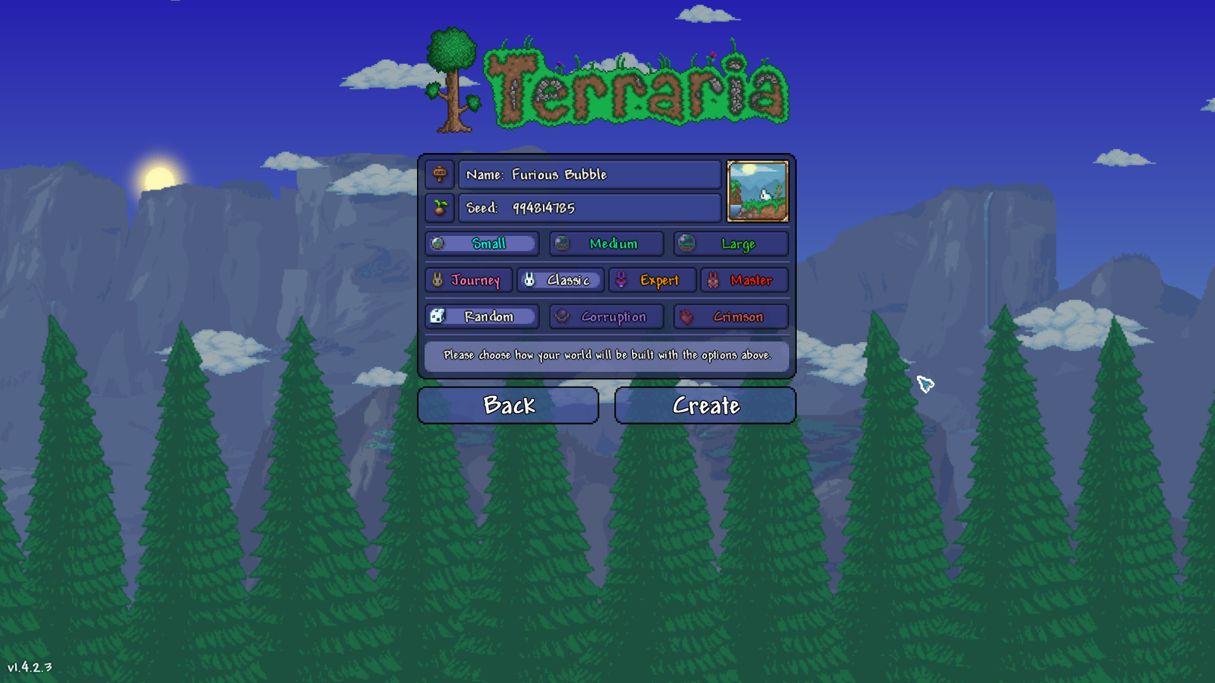

The one aspect that stands out to most players about this game is its style. The game is set in 2D and is heavily pixelized. This is a style that I personally really enjoy and find it looks really nice. Other games that use a similar style include Eastward, Stardew Valley and Celeste. This is where the inspiration for my project comes in as I intend on using this style, or a similar one to it. My aim for my project is to take most inspiration from Terraria, whether it be the backgrounds, the inventories, the difficulties, the enemies or even the weapons. Terraria is my favorite game of all time which is the main reason as to why this game is really important for my project.

**Platforming**

Platforming is one of the most important aspects in a 2D game, as it provides height and depth which is more interesting than a flat surface. It also allows for a larger sense of difficulty within the game, as the player will be required to perform jumps, crouch, and various other moves to explore the area around them or access a treasure/enemy. That is why I will need to conduct extensive research in this department. To do so, I have decided to research 2 games: Hollow Knight and Celeste. This research will allow me to take inspiration from these games from how they portray platforming and how they use it to their advantage.

**Hollow Knight**

Hollow Knight is a 2D indie metroidvania adventure game where the player controls an insect-like, nameless knight while exploring an underground world. It was released in 2017 and had already sold 1 000 000 copies on PC a few months after a year of being available. Only 2 years after its release, it had hit 3 000 000 copies sold. A sequel to the game, Hollow Knight: Silksong is in the works and set to be released on February 1st, 2022. Hollow Knight and its sequel were both made in Unity, which is one of the many reasons as to why I have chosen this game for research.

What stood out to me when I first played this game was its platforming. Whenever you enter a new room, there are many different paths that could be explored, each with a different access route than the others. Some are routes that cannot be explored due to the player not having learnt certain skills. In each room, the player will also encounter different traps and enemies. The picture below shows an example of the rooms that the player will encounter, an enemy the player is avoiding and the platforms that lead to different rooms – there are 4 different paths in this picture – that the player can access.

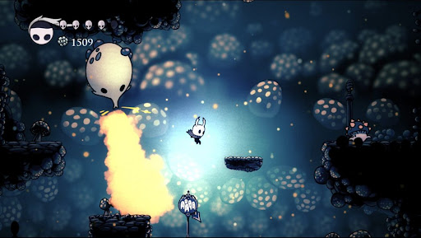

Taken from Google

This is the style of platforming I would like to add to my game as having different rooms to access forces the player to explore them all and go back on their paths to do so. This trick will be resulting in higher play time and with that comes more experience in the game and the player will improve on their skills. This is a key aspect in a game as it helps the player enjoy the game more than if they weren’t so good at it. When programming the project, I want to include this as much as possible to make the game more enjoyable to the player.

Hollow Knight also offers a boss battle after an hour or so of exploring, challenging the player even further and forcing them to use their abilities that have gained throughout the beginning of the game. It is not the only boss the game will offer and with every new boss, it gets harder and more challenging. This will allow the player to increase their skills at the game but will also allow the character to increase in strength and gain abilities.

**Celeste**

Celeste is a 2D platforming game made by Maddy Thorson and Noel Berry in just 4 days at a game jam. The description of the game states: “Help Madeline survive her journey to the top of Celeste Mountain in this super-tight, hand-crafted platformer from the creators of TowerFall”. This game can be found on Steam, Nintendo Switch, Xbox, and PlayStation. The game has won awards at IGF, The Game Awards, DICE, the GDCAs, and more. By December 21, 2018, a bit before a year after release, it had reached 500 000 copies sold.

This game stands out to because of its platforming, but also its style. It is heavily pixelized, similar to Terraria and unlike Hollow Knight. But the main reason I have chosen this game is due to its complexity of platforming. The game features many different platforms that move around, deal damage, disappear and more. This variety of platforming means every single room is different and challenges the player even more. It also allows for a more enjoyable experience as there is no repeated rooms. The game also features items that can be picked up throughout the players journey and used later on. In Celeste, the most common item is the strawberry. These strawberries do not give an advantage for the player throughout their journey, but they instead give them a challenge as they are located in places that are hard to access, and the player will have to use their skill to collect them. They do still reward the player, but not in-game, they do so with an achievement called ‘Impress Your Friends’ which reflects the difficulty of getting these items. For my project, I do not intend on making items hard to get but I will try and add difficulty by hiding some and rewarding the player for finding them. Examples of the rooms and items are shown below (all images taken from the trailer):

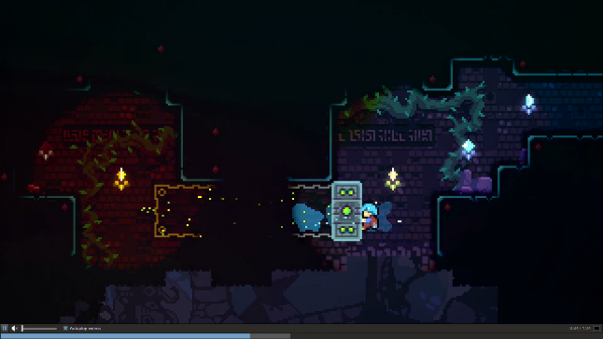

This room features a vertical platform that allows the player to get to the other side of the room. The platform moves when the player sticks to the side of it. The room also has some dark spots, but the lights on the wall light up the room so the player is able to see the other side of the room. This adds ambiance to the room.

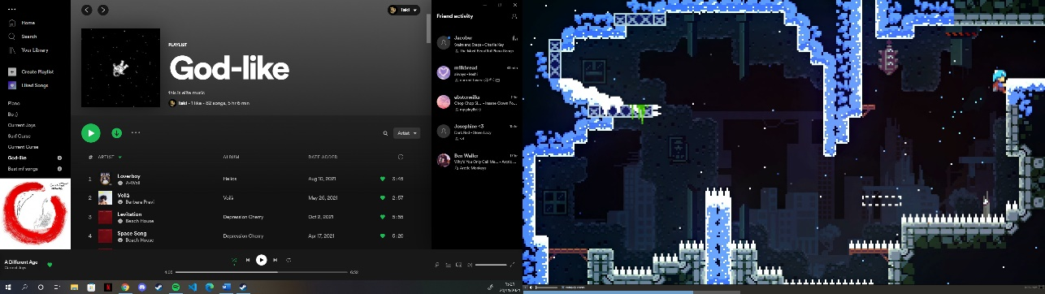

This is one of the earlier and simplest rooms you will encounter throughout the game. It includes spikes, that will kill the player if they were to land on them. It also includes a platform that will fall shortly after the player stands on it (it has already fallen in the picture and is outlined by the white outline). These different features add complexity to the game and would like to implement them in my project.

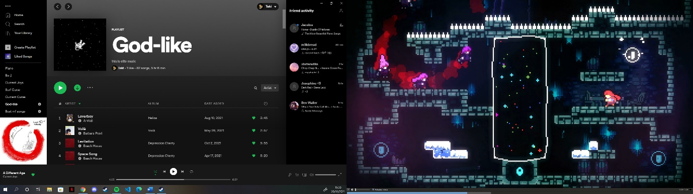

This room looks to be more complex than the others and is possible explored near the end of the game. However, we can still see simple spikes being used and ice platforms the player might slide across. The thing that stands out to me is the 3 replicas of the player, possibly chasing them down. This element would give the player a time limit of some sort and challenge them even further as they get through the game

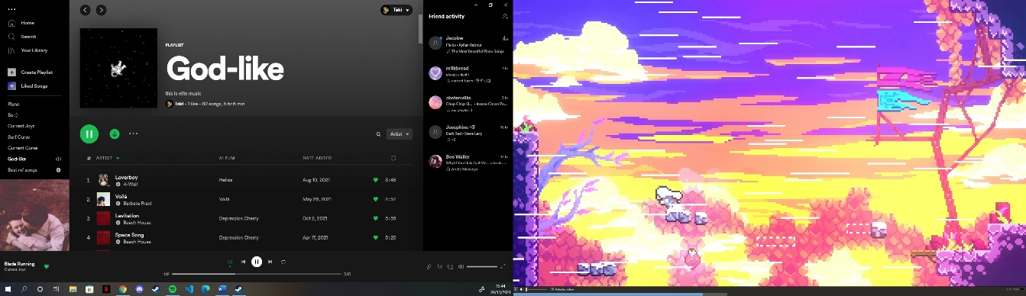

This area is located outside, unlike the other rooms and includes wind, which is one of the reasons why I picked this area. The character has a different animation due to the wind, and the force of the wind makes it harder to jump and move. You can also see this room re-uses the falling platforms outlined with the white lines. There is also a strawberry seen at the bottom, which the player can collect. These items will be something I will think about when making this project.

Celeste is a game I am heavily inspired by for this project. The features I will take from this game include the re-using of platforms and features throughout different rooms (spikes, falling platforms), the items and their difficulty in finding them, and finally the different platforming features themselves.

**Space**

One of the key themes to this game is space and to make this game, I will need to research about it to expand on my knowledge. This will allow me to add as much information as possible in the game. This is essential for my project as it will allow the player to learn as much as possible about space, which is of the main purposes of this game. To do this, I have chosen books, documentaries, and games to research.

I have always been interested in space, how the universe works, why the universe expands, the laws of the universe and so on. This is why I intend on making space a big theme in my project, in any way possible. I will use my knowledge and the research I will do on it as much as I can to draw the attention of the player and make the game more enticing and interesting to play.

**Astroneer**

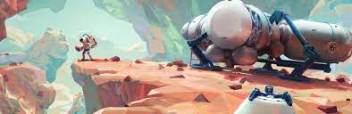Astroneer is a 3D sandbox adventure game developed by System Era Softworks and was released in December of 2016. This game is all about exploring planets and surviving on them. Throughout your journey, you are to dig up new materials, explore caves, find crystals, and craft stations like the Smelting Furnace, Chemistry Lab and more. I have chosen this game as it will allow me to find out what materials and items can be found in space, and their properties as I would like to inform the player about the materials they find. It would be boring to find a material, e.g.: copper, and not be aware of its properties, for example the fact it is a good conductor of electricity. In Astroneer, you are able to travel between planets after having built a rocket ship. I do not intend on making my character creating a rocket ship, but they would rather find one that would allow them to travel elsewhere, on another planet, or maybe an asteroid. There, they will be able to find new materials and with that, more knowledge about space and a specific planet/asteroid.

Taken from Google

**Astrophysics for people in a hurry**

Taken from Google

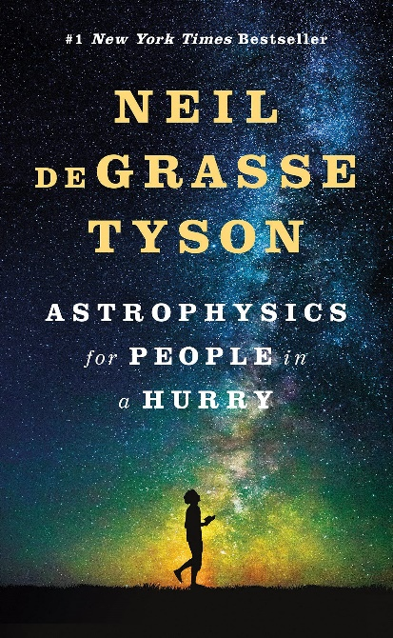Astrophysics for people in a hurry is a non-fiction book written Neil deGrasse Tyson, an acclaimed astrophysicist, and published in May 2017. The book was a success, getting a rating of 4.7 / 5 by its audience. The book was written with a purpose to shorten all we know about the universe into information that would be easier to understand, all while keeping the complexity of the universe. It would’ve been really difficult to “dummy” down the information so that kids could understand due this complexity. The book contains 12 chapters and covers topics ranging from light to dark matter/energy and to particle physics. Having read the book, it has taught me much about our universe and I will apply this knowledge when creating the learning aspect of the game. Some of the information in the book may be unnecessary to add, and some would be too complex to add. The chapter I will focus on the most would be Chapter 1: The Greatest Story Ever Told, as it covers the beginning of the universe, the materials that make up our universe and the laws that make it the way it is. I will also focus on Chapter 3: Let There Be Light, but less so than the first one. This chapter, as the title suggests, covers what we know about light and its properties. This book will allow me to make my game more interesting and appealing to my audience, as they will learn more about space through my game.

**The Universe**

The Universe was a documentary originally first aired in May 2007 and last aired in May 2015 on their 9th season. Their 8th season only had 4 episodes while their 2nd had 18, for a total of 88 episodes over 8 years. The documentary covers all the corners of the universe from the sun to dark matter and energy. It shows CGI renderings, video footage, photographs, and views from scientists, project managers, engineers, advocates, writers and other experts. Researching and watching this documentary will help me gain a better understanding of space and its secrets. This knowledge will be key for the development of my game. While making the game, I will add key facts about space throughout gameplay, through finding new items, finding diaries, landing on a new planet or even looking at through a telescope at distant planets.

**Research summary**

After doing my research, I now have plenty of inspiration for my project, and have strengthened my initial plan to create a 2D platforming game based around the theme of space.

For platforming, it is essential for every room to be different than the others, to challenge the player. These rooms could include the different types of platforms previously mentioned when researching Celeste, to add variety to each room and increase enjoyment for the player. I will also include different enemies in all the rooms, some having the same enemies to reduce the number of enemies needed. But this will challenge the player even further and test their skills throughout the game.

Taking inspiration from Terraria, I plan to add different weapons that the player will find over time. All their weapons will be stored in an inventory that will be accessible with the click of a key. There, the player will be able to change weapons. Terraria has also inspired me to use accessories, or upgrades for the player, that will make the player jump higher, walk faster, deal more damage and more. Having these available to the player allows for a more enjoyable experience. Finally, Terraria’s style has inspired me, and I intend on finding/making sprites that have a similar style to the ones in Terraria as they look amazing.

Space is the main theme of this game and I have done a lot of research on it through books and tv shows. This research has allowed me to expand my knowledge on the theme and I will add as much as I can into the project, while keeping it simple for the younger minds that will play this game. Having a strong theme around my game will allow it to be interesting, enjoyable and will help the players understand more about the beauty of the universe and what lies inside of it.

# 1.4 Essential features

To be able to make a playable game, I will add need these essential features:

* For the game to be playable, it will be essential to add **real time responses to the commands.** This will allow the game to flow properly, and the player won’t seem “behind” compared to the enemies. If that was to happen, it would be impossible for the player to dodge the enemy attacks and would die easily. This takes away the enjoyment of the game and will get frustrating.
* Whenever the player picks up a coin, or loses health, it is essential tom **display the scores / health to the player** so that they are aware of their health when battle enemies. This is essential for gameplay purposes as the player will get frustrated if they are not shown their health. This could be done with a bar decreasing over time, or simply a fraction.
* In order to keep the game entertaining, it must include **challenging enemies and tricky platforming.** This addition is one of the main reasons people find enjoyment in games. Therefore, I will ensure to make every room different than the others and add variation with the enemies.
* A final essential feature my game will require is the ability to **attack and defend.** The player is going to need this, so they are able to kill the enemies and limit the damage taken from them. Doing this is simple, the player will have the ability to shoot and damage the enemies as well as jump to avoid enemy attacks. Without this, the game will get frustrating for the player and there will be no need for enemies if the player isn’t able to kill them.

Without these features, the game will not be enjoyable to the player, who will easily get frustrated and won’t want to play the game again. The game’s quality will also decrease without these features, leading to another decrease in players and limiting the game’s success.

# 1. 5 Limitations

* One my biggest limitations when making this game will be the **graphics.** Popular video games have complex graphic requirements, but my game will not have the ability to have that. Instead, I will need to download or make my own sprites. Downloading from the internet limits my options as not everything I want will be there. I would therefore need to make some sprites, using websites such as Piskel – a free online sprite editor. The problem with making sprites is that it takes a lot of time to get them to fit into the game and look somewhat nice. Hence, I will try and find as many sprites as I can off the internet, some from different games including Terraria or maybe even Mario and Luigi games.

Having bad graphics will reduce the players enjoyment when playing the game as they will be distracted from the game by any mistakes in the sprites they see.

* The second biggest limitation for this game is **time.** There is a lot to do when making a video game, and I have a deadline to meet. Everything has to be as perfect as I can make it when the deadline is reached, and this will take a lot of time. To combat this, I will focus less on features that aren’t as important as others. For example:
  + The game will be limited in levels/area. It will feature a suitable amount of them, but I will not spend too much time making a lot of them as the player can find enjoyment after a few levels.
  + The storyline that may go with the game will be short, but I will keep it exciting so the player still finds the will to keep playing. I will also not stretch the story too much as it might get boring for some players as they get through it.
  + It will be hard to implement some difficult features into the game, including drops from enemies, random map generators and cutscenes.

Ultimately, these features will make the game more interesting and enjoyable, however I feel like they will not have a huge and negative impact on the game. Without them, the player will still be able to progress through a number of levels and advance through the storyline. Not having harder features to add will, most of the time, not be noticeable, and wont impact the gameplay much.

# 1.6 Requirements

These are the requirements for my game:

1. The game will be in two dimensions
2. The game will have a main menu
3. The game will feature a pause menu so the player can stop and come back whenever they like
4. The game will feature a save mechanic so the player does not lose progress if they were to leave
5. The character should be able to respond to the player in real time
6. The character will be able to move left (D), right (A), jump (space) and attack enemies (mouse click)
7. The player must be affected by gravity
8. The camera will be locked on the player so the player will be centralized on the screen for the duration of the game
9. The game will feature different rooms that the player advances through when having met a certain criteria.
10. The game will feature different enemies that are able to move and shoot the player.
11. The enemies will have a pre-determined amount of life and will die when losing it all
12. The game will feature a boss before the player beats the game
13. The player will have a pre-determined amount of life
14. The player will not be able to continue if they lose all of their life and will have to start again.
15. The player will have an inventory where they will be able to switch weapons
16. The player will be able to collect coins that will be displayed to them
17. The game should get progressively harder as the player advances through the level
18. The game will have different sprites for the different enemies and the different tiles.
19. The game should feature sound effect when an enemy dies, the player gets hit and when walking.

## 1.6.1 Hardware requirements

* Keyboard – this will be used for controlling the player with ease
* Mouse – giving the player the ability to attack enemies and select certain items when in the inventory
* Monitor – used to display the game to the player, without it they are unable to play.
* Speakers – for outputting sound so the player can hear the sound effects
* Computer – the most important hardware requirement. It will need enough power to be able to run the game smoothly

## 1.6.2 Software requirements

To create the game:

* Visual Studio Code: Allows me to write the code for the game, in C#, and gives me plenty of useful features.
* Unity: Allows me to create the main block of the game including the player, the enemies, the levels, the menu and more.
* The Spriter’s resource: This website allows me to use as many sprites as I want from various games. I will need this to make the graphics of my game.

To run the game:

* Unity engine: As well as helping me make the game, Unity also allows me to run the game.

To test the game:

* Bandicam: I will sue this software to create videos of my game that wills serve as proof for the game’s development

# 1. 7 Success Criteria

1. **The game will be a 2d platformer that obeys the laws of physics –** This is the main criteria of this game. Without it, my game is unplayable.
2. **The game should feature a main menu and a pause menu –** Having a main menu for the game allows for it to feal like a real game and enables the ability to change options for the game, like sound or controls. A pause menu will allow the player to save their game, quite the game and of course, pause the game.
3. **The character should be able to move left and right while also being able to jump –** This is very useful for making the game as it will allow the player to move freely and dodge any enemy attacks. Without it, the player will not be able to move and the game will be unplayable.
4. **The character should have a defined amount of life –** Giving the character a set amount of health gives a sense of difficulty to the game. As the character isn’t immortal, the player will be more careful when progressing through the game as they are aware that losing all that health means they will have to start the level all over again.
5. **The character health and coins collected should be displayed to the player –** This is a very common trait in the video games I have researched. The player must be aware of these at all times as it allows them to know if they are close to dying, and their score. Without displaying this, the game will get frustrating for many players.
6. **There should be different enemies, all with different amounts of health –** This is a simple criteria, but it is very important for this game as it makes it more enjoyable. If the enemies were the same and had the same difficulty to kill, the game will get very boring quickly. In all the games I have researched, there was always a big variety of enemies that got stronger as the game progressed.
7. **Different enemies will have different AI –** This is also an important criteria as it gives variety to the enemies the player encounters. Having different AI for all the enemies means they will attack the player differently, and some might not attack the player at all, rather just walk around freely.
8. **The character should have an inventory interface –** The addition of this inventory interface will allow the player to see the weapons they have collected throughout their journey and be able to change through them. It gives them the choice of which weapon to use instead of having to use the same one throughout the whole game. I took this inspiration from Eastward, who used a similar feature.
9. **Multiple levels that get harder as the game progresses –** This is a feature that servers the purpose of keeping the player hooked with the game and not get bored of it. Having multiple levels will add variety to game and make it worth a player’s time, and these levels getting harder will allow for a more difficult experience, but also more enjoyable experience when playing the game.
10. **The character must be able to fight against enemies –** This is another simple criteria, but it is very important. Without the ability to fight against enemies, the player is harmless towards them and can easily get killed. As previously said, the player will have a range of weapons to choose from their inventory which will allow them to fight against these enemies
11. **There will be a final boss at the end of the game –** This is the final and big challenge for the player. After advancing through a number of rooms, they will find themselves locked in a room, unable to get out until the boss is dead. Having a boss at the end of the game gives the player a purpose to progressing through every room and allows them to test their skills on a challenge more difficult than any they had to face before.
12. **The game will feature information about space –** Space is the main theme of my game. I want the player to finish the game with facts and knowledge about the universe they never had before. This also gives the player a purpose to progressing through the game while also allowing the player to stop fighting once in a while and learn about space.
13. **Enemies should be able to drop coins and drops –** I intend on making coins accessible to the player by dispersing them around the levels, but also by making them drop from enemies. Enemies will also be able to drop health points to allow the player to increase their heath back up. This gives the player a purpose to kill the enemies they encounter.
14. **The game should be able to run on a standard computer –** This is the final success criteria, and it is the most important one. If the game can’t run on a standard computer, the player will mostly likely experience lag when playing. This will make it difficult to play the game as they won’t be able to move, attack, dodge and kill smoothly, resulting in a frustrating experience.

**Section Two: Design**

**Max marks 15**

# 2.1 Top - down design

A top - down design is the decomposition of the program into smaller chunks. This allows for an easier understanding of the program and allows me to know how I want to structure it. It will also allow me to keep track of what I have accomplished as I will tackle each of the chunks individually. These chunks include all that need to be done for the player, the enemies, and the boss, but also the levels, the main menu, and the options. Through making this, I have given myself a clearer idea of what I need to focus on when coding and designing.

This is my top – down design:

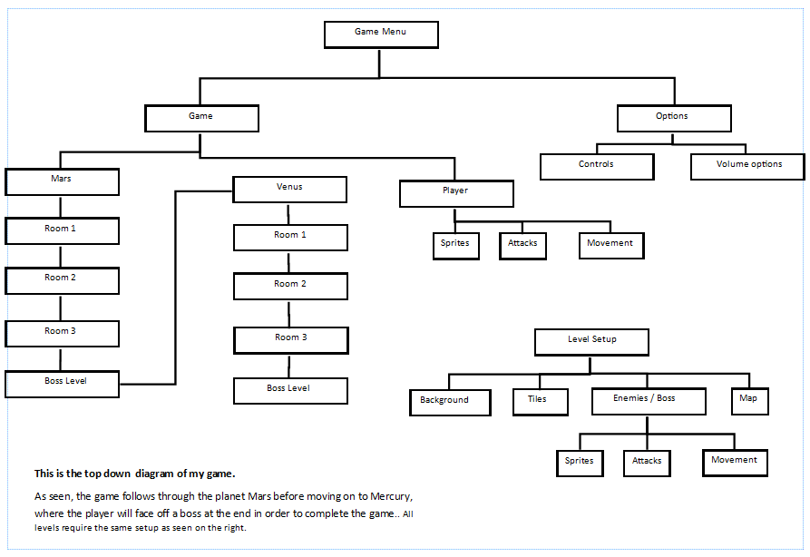

Made in publisher

# 2.2 Detailed breakdown of each part of the system

Aim of the Game

The game I am designing is a 2d platformer, where the player will explore different areas and fight different enemies. The player is an astronaut trying to survive on a planet where they will gain knowledge about its features and characteristics. When travelling through the game, the player will have to put their fighting and platforming skills to the test in order to survive. Before completing the game, the player will have to fight a boss, which will test all the skills they have learnt throughout their journey.

The storyline hoes as follows: The astronaut is left stranded on Mars after being sent on a mission to collect valuable items such as rocks and data. As they advance through, they collect coins which can be dropped by enemies or through platforming. They will also have to find a special part, located at the end of the rooms, to force the player to go through all of them. Using these, the player fixes their ship and leaves the planet. Their next mission is to head to Mercury, where their mission is similar to the one on Mars. However, the player attempts to leave, they realize some of the enemies have taken part of their ship and in order to get them back, they must fight their ruler, the final boss of the game. Once the player defeats the boss, they can safely make their way back to earth and the game is completed.

Main Menu

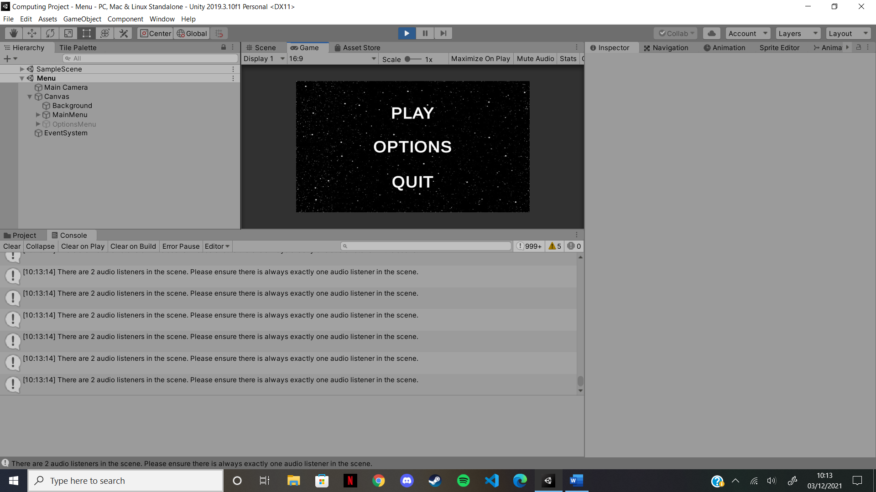The main menu for my game will be simple. It will have three buttons: Start, Options and Quit. These options will allow the player to play the game, look at the controls and control the sound and quit the game entirely. They will be able to click on the buttons in order to access them. The background for my main menu will simply be a picture of space, with the title written across it. I don’t want the background to look complex as it is just a title screen and the player will not spend too much time on it.

Options Menu

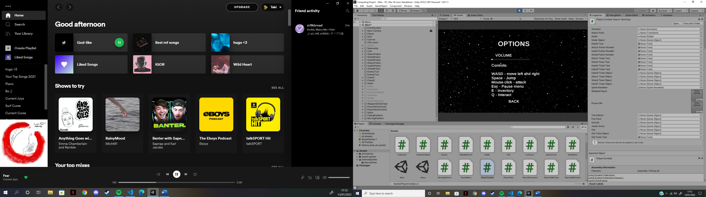The options menu for the game will not feature much. It will remind the player on how to play the game (which controls to use) and allow them to adjust the sound of the game (sound effects, music).

Background

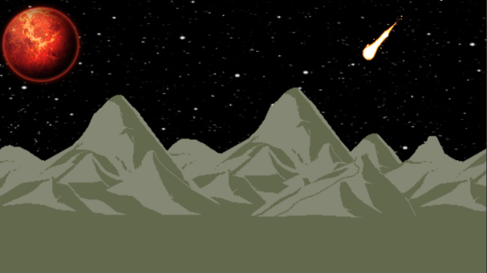The background is an essantial part to the game as it creates the atmosphere and reminds the player where they are. I will have two main bckgrounds, one for Maes and the other for Venus:

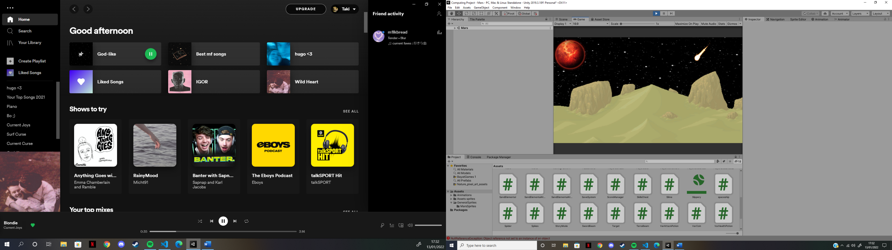

The Venus background will be very similar to Mars’ background; however, the land part will look different. I decided to go for a gray background as it blends in well with the rest. As with Mars, the background will be same throughout the whole planet.

The Mars background features sand dunes along with a star and a meteor. To give the background some life, the meteor is animated, however it stays in place. This background is the same throughout all of Mars.

Pause Menu

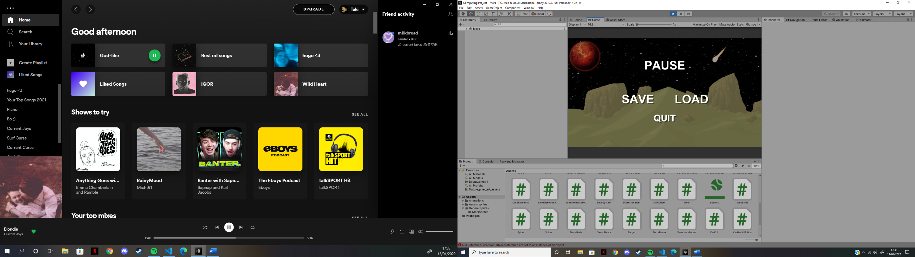The pause menu will appear after the player hits the key “escape” on their keyboard. It will freeze the game behind, so the player is unable to move while on the menu, and unable to get attacked. It will feature buttons such as “save” and “load” so the player is unable to lose their progress as they play. The other button is “quit”, to allow the player to exit back to the main menu. To exit the menu, they will just need to press “escape” again

Inventory

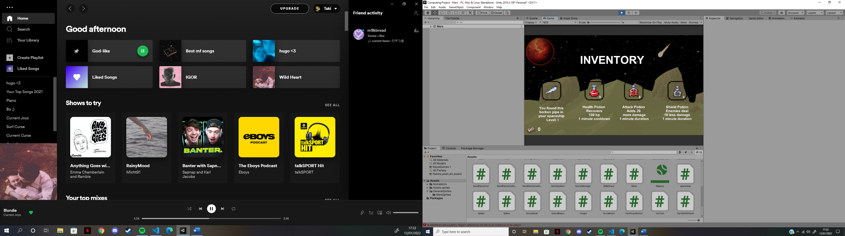The Inventory is a key part to playing the game. It reminds the player of the amount of potions they have and so if they have the ability to use them. It also includes the weapon, which is a pipe the player acquired from their broken spaceship, and its level. Finally, it will remind the player of other useful information including the number of other items and descripiton of such items.

Useful Information

In order to make the game more inclusive and entertaining, the player is going to require some additional information when playing the game, including health, coins, etc… . Here are two detailed pictures which show the information:

A coin counter. Reminds the player of their number of coins.

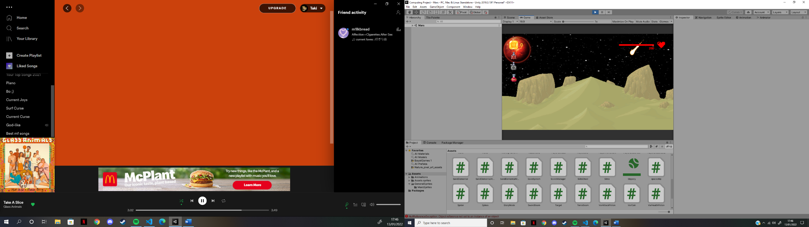

Health bar. The player will need to know their health throughout playing the game. To do so, I have added a slider to act as a health bar, along with the amount of health underneath. The heart indicates that it is the players health.

Potion timers. When the player takes a potion, a 60 second timer will appear and the player will not be able to take another potion.

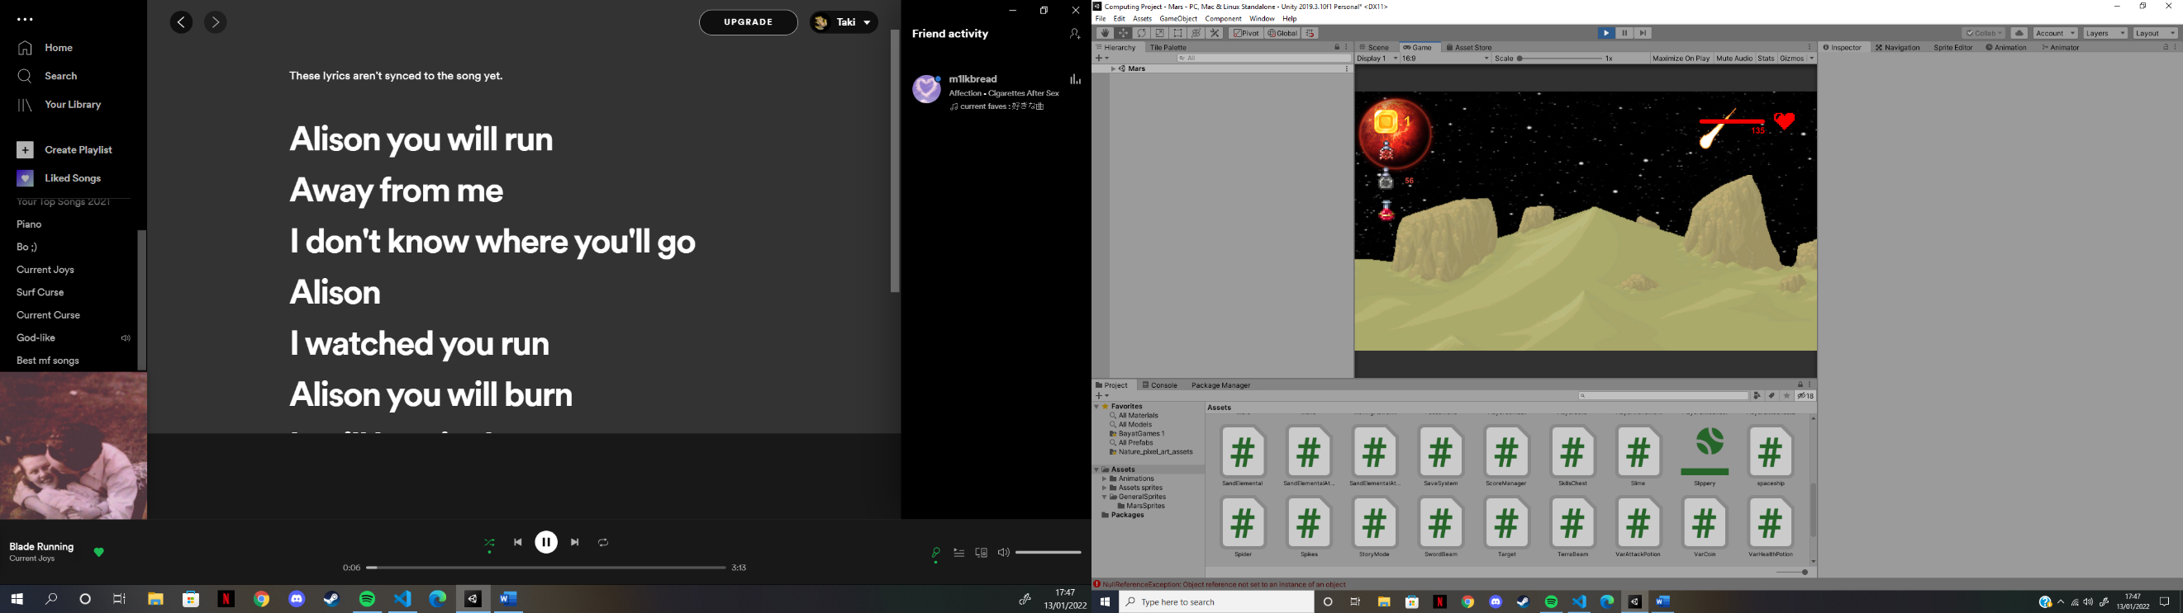

Here you can see the player has taken damage and the slider has become shorter. The amount of health under the slider has also decreased.

Here you can see the coin counter has changed as the player has picked up a coin.

Here, the timer for the shield potion has been activated as the player has taken that potion. Therefore, for the next 56 seconds, the player will not be able to take another shield potion.

Items

The game includes items the player will be able to pick up and use in different ways. These include the potions, coins and more. Having these items in the game allows for more interactive gameplay and will make the player think about their actions, how it affects them and whether or not they will need to use an item.

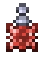

The Attack Potion. This potion will be found from chests and sometimes on the ground. It gives the player 20+ attack damage for a minute.

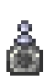

The Shield Potion. This potion will be found from chests and sometimes on the ground. It reduces the enemy’s attack damage by 10 for a minute.

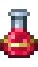

The Health Potion. This potion will be found from chests and sometimes on the ground. It allows the player to heal 100 health points but will not be able to do so for a minute.



The Coin. This item will be found from chests, in the level and can drop from enemies. It will allow the player to fix their spaceship and move on with the storyline.

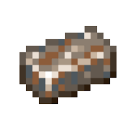

The Iron Bar. This item will only be found from chests. It will be a key item for the player as it will be needed to fix the spaceship which then allows them to move on.



The Heart. This item will only be found by killing enemies. It gives the player 20+ health points (even if the player is unable to take a health potion).



The Bat. This is the weapon the player will use throughout the whole game. It can be upgraded but will have base damage 20 hit points upon starting the game.

Weapon Skills

To upgrade the weapon, I decided the player will be able to find and activate skills which will change the weapon’s abilities. There are two skills, which will be available before the player finishes the Mars section of the game. Their purpose is to aid the player in their adventure, as it will make some enemies easier to kill. It may reduce the challenge of the game, but it is necessary as I feel the game will get frustrating if the player always has to be up-close to the enemy and take a lot of damage. These skills will be found inside a chest.



The first skill will allow the weapon to shoot out a beam (as seen on the left). This beam will shoot from the weapon in the direction of the enemy and will be destroyed after a pre-determined number of seconds. This allows the weapon to pierce and hit multiple enemies. Its base damage will be 30 hit points.

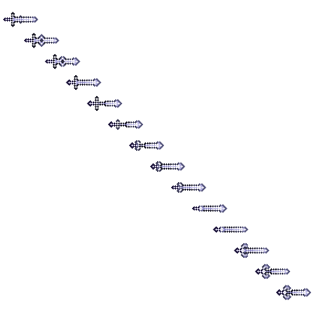

The second skill will allow the weapon to shoot out a barrage of 5 smalls swords (as seen on the left). These swords will also shoot from the weapon in the direction of the enemy and hit for a base damage of 5 hit points. However, the destroy on impact and will inflict a debuff on the enemy hit for an extra 10 hit points.

Upon finding these skills, the player is then faced with a choice between the two, as they are only allowed to pick one. They can either get 30 extra damage and a piercing attack, or 25 extra damage plus a debuff. I feel as if I have made this a good choice as both skills are really good. Hopefully these skills keep the player entertained and wanting to keep going.

Interactive objects

Throughout their journey through the lands of Mars and Venus, the player will find objects they can interact with. These are different to the items as they cannot be picked up and used later on.

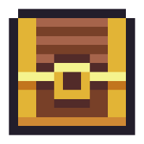

These chests will be found on the ground on either Mars or Venus. Some will be difficult to find while some might be right in front of the player. They can include coins, potions, skills, and iron bars.



The spaceship is a key part to the story. It is what the player arrives and leaves with. The player will be able to interact with the spaceship whenever they wish to leave if they are allowed to do so of course.

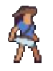The Character

The character is at the center of the game and they are controlled by the player. They were sent on a mission to recover data from the planet Mars and ended up in some trouble. Finding the right sprite for the character was very difficult. I had to find someone that had a weapon, looked like an astronaut, and had all the animations I needed. In the end, I ended up with this as a sprite:

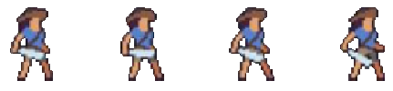The sprite does not check every box, but it had the weapon and the animations I wanted and so I decided this was the one I was going to use. The sprite sheet used included more animations that I did not require, and so I cut them out. Here are all the animations:

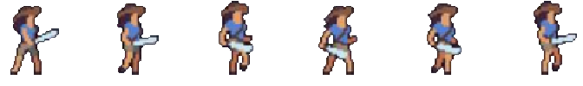This is the character idle animation that will play anytime the character isn’t moving or attacking.

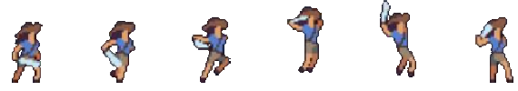This is the character walking animation that will be played anytime the character moved left or right in the scene.

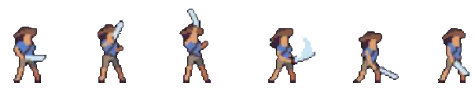This is the character’s jumping animation, which will be played anytime the character is jumping.

This is the character’s attacking animation which will be played at any time if the player decides to attack.

Character skills

To upgrade the character, I decided to add character skills in the game. These skills will enhance the player’s movement, health, and defense. They will be 6 skills, separated into 2 chests, one on Mars and the second on Venus. These chests will be hidden on each planet to give the player an extra challenge and make them work towards acquiring these skills if they wish to do so. These will help increase the interest of the player in the game and perhaps allow them to enjoy it more.



The black belt. Upon selecting this skill, the character is now able to dodge any attacks from enemies with a 10% chance.



The Orb. Upon selecting this skill, the character is now able to summon an orb around themselves which will protect them from any damage for 10 seconds. It will then have a cooldown of 40 seconds.



The tabi. Upon selecting this skill, the character is now given the ability to dash when double pressing the “a” or “d” keys.



The Hermes boots. Upon selecting this skill, the character’s run speed is increase massively to give them extra movement.



The chest plate. Upon selecting this skill, whenever the character gets hit a projectile will shoot towards a nearby enemy.



The Heart. Upon selecting this skill, the character now has the ability to regenerate their health, 2 health points per second.

Enemies

Enemies are play a big part in the game. They act as a challenge for the player, and as a way to get resources and regain health. When making the enemies, I tried to make all enemies as unique as I could, giving them all different mechanics, abilities, and statistics. Some enemies will shoot projectiles, while some will attack using melee weapons. The sprites used for the enemies were all taken from Terraria, however, I made sure most of the enemies do not have the same attacks that they do in Terraria, to not copy the game directly. Some enemies will also have variants, meaning they have the same mechanics and abilities, but they deal more damage, and have more health. Doing this helps the player as they will not require to lean a new enemy’s attacks and abilities but will have to work harder to kill the variant. The biggest goal with the enemies was to include a range of attacks and abilities to keep the game interesting for the player. Some of the enemies may not fit into the theme of space and aliens, but that is not a huge issue.

**The goblin**

The goblin is a melee enemy that the player will encounter near the beginning of the game and will appear in both Mars and Venus. Its main attack is his sword, which he slashes at the player once the player is in attacking distance.

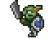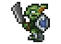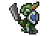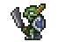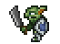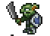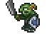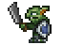

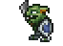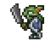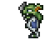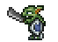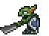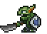

**The Slimes**

The slimes are a variety of enemies which come in different colors. There are 3 variants of slimes. The first being a muddy green slime that the player will encounter early on in their adventure and the other two are stronger versions of that one. The red slime will only appear on Mars and the purple one on Venus. These slimes do not move like other enemies, they bounce in a direction, stop, and bounce again repeatedly. They will not stop for a player and will deal damage through contact.

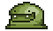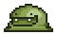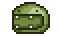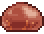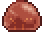

**The Drakanian**

The Drakanian is a unique enemy from the planet Mars. It is melee and will only attack the player when it is in attacking distance. It holds a spear as it main weapon, but upon dying, the beast it was riding on still lives and the player must kill it too to finish the enemy off. The beast will attack the player by biting them. I really like this mechanic as it acts as a ruse to the player, making them think they killed the enemy when they haven’t. Those little things might help increase a player’s enjoyment in the game.

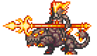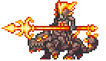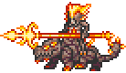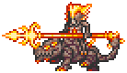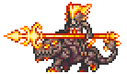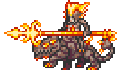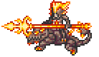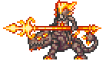

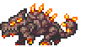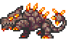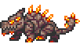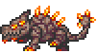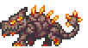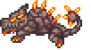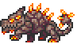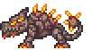

**The Vortexian**

The Vortexian is a ranged enemy that appears in all areas of the game. It will move just like all other enemies (left to right) but will stop whenever the player gets within a certain distance of it. At that point, the Vortexian will shoot a Vortex bullet at the player and will do so infinitely until the player steps out of the shooting area (it will then move off) or whenever the Vortexian dies.

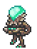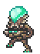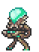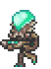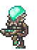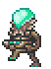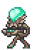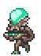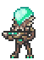

**The Spider**

The Spider is another ranged enemy that the player will encounter in caves in both Mars and Venus. It’s AI is the same as the Vortexian’ s, however it has an extra ability. The spider shoots a cobweb at the character, and if the character was to be hit by a cobweb, they will be frozen in place for 2 seconds, with the incapability to jump or move. However, the player will still be able to attack and use abilities in order to defend themselves and survive.

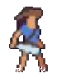



**Ancient Doom**

Ancient Doom is a flying and ranged enemy that lives on Venus. It flies above the character’s head and shoots a demon scythe at the character. The demon scythe it shoots will gradually accelerate, making it harder to dodge when shot from far way. This enemy will test the player’s dodging skills as they try to not get hit by the demon scythe.

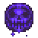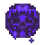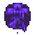

**The Ghoul**

The Ghoul is a Mars exclusive enemy that the player will encounter late in their exploration of the planet. I really like the colors of this enemy and I feel like it fits in well with the environment. The ghoul is a melee enemy and attacks similarly to all other melee enemies. However, when hitting the player, its attacks have a chance to debuff the character and deal extra damage. The player should be really careful when fighting this enemy in order to keep the most of their health as possible.

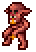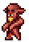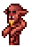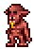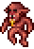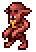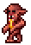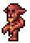

**The Solarian**

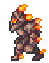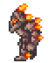The Solarian is another Mars exclusive enemy that the player will encounter towards the end of their exploration of the planet. This enemy has a unique attack. Upon the character entering a certain area. It will roll towards them and deal damage that way. After rolling, the Solarian will deal melee damage to the character, although considerably less than the roll damage. The Solarian’s roll will be on cooldown, so that it is not repeated too often. This will be a very challenging enemy for the player and will test their skills even further than ever before.

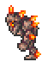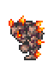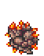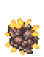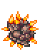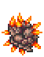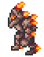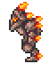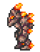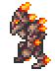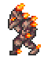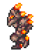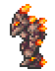

**The Sand Elemental**

The Sand Elemental will the boss of the planet Mars. The player will have to defeat her for them to continue on their adventure. To make her feel like a challenge for the player, I had to make her as challenging as possible, while making her possible to defeat. She will hover in the air and will always face the character. If the character moves too far away from her, she will chase after them until they are in an area close enough to her. She will have two attacks, which will be chosen randomly every time she attacks. The first attack will be a fast-moving projectile that will track the character. If the character gets hit by this projectile, they will be debuffed for extra damage, so it is best to stay away from the projectile. The second attack will be an explosive. Upon using this attack, a target will appear at the character’s location, that will act as a warning for the player. After less than a second, the explosion will occur. If the character had not moved in such time, then they will be hit from the explosion, dealing a lot of damage to their health points. With these two attacks, I believe that the Sand Elemental will act as a tough challenge to the player. Here are all the sprites used:

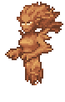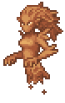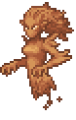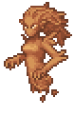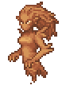

# 

# 

# 

# 

**Old One’s Skeletons**

The Old One’s Skeletons are Venus exclusive enemies. The player will encounter these enemies at the start of their journey through the planet. They are fairly simple enemies with no special attacks or abilities. However, they hint at the final boss of the game, which the player will encounter at the end of their adventure.

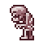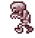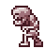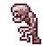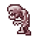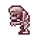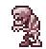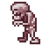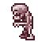

**Evolution Beast**

The Evolution Beast is another Venus exclusive enemy, but the player will only encounter later throughout their exploration of the planet. It is similar to the Drakanian beast, however, will be a ranged enemy. When the beast opens its mouth, a projectile will shoot out towards the character. It’s AI will be the same as the Vortexian.

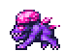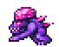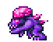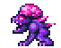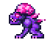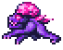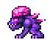

**The Summoner**

The Summoner is the final Venus exclusive enemy before the boss. It is a ranged enemy and is going to be similar to the Vortexian and Evolution Beast. When attacking, the Summoner will summon a bomb above its head which will shoot at the character after 2 seconds. This bomb will create an explosion which will damage the character.

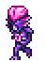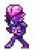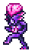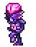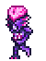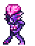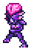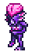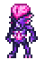

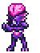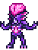



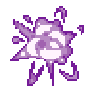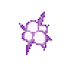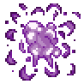

**The Dark Mage**

The Dark Mage will be the boss of Venus and the final boss of the game. To finish the game, the player will have to defeat the Dark Mage. Upon doing so, the game is over and a cutscene will appear. I designed this boss to be as challenging as I could make it. He has 4 different attacks, all ranging in dodging difficulties, abilities, damage, and health. Unlike every other enemy, the dark mage will be able to teleport every ten seconds to give an extra challenge to the player. He will attack the player as soon as the player enters the boss room. The Dark Mage will always be facing the player, just like the Sand Elemental. As previously said, the mage will have 4 different attacks which will all be chosen at random every 5 seconds. His first attack will be a new mechanic I have never used in the game before. The Dark Mage will summon a bomb, a few blocks above the ground, that will fall and upon hitting the ground, the bomb will summon two purple flames, one going left and the other going right, that will damage the player every 2 seconds. His second attack will be a shield of 8 orbs which will summon around him and will block any attacks from the character. These orbs can be destroyed and they will not have much health. This attack will not be re-used until 5 or more orbs have been destroyed. The third attack will be similar to the second as the mage will summon 5 eye – like projectiles in a semi-circle in front of him. These projectiles will shoot out towards the player after 2 seconds. The Mage’s final attack will be to summon 4 Old One’s skeletons to help fight the player. These skeletons will have the exact same AI as the other skeletons the player would’ve already encountered earlier in their adventure. With tall these attacks, I believe the Dark Mage will be a very difficult boss for the player to defeat in order to beat the game. Here are the sprites used:

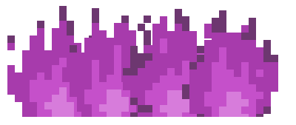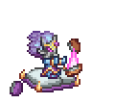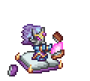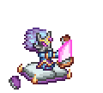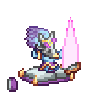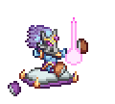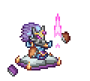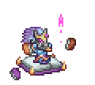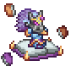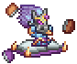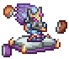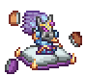

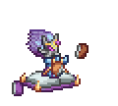

This table shows a summary of every enemy, including their health and damage:

|  |  |  |
| --- | --- | --- |
| **Enemy** | **Damage** | **Max health** |
| Goblin | 5 | 50 |
| Slime Variant 1 | 5 | 50 |
| Slime Variant 2 | 10 | 70 |
| Slime Variant 3 | 20 | 100 |
| Drakanian | 15 | 70 |
| Drakanian Beast | 15 | 100 |
| Vortexian | n/a | 100 |
| Vortex Bullet | 15 | n/a |
| Spider | n/q | 100 |
| Cobweb | 5 | n/a |
| Ancient Doom | n/a | 130 |
| Demon Scythe | 20 | n/a |
| Ghoul | 25 | 120 |
| Solarian | 20 | 140 |
| Solarian Roll form | 30 | n/a |
| Sand Elemental | n/a | 1000 |
| Sand Elemental Attack 1 | 30 | n/a |
| Sand Elemental Attack 2 | 40 | n/a |
| Old One’s Skeletons | 15 | 100 |
| Evolution Beast | n/q | 250 |
| Evolution Beast projectile | 30 | n/a |
| Summoner | n/a | 200 |
| Summoner Bomb | 50 | n/a |
| Dark Mage | n/a | 2000 |
| Dark Mage Flames | 20 | n/a |
| Dark Mage Shield | n/a | 100 |
| Dark Mage Projectile | 10 | n/a |

Overall, I believe all these enemies and bosses are going to pose a challenge to the player when they adventure through this game. Most vary in abilities, in attack patterns, in health, in damage and in projectiles. With all this combined, the player will be put the test whenever facing an enemy. The ramp up of health and damage for the enemies allows for the challenge to be continuous. For example, a Drakanian at the start of the game will have the same level of difficulty as a Summoner, even with the character and weapon skills equipped due to the increase in health and damage. All ranged enemies share a similar AI; however, they differ with their projectile. To make the game more interesting and enjoyable, I tried to add as much variety as I could in the ranged enemies. The way to do that was with the projectiles. I believe that I have accomplished this with the bullet, cobweb, and bomb projectiles. These ranged enemies also have zero contact damage and will only hit the player through said projectiles. Their projectiles have zero health and will destroy on impact with the player, or any ground / wall in the way. Overall, I believe this is a suitable number of enemies for the game. They are spread out amongst both planets, and the player might see a few from Mars through their adventure on Venus, but not too many, to avoid repetition.

# 2.3 Key variables and data structures and classes

C# is an object-oriented programming language. This is very useful when building a video game, as it allows the use of many features. This includes classes, objects, attributes and more. Not only this, but it also allows for the use of encapsulation, polymorphism and most importantly, inheritance.

As previously said, object-oriented languages are very useful when programming a video game. This is due to the classes. These classes allow me to control any part of the game I want throughout the script. For example, I may have a class dedicated to controlling all enemies. Inheritance may also come into play, as I can create sub-classes for all the different enemies. These sub-classes will inherit all the necessary data from the parent class, allowing for a more efficiently structured program and the loss of repeated code.

Another very useful role in this program is the Unity Engine. The Unity Engine is key to using unity as it provides a lot of functions for me to use which are directly connected to unity, which we will see later on.

Combining C# and the Unity Engine is what allows me to create this game. Here are all the classes I will require for this program to function:

**Parent Classes:**

The program will not feature many parent classes, but they will still be very important. The biggest parent class for this game will be the **Enemy** class, which will control the basics of all the enemies’ AI and attacks. The next important parent class is the **Projectiles** class. This class will control all of the projectiles “summoned” by all the enemies. The final parent class that will be used is the **Chest** class. This class will control all the chests that will be placed throughout the map. These are the only three parent classes that will be used in this program.

**Subclasses:**

A subclass is a class that is derived from another. For my program there will be a number of subclasses, each inheriting from their parent class. Listed below are all the subclasses that will inherit from the **Enemy** parent class:

* **Goblin –** A class for the Goblin enemy
* **Slime –** A class for the Slime enemy
* **Drakanian –** A class for the Drakanian enemy
* **DrakanianBeast –** A class for the Drakanian Beast enemy
* **Vortexian –** A class for the Vortexian enemy
* **Spider –** A class for the Spider enemy
* **Ghoul –** A class for the Ghoul enemy
* **Solarian –** A class for the Solarian enemy
* **OldOne’sSkeletons –** A class for the Old One’s Skeletons enemy
* **AncientDoom –** A class for the Ancient Doom enemy
* **EvolutionBeast –** A class for the Evolution Beast enemy
* **Summoner –** A class for the Summoner enemy
* **SandElemental –** A class for the Sand elemental boss
* **DarkMage –** A class for the Dark Mage boss

Listed next are all the subclasses that derive from the **Projectiles** parent class:

* **Bullet –** The class for the Vortexian’s bullet
* **Cobweb –** The class for the Spider’s cobweb
* **Demon Scythe –** The class for the Ancient Doom’s demon scythe
* **EvolutionBeastProjectile –** The class for the Evolution Beast’s attack
* **SummonerBomb –** The class for the Summoner’s bomb
* **SandElementalAttack1 –** The class for the Sand Elemental’s first attack
* **Target –** The class for the Sand Elemental’s target
* **DarkMageProjectile –** The class for the Dark Mage’s projectile attack

Finally, here are the subclasses that will inherit from the **Chest** parent class:

* **SkillsChest –** Class overseeing the chest containing the weapon skills
* **PlayerSkillsChest1 –** Class overseeing the 1st chest containing the player skills
* **PlayerSkillsChest2 –** Class overseeing the 2nd chest containing the player skills

**Player Classes:**

My program will require a number of classes dedicated to the player. They will oversee all that is necessary, from movement to combat and data saving:

* **CharacterController2D –** The class controlling the basics for the player
* **PlayerCombat –** The class controlling the combat for the player
* **PlayerMovement –** The class controlling the movement of the player
* **PlayerData –** The class controlling the player’s data
* **SaveSystem –** The class controlling the saving process of the player’s data
* **TerraBeam –** The class controlling the first weapon skill, the terra beam
* **SwordBeam –** The class controlling the second weapon skill, the swords
* **JesterArrow –** The class controlling the chest plate’s projectile (if chosen)
* **Inventory –** The class controlling the player’s inventory
* **ScoreManager –** The class controlling the player’s coin score

**Enemy Attacks Classes:**

Not all enemy attacks involve a projectile, and therefore they do not need to derive from the projectile class. These include:

* **SummonerExplosion –** A class for the Summoner’s explosion
* **DarkMageBomb –** A class for the Dark Mage’s bomb attack
* **FlamesLeft –** A class for the bomb’s left flames
* **FlamesRight –** A class for the bomb’s right flames
* **DarkMageOrb –** A class for the Dark Mage’s orb attack
* **SandElementalAttack2 –** A class for the Sand Elemental’s second attack

**Other Classes:**

There are many classes that may not fit into an overall category, or inherit from a parent class, but are very useful nonetheless. These are listed below:

* **FallingPlatform –** The class controlling all the falling platforms
* **MovingPlatform –** The class controlling all the moving platforms
* **Grid –** The class controlling the floor and platforms
* **MainMenu –** The class controlling the main menu
* **PauseMenu –** The class controlling the pause menu
* **Spaceship –** The class controlling the spaceship
* **Spikes –** The class controlling the spikes
* **StoryMode –** The class controlling the story mode
* **VarAttackPotion –** The class controlling the attack potion
* **VarHealthPotion –** The class controlling the health potion
* **VarShieldPotion –** The class controlling the shield potion
* **VarCoin –** The class controlling the coins
* **VarHeart –** The class controlling the hearts
* **VolumeController –** The class controlling the volume slider

|  |
| --- |
| **PlayerCombat** |
| maxHealth  currentHealth  attackRange  attackDamage  attackRate  nextAttackTime  firePoint |
| Update  Attack  TakeDamage  UpdateHealth  OnDrawGizmosSelected  LoadPlayer  SavePlayer |

*Key variables and methods - PlayerCombat:*

This class is made to control the player’s combat, potions and more

The methods will let the player attack, get hit, regenerate their health, use skill and more.

The variables will mostly change when the player attack, use a skill / potion, picks up a heart, or gets hits.

|  |
| --- |
| **PlayerMovement** |
| runSpeed  horizontalMove  jump  canPlayerDash  dashDistance  lastKeyCode  doubleTapTime  isDashing |
| Update  FixedUpdate  Dash |

*Key variables and methods - PlayerMovement:*

This is made for the player’s movement and will control all that is to do with it

The methods will help set up the player to move, as the function to move and jump will be located in the CharacterContrller2D class.

The variables will mostly change when the player moves, jumps, dash, presses a certain key.

|  |
| --- |
| **Enemy** |
| maxHealth  currentHealth  attackRange  attackDamage  attackRate  nextAttackTime  speed  moveRight |
| Update  OnTriggerEnter2D  Attack  Die |

*Key variables and methods - Enemy:*

This class is the parent class for all the different enemies I will have in my game

The methods will let the enemy attack, take damage, move, die and more

The variables will mostly change when the enemy turns around, attack, get hit or get debuffed.

|  |
| --- |
| **Enemy** |
| ChestIsOpen  ChestContentsUI  Content1  Content2  chestRange |
| Update  OpenChest  CloseChest |

*Key variables and methods - Chest:*

This class is the parent class for all the different chests I will have in my game

The methods will control the chest opening, closing and all the different buttons that will be included within the chests.

The variables will mostly change when the chest opens and closes.

2.4 Algorithms

An algorithm is a set of rules that requires to be followed to solve a problem. These problems can be anything, and in this program, they will refer to things like movement, attacking, abilities and more. Here are most of the algorithms I will be using in this program, and the pseudo code for them. These are very important as they will control how my player and enemies move, attack and more.

**Player Movement:**

This algorithm will be used to move the player. This will be done whenever the “a” or “d” key is pressed as it is a 2D game, and the other keys are not needed. I am able to use a built-in unity feature to do so:

**START**

Float HorizontalMove = 0f

Float RunSpeed = 40f

Update Function:

HorizontalMove = HorizontalValue x RunSpeed

Move(HorizontalMove)

Move function;

Add movement to a Vector

**END**

HorizontalValue refers to a built-in unity feature. It will be set as 1 if the “a” key is pressed, and -1 if the “d” key is pressed. This will make the player move left or right according to the pressed key. I can adjust the speed of the movement by changing the variable RunSpeed.

**Player Jump:**

This algorithm will be used to make the player jump. This will occur whenever the “space” key is pressed. The player will be given a jump force and that will allow it to jump. As I am able to set a gravity value to my player, it will automatically come back down.

**START**

Bool jump

Float jumpForce = 40f

Update function:

IF “space” key is pressed:

jump = true

IF jump = true AND player is grounded:

Add jumpForce to the Rigidbody

**END**

The rigidbody is a built in Unity feature which allows for movement of an object. It is where I can set the gravity for the player to fall back down. By adding the jump force to rigidbody, the player is able to jump.

**Player Attack:**

The player attacking algorithm will make use of the Time.time feature from Unity. It allows for the creation of an attack rate, to make sure the player is not able to attack constantly and be too overpowered.

**START**

Float nextAttackTime

Float attackRate

Int attackDamage

Update Function:

IF Time.time > nextAttackTime AND “mouse0” is pressed:

Attack()

nextAttackTime = Time.time + 1 / attackRate

Attack function:

Collider Array[]

IF there are any enemies in the array:

Enemy takes attackDamage

**END**

Upon attacking, the program must set the nextAttackTime to a higher value than before, so that more time must go by before the player is able to attack again. In the attack function, I create an array where if an enemy enters a certain region, it will register it and be placed in the array. “mouse0” refers to the left click on the mouse.

**Player Dash:**

This algorithm will only be in use if the player was to pick up the dash ability from one of the chests. The algorithm will make use of another Unity feature, StartCoroutine, which allows for a delay to be used in the algorithm.

**START**

Bool canPlayerDash

Bool isDashing

Float dashDistance

Float doubleTapTime

KeyCode lastKeyCode

Update Function:

IF canPlayerDash = true

IF key “a” is pressed:

IF doubleTapTime > Time.time AND lastKeyCode = “a”:

StartCoroutine(Dash(-1))

ELSE:

doubleTapTime = Time.time + 0.5

lastKeyCode = “a”

ELSE IF key “d” is pressed:

IF doubleTapTime > Time.time AND lastKeyCode = “a”:

StartCoroutine(Dash(1))

ELSE:

doubleTapTime = Time.time + 0.5

lastKeyCode = “d”

Dash Function:

isDashing = true

Set velocity in upwards direction to 0

Set gravity to 0

Add force to the rigidbody to launch the player in the given direction

Wait for Seconds(0.4)

isDashing = false

Set gravity back to 1

**END**

This is quite a complex algorithm, but it all fits in properly. If “a” or “d” is pressed, the same key must be pressed in “doubleTapTime” time before the dash is no longer possible. The value passed on to the dash function indicates the direction of the dash.

**Player Hit:**

This algorithm refers to whenever the player receives a hit, whether from an enemy, a spike or other. It is a fairly simple algorithm that will not use many Unity built-in features.

**START**

Int currentHealth

Take Damage function:

currentHealth = currentHealth – damage

IF currentHealth <= 0

Set player as inactive

**END**

This Take Damage function will be called from the enemy class, the spike class other. As well as calling it, it will also pass a parameter with it, in this instance, it is the variable damage.

**Player Freeze:**

Whenever the player gets hit by a spider’s cobweb, they get frozen and are unable to move or jump.

**START**

Freeze Player Function:

Change speed to 0

Change jump force to 0

Change player sprite to the webbed sprite

Invoke Unfreeze Player function after 2 seconds

Unfreeze Player Function:

Change speed back to original value

Change jump force back to original value

Change player sprite back to the original

**END**

The Invoke function is a built-in unity feature which allows the program to call the unfreeze function after a given amount of time.

**Player Debuff:**

This algorithm occurs whenever the player is debuffed, which can occur in a few different ways (Sand elemental, ghoul and more).

**START**

Bool playerIsDebuffed

counter

Debuff Player function:

playerIsDebuffed = true

IF counter < 10

TakeDamage(1)

Add one to counter

Invoke Debuff Player function after a second

ELSE IF counter = 10

playerIsDebuffed = false

**END**

This function will be called from any class that have the ability to give the player the debuff. Again, I make use of the Invoke feature to make the sure the player takes one hit per second, and not 10 damage instantly.

**Player Health:**

The player’s health is a very important feature in the game and this algorithm will control updating the health of the player whenever the player picks up a heart object

**START**

Int currentHealth

Int maxHealth

Update Health function:

IF currentHealth + health > maxHealth:

currentHealth = maxHealth

ELSE:

currentHealth = currentHealth + health

**END**

The value of the variable health will be passed as a parameter when the function is called in the VarHeart class.

**Enemy Movement:**

Enemy movement is just as important as the player’s. However, it is a little more difficult as no keys are pressed to make them move. Instead, they will be constantly moving until the hit an invisible object, which will make them turn in the other direction.

**START**

Bool moveRight

Float speed

Update Function:

IF moveRight = true:

Add a positive movement to the enemy’s vector and multiply by speed

Change the sprite’s x value to the opposite to flip it

ELSE

Add a negative force to the enemy’s vector and multiply by speed

Change the sprite’s x value to the original to flip it

**END**

This is very similar to the player’s movement algorithm, but at the moment, I have no way of changing the value of moveRight, which we will look at for the next algorithm

**Enemy Turning:**

In order for the enemy to turn and walk in the opposite direction, I need them to collide with an object. It could be a wall, however, using an invisible object – that the player could pass through – is more efficient and I will do so in the unity engine.

**START**

Bool moveRight

Colliding function:

IF Collider hits the invisible object:

IF moveRight = true:

MoveRight = false

ELSE:

moveRight = true;

**END**

This algorithm will allow for the enemy to now turn to the other direction whenever hitting the invisible object.

**Enemy Attack:**

This algorithm will again be similar to that of the player attacking one and will be just as important it. However, once again, there is no key to be pressed and therefore, the program will need to constantly check if there are any players in the array

**START**

Float nextAttackTime

Float attackRate

Update function:

Collider Array[]

IF there are any players in the array:

Speed = 0

IF Time.time > nextAttackTime AND “mouse0” is pressed:

Attack()

nextAttackTime = Time.time + 3 / attackRate

**END**

The attack function is not mentioned in this algorithm as it will be different for most of the different enemies. The speed is set to zero so the enemy stops in front of the player to attack them.

**Enemy Hit:**

This is a relatively short algorithm and will control all the damage the enemies will take, from any sources.

**START**

Int currentHealth

Take Damage function:

currentHealth = currentHealth – damage

IF currentHealth <= 0

Die()

**END**

The damage variable acts as a parameter that will be passed on when the function is called from other classes. If the health is smaller or equal to zero, the death function is called, which will be looked at next.

**Enemy Death:**

This algorithm will control what happens when an enemy dies. This algorithm will make use of a unity feature that will be very useful:

**START**

Array enemyPosition[]

Int num

Die Function:

Set enemyPosition[] values as the enemy’s current position

Generate a random number (num) , either 0, 1 or 2

IF num = 1:

Enemy drops heart on death at the enemyPosition[] values

ELSE IF num = 2:

Enemy drops coin on death at the enemyPosition[] values

Destroy the enemy

**END**

“Destroy the enemy” refers to the unity function that I will be using in the algorithm. This function will erase the enemy from the current game, along with all its data. The enemy will only come back when the game is run again.

**Melee Enemy Attack:**

This algorithm will be used when a melee enemy attacks. All the enemies with special attacks, like the ranged enemies and the bosses will not make use of this algorithm.

**START**

Int baseDamage

Attack function:

IF player has orb activated:

damage = 0

ELSE IF player has shield potion activated:

damage = baseDamage – 10

TakeDamage(damage)

ELSE:

TakeDamage(baseDamage)

**END**

The TakeDamage function refers to the one in the player class and it will be linked to all the subclasses of Enemy so that they player can be hurt. This algorithm will also be used to control the contact between projectiles and the player.

**Ranged Enemy Attack:**

This algorithm refers to the attack of a ranged enemy. These include the Vortexian, spider, ancient doom, and summoner. The bosses will also use a similar algorithm, but it will be combined with other ones.

**START**

Object bullet

Object firePoint

Float fireRate

Float nextFire

Start Method:

fireRate = 3

nextFire = Time.time

Attack function:

FireBullet()

Fire Bullet function:

IF Time.time > nextFire

Instantiate bullet at the firePoint’s position

nextFire = Time.time + fireRate

**END**

The use of Time.time in this algorithm allows for the ranged enemies to only attack every 3 seconds (fireRate). The Start method is a Unity method which is called at the very beginning when the game is run. Once again, the attack function is called from the parent class, Enemy. The object variables refer to a GameObject, which are the building blocks for a Unity program.

**Enemy** **Projectile**:

The projectiles class will be a parent class in this program and will control all the enemy projectiles. This algorithm will show how the projectiles should act.

**START**

Float moveSpeed

Object target

Vector moveDirection

Start method:

Target = player

moveDirection = (player’s position – projectile’s position) x moveSpeed

Add moveDirection to the rigidbody of the projectile to make it move

Update function:

IF projectile hits ground

Destroy the projectile

**END**

This algorithm isn’t particularly finished. If the projectile was to hit the player, nothing would happen. But as this will be in a parent class, hitting the player will take place in each of the subclasses to allow the different projectiles to do different hit points of damage to the player.

**Slime jumping:**

The slimes will have a complicated jump pattern. They will jump in a direction, then stop for a few seconds, and then jump again. They will repeat this pattern until they are killed by the player.

**START**

Int jumpHeight

Bool isEnemyGrounded

Bool isJumping

Bool canJump

Update function:

isEnemyGrounded = any collisions with the ground

IF isEnemyGrounded = true:

Set gravity to 0

IF isJumping = true:

Set speed to 0

Set gravity to 0

isJumping = false

canJump = false

Add force to the rigidbody to make it move in the air

Invoke resetCanJump after 1 second

ELSE:

IF canJump = true:

Set gravity to 1

Set speed to 1

Add jumpHeight to rigidbody to make it jump

Invoke resetIsJumping after x second(s)

Reset canJump function:

canJump = true

Reset isJumping function:

isJumping = true

**END**

This is a pretty long algorithm but I believe it will do the job. I have set a letter “x” in the algorithm as I cannot be sure of the timing for the jump until I test this in the Unity engine later on.

**Drakanian Beast Spawning:**

When the Drakanian dies, it will spawn a Drakanian beast at its location. Here is the algorithm to do so:

**START**

Object DrakanianBeast

Overriding Die function:

Instantiate the Beast

ChangeBeastPosition()

Base.Die()

Change Beast Position function:

Array enemyPosition[]

Add the Drakanian’s position in the array

Change the Beast’s position based on the values in the array

**END**

In this algorithm, I have to override the die function in the Enemy parent class as I have to include more code. However, I still require the Enemy Die function, and I am able to use it by simply writing “Base.Die()” thanks to the Unity engine.

**Ghoul Debuffing Player:**

The ghoul has the unique ability to debuff the player when attacking them. It will be set at a random chance to reduce the effect’s power.

**START**

Int baseDamage

Int num

Attack function:

IF player has orb activated:

damage = 0

ELSE IF player has shield potion activated:

damage = baseDamage – 10

TakeDamage(damage)

num = random number between 0 and 6

IF num = 1:

DebuffPlayer()

ELSE:

TakeDamage(baseDamage)

num = random number between 0 and 6

IF num = 1:

DebuffPlayer()

**END**

The DebuffPlayer function will link directly to the player class via instances. In this algorithm, the effect is able to stack (if the player is unlucky and gets 1 multiple times in a row), and I might look at changing that when testing.

**Solarian Roll:**

The Solarian’s roll is a very unique ability. Whenever the player is in a certain range of the Solarian, it will roll towards it, changing to its rolling animation and dealing more damage.

**START**

Bool isRollling

Bool canRoll

Update function:

Collider Array[]

IF player in the array:

IF isRollling = false and canRoll = true:

isRollling = true

canRoll = false

Invoke StopRolling function after 5 seconds

Stop Rolling function:

isRollling = false

Invoke ActivateRoll function after 10 seconds

Activate Roll function:

canRoll = true

**END**

Again, I make use of the Invoke function to control the time the Solarian rolls for and to control the time before the Solarian is allowed to roll again.

**Dark Mage Teleport:**

The Dark mage has a unique ability that allows him to teleport to a random location after a certain amount of time.

**START**

Bool canTeleport

Int newPositionX

Int newPositionY

Int leftOrRight

Int upOrDown

Update function:

IF canTeleport = true:

canTeleport = false

newPositionX = random number between 0 and 9 + 5

newPositionY = random number between 0 and 1 + 2

leftOrRight = random number between 0 and 1

upOrDown = random number between 0 and 1

IF leftOrRight = 0 AND upOrDown = 0:

newPositionX = - newPositionX

Move Dark mage according to newPositionX and newPositionY

ELSE IF leftOrRight = 1 AND upOrDown = 0:

Move Dark mage according to newPositionX and newPositionY

ELSE IF leftOrRight = 0 AND upOrDown = 1:

newPositionX = - newPositionX

newPositionY = - newPositionY

Move Dark mage according to newPositionX and newPositionY

ELSE

newPositionY = - newPositionY

Move Dark mage according to newPositionX and newPositionY

Invoke ResetTeleport function after 5 seconds

Reset Teleport function:

canTeleport = true

**END**

This algorithm requires a lot of iteration as there are 4 ways the mage can go. Up and right, up and left, down and right, or down and left. The mage will be moved based on his initial position to avoid him moving too far away.

**Falling Platform:**

As part of making difficult levels for the player to traverse, I decided to include falling platforms. Once the player is on it, it disappears after 2 seconds, and then comes back.

**START**

Update Function:

Collider Array[]

IF player in array:

Invoke DestroyPlatorm function after 2 seconds

Destroy Platform function:

Set platform as inactive

Invoke ResetPlatform after 5 seconds

Reset Platform function;

Set platform as active

**END**

In this algorithm, I make use of the active/inactive feature unity offers. By using this, when the platform is inactive, the player cannot interact with it and will be invisible. When the time is right, I can just set as active again.

**Moving Platform:**

Along with falling platforms, I will add moving platforms in my game, to increase the diversity in the platforming, but also its difficulty

**START**

Transform postion1

Transform postion2

Float speed

Transform startPosition

Vector nextPosition

Start function:

nextPosition = startPosition

Update function

IF platform at position1:

nextPosition = position2

ELSE platform at position2:

nextPosition = position1

Add force to a vector to make the platform move towards nextPosition

**END**

The data type Transform used in the algorithm above is used to access the object’s position, scale, and rotation. In this instance, we require the position of the points position1, position2 and startPosition, and therefore use the data type Transform.

**Score System:**

The scoring system is important for the story as the player is required to get a certain number of coins and iron bars to fix their ship before heading onto the next step of the game.

**START**

Int coins

Int bars

Start function:

Coins = 0

Update function:

IF coins >= x and bars >= y

Output text to tell player the spaceship can be fixed

Add Coin function:

Coins = coins + number

**END**

The AddCoins() function will be called from the player class whenever the player interacts with a coin. It will also pass the number to add as a parameter, here seen as “number”.

**Potions:**

Potions are very useful items in the game as they give more flexibility for the player in terms of their gameplay. They allow to regain health, do more damage, or limit the damage taken. In this algorithm, we will look at the damage potion, which increases damage done by 20.

**START**

Int attackDamage

Bool canTakeAttackPotion

Int timer

Update Damage function:

attackDamage = attackDamage + 20

canTakeAttackPotion = false

Invoke ChangeTimer function after a second

Change Timer function:

timer = timer - 1

IF timer = 0:

attackDamage = attackDamage + 20

canTakeAttackPotion = true

ELSE:

Invoke Change Timer function after 1 second

**END**

The UpdateDamage function will be called from the Inventory class whenever the player takes a damage potion from the inventory.

**Save System:**

The saving system will be a very complex algorithm to make as it requires making use of binary formatters to save and load the data. All the data would have been recorded in the Player Data class.

**START**

Save Player function:

Create a binary formatter

Create a path for the file

Create the file

Acquire data from the Player Data class

Add data to the file

Load Player function:

Reinstate path

Create binary formatter

IF file exists in the path:

Open the file

Save data in the file in the Player Data class

Close the file

ELSE:

Error message as file wasn’t found.

**END**

Once again, Unity provides me a very useful feature, binary formatters. These are used to save the data into the file and used to read the data from that same file.

# 2.5 Usability Features

**Ease of use:**

The ease of use will look at how easy the game’s features are to use. This will include the controls, the menus and the GUIs. This is essential as I do not want to create a game that is hard to understand for a player. The controls will be the ‘a’ and ‘d’ keys for movement, ‘space’ for jumping and other ones for more features. The menus will be the options menu, the main menu, the pause menu and the inventory. The options menu will include the controls so that the player is able to look back at them whenever they wish to do so. Finally, the GUIs will be the information displayed to the player on screen, which will include a health bar, timers and more (refer to section 2.2).

**Engagement:**

To make the players engage with my game, I have to make it enjoyable for them. If it isn’t, they wouldn’t want to keep playing and engage with it. To do so, I will make sure the game has a good balance with difficulty (enemies, platforming, bosses, etc…). It must also have a good soundtrack, an engaging story and nice interactive graphics. This will pose a challenge for me, especially finding the balance in the difficulty, as I have to make sure some enemies do not deal too much damage, and some platforms do not take 10 minutes to reach. But in the end, with all of this combined, I believe my game will be as enjoyable as it can be, and therefore, as engaging as it can be.

# 2.6 Test data to be used during iterative development

As part of development, I have to test every section before moving on to the next. To do so, I can use the debugger from Virtual Studio. This feature allows me to check the values stored in the variables at any time when running the code. This will be very helpful as I am able to check if they are storing the right variables at the right time. Below are the tests I will conduct for all of the important classes:

**Player:**

The player will be the main focus of the game and therefore will need a lot of testing. These include;

|  |  |  |
| --- | --- | --- |
| Feature Being Tested | Testing Method | Expected Outcome |
| Player moving to the right | Hold down the “a” key while in the game | The player will move to the right |
| Player moving to the left | Hold down the “d” key while in the game | The player will move to the left |
| Player attacking | Left click while in the game to test | The player will inflict damage upon an enemy |
| Player jumping | Press the “space” key in the game | The player will jump into the air and fall back down |
| Player taking damage | Add an enemy in game and make them hit the player for the test | The player’s health points will decrease by the damage dealt |
| Player dying | Get the player’s health to zero | The player will die and a death message will appear |
| Player taking damage when debuffed | Add enemy with debuff ability and make them hit the player | Once debuffed, the player will take 1 hit point of damage for 10 seconds |
| Player not moving when frozen | Make the player get hit by  a cobweb | The player is unable to move and jump for 2 seconds |
| Player dashing (dashing skill must be acquired) | Press the “a” or “d” key in quick succession | The player will launch forwards for a short time |
| Player regenerating (regeneration skill must be acquired) | Activate the skill and test 1 health point comes back every 2 seconds | The health amount will increase by 1 point every 2 seconds |
| Player activating orb (orb skill must be acquired) | Activate orb skill and press “k” when in game | The orb will be activated around the player. |

**Enemy:**

The enemy’s tests will be similar to the player’s as they are both moving objects. These include:

|  |  |  |
| --- | --- | --- |
| Feature Being Tested | Testing Method | Expected Outcome |
| Enemy movement | Watch the enemies move in the game | The enemy will not move down or jump, but only left or right |
| Enemy changing direction | Watch the enemy when it hits the turn object | The enemy will change direction upon hitting it, and its sprite will flip |
| Enemy taking damage | Use the player to attack the enemy | The enemy’s health bar will show up and its health will decrease |
| Enemy death | Kill the enemy by attacking it with the player | The enemy will disappear completely |
| Enemy attack when in range | Move the player towards the enemy | The enemy’s attack animation will play and the player will take damage |
| Enemy drops | Kill the enemy by attacking it with the player and see | Either a heart or a coin will drop at the enemy’s location upon death |
| Ranged enemy shooting | Move the player in the shooting range of a ranged enemy | The ranged enemy will instantiate the projectile upon the player being in that range |

**Slime Jump:**

The slime’s jump will not require a lot of testing but is still very important as it is a complex algorithm

|  |  |  |
| --- | --- | --- |
| Feature Being Tested | Testing Method | Expected Outcome |
| Slime jumping | Watch the slime jump in the game | The slime jumps in the air, but not too high up |
| Slime falling to the ground | Watch the slime fall in the game | The slime will fall back down to the ground after jumping |
| Slime hitting the ground and stopping | Watch the slime hit the ground in the game | The slime will stop and not go through the ground |
| Slime staying stationary | Watch the slime in the game | The slime will not move or jump for a second |

**Drakanian Beast:**

With the Drakanian beast, there will only be one thing to test, but it is still important as it relates to its ability:

|  |  |  |
| --- | --- | --- |
| Feature Being Tested | Testing Method | Expected Outcome |
| Drakanian disappearing | Kill the Drakanian with the player in game | The Drakanian will disappear and drop a heart or coin |
| Drakanian Beast appearing | Wait for the beast after the Drakanian dies | The Drakanian beast will spawn and act like all other enemies |

**Solarian Roll:**

The Solarian roll will need a lot of testing as there can be quite a lot of problems in the game when the solarian rolls:

|  |  |  |
| --- | --- | --- |
| Feature Being Tested | Testing Method | Expected Outcome |
| Solarian roll distance | Move the player inside in the roll range | The Solarian will change to tis rolling animation and roll towards the player |
| Solarian stop rolling | Watch the Solarian roll in the game | The Solarian will switch back to its walking animation after a few seconds |
| Solarian hitting player when rolling | Let the player get hit by the solarian while rolling | The Solarian will stop its rolling animation |
| Solarian waiting to roll again | Watch the Solarian after rolling in the game | The Solarian will not be able to roll for a few seconds |

**The Ghoul:**

The Ghoul will require testing as it will be able to randomly debuff the player upon attacking them

|  |  |  |
| --- | --- | --- |
| Feature Being Tested | Testing Method | Expected Outcome |
| Ghoul debuff ability | Let the Ghoul attack the player in game | The ghoul will be able to debuff the player when attacking |
| Frequency of debuff ability | Record the ratio of hits to debuff hits | The number of hits is higher than debuff hits |

**The Ancient Doom:**

The Ancient is a little bit different to the other ranged enemies as it floats around above the player and can shoot in any directions. Therefore, this enemy will need extra testing along with the overall enemy testing

|  |  |  |
| --- | --- | --- |
| Feature Being Tested | Testing Method | Expected Outcome |
| Ancient Doom floating | Watch the Ancient Doom in the game | The Ancient Doom will not fall down to the ground |
| Ancient Doom shooting | Get the Ancient Doom to attack the player from different directions | The demon scythe can spawn in any direction from the Ancient Doom |
| Demon Scythe accelerating | Watch the demon scythe in the game | The demon scythe will gradually get faster |

**The Sand Elemental:**

The Sand Elemental is the first boss in the game and has 2 attacks to randomly choose from. As it is different to most enemies, it will require extra testing along with the overall enemy testing.

|  |  |  |
| --- | --- | --- |
| Feature Being Tested | Testing Method | Expected Outcome |
| Sand Elemental attacks | Let the Elemental attack the player in game | The Sand elemental will attack the player with two different attacks |
| Frequency of attacks | Record the ratio of attack 1 to attack 2 | The attacks don’t play one after the other but the ratio is approximately 1:1 |
| Elemental’s debuff ability | Let the Elemental attack the player in game | The Elemental’s first attack will debuff the player on hit |
| Elemental’s target before attack | Let the Elemental use the second attack in game | The explosion will play as second after the target shows |

**The Dark Mage:**

The Dark Mage is the final boss in the game and the hardest enemy the player will encounter. He will have a variety of attacks and will therefore need extra testing along with the base enemy testing.

|  |  |  |
| --- | --- | --- |
| Feature Being Tested | Testing Method | Expected Outcome |
| Dark Mage attacks | Let the Dark Mage attack the player in game | The Dark Mage will attack the player with the 4 different attacks |
| Frequency of attacks | Record the ratio of attacks | The attacks will play randomly and all of them will be seen often |
| Dark Mage teleporting | Watch the Dark Mage in game | The Dark mage will teleport to a random location |
| Frequency of teleports | Record the time between teleports | The time intervals will not be too high |

**Inventory:**

The inventory will be a very useful UI in the game as it will allow the player to check their resources, but also to interact with them, like using a potion

|  |  |  |
| --- | --- | --- |
| Feature Being Tested | Testing Method | Expected Outcome |
| Opening the inventory | Press the “e” key in the game | The inventory will open and the game will pause |
| Contents of the inventory | Look at the inventory when opened | The number of potions and bars will be shown near their pictures, along with the weapon |
| Ability to use a potion | Use a potion when the inventory is opened | The number of potions will decrease when taking one |
| Closing the inventory | Press the “e” key again when the inventory is opened | The inventory will close and the game will un-pause |

**Chests:**

Chests are all very useful in the game. They will contain coins, bars, potions and in exclusive chests, the player and weapon skills.

|  |  |  |
| --- | --- | --- |
| Feature Being Tested | Testing Method | Expected Outcome |
| Chest opening | Press the “q” key in game | The chest will open |
| Chest opening distance | Press the “q” key near a chest and away from a chest | The chest will not open when pressing the key away from it |
| Chest contents | Look at the chest contents when opened | The contents will be shown |
| Player can only take one skill (skills chests only) | Take a skill from a skills chest | The other skills will disappear to restrict the player to one skill only |

**Falling Platforms:**

The falling platforms will not require much testing but it is essential to get the timing right otherwise they become useless:

|  |  |  |
| --- | --- | --- |
| Feature Being Tested | Testing Method | Expected Outcome |
| The platform disappearing | Step on the platform with the player | The platform will disappear after a second |
| The platform will only disappear if it is a player stepping on it. | Place an enemy on the platform | The platform will not disappear |
| The platform re-appearing | Watch the platform after it has disappeared | The platform will come back 2 seconds after disappearing |

**Moving Platforms:**

Moving platforms will require some testing but not too much. I will need to make sure they move according to the algorithm:

|  |  |  |
| --- | --- | --- |
| Feature Being Tested | Testing Method | Expected Outcome |
| The platform moving | Watch the platform moving | The platform will move from position1 to position2 |
| The platform switching directions | Watch the platform moving | The platform will go back the other way when hitting the end |
| The platform will not move the player | Use the player to stand on the platform | The player will fall off the platform if not moving |

**Scoring system:**

The scoring system is very important in the game as it will allow the player to leave the first part of the game to get to the next:

|  |  |  |
| --- | --- | --- |
| Feature Being Tested | Testing Method | Expected Outcome |
| The coin counter | Look at the ui for the coin counter | The coin number will display on the screen |
| Coin counter increasing | Grab a coin with the player | The coin number will increase after grabbing a coin |
| Coin completion | Grab enough coins to complete the mission | The player will be informed when the score is high enough to fix the spaceship |

**Potions:**

All 3 potion types have different abilities but will all be tested in the same way as only their ability changes

|  |  |  |
| --- | --- | --- |
| Feature Being Tested | Testing Method | Expected Outcome |
| Using a potion | Click on a potion in the inventory | Upon grabbing a potion, its ability will immediately occur |
| Potion timer | Wait 60 seconds after using a potion | The player will not be able to take another potion for a minute |
| Potion timer UI | Look at the screen after using a potion | A timer will show up on the screen to show the player the time left |
| Null potions | Grab a potion when the player has none | Nothing should occur if the player has no potions |
| Attack potion | Attack an enemy with the potion active | The enemy should take 20 more damage |
| Shield potion | Let an enemy attack the player | Th player should take 10 less damage |
| Health potion | Take damage before taking the potion | The player’s health should increase by 100 |

**Save system:**

The saving system will be the last needed test for this program. I need to ensure everything is saved properly and put back when loading

|  |  |  |
| --- | --- | --- |
| Feature Being Tested | Testing Method | Expected Outcome |
| Data saving | Click on the save button in the pause menu | The data will be saved through the player data class when pressing the save button |
| File created | Find the file after clicking the save button | The file will be created and the data saved in there |
| Data loaded | Check variable components after pressing load button | The data will be correctly loaded when the load button is pressed |
| Data loaded in game | Watch what happens in game | The game’s state will go back to the state it was when saving |

# 2.7 Further data to be used in post development

Upon finishing development, I will need to check a number of things. For one, I will need to complete the testing that was described above, but I will also need to some other testing, including beta testing. Beta testing will allow me to receive feedback on the gameplay, the difficulty, the visuals, the enemies and more from the people that I will let test the game. This will give me a chance to reflect upon the game and improve based on the feedback given. Second, I will need to check if the success criteria has been met, to ensure I have done what I set out to do in the beginning. Here is a table describing how I will be able to know if the success criteria has been met:

|  |  |
| --- | --- |
| Success Criteria | How I will know it has been met |
| The game will be a 2d platformer that obeys the laws of physics | I will play through the game. The perspective should match a 2D one, there should be gravity and platforms |
| The game should feature a main menu and a pause menu | I will play the game and check a main menu appears. I will also attempt to pause the game to show the pause menu |
| The character should be able to move left and right while also being able to jump | I will attempt to move the player left and right and also attempt to jump |
| The character should have a defined amount of life | Upon starting the game, I will look and see if the player’s health is displayed as a defined amount |
| The character health and coins collected should be displayed to the player | Once in game, I will look and see if the screen displays such information |
| There should be different enemies, all with different amounts of health | I will let the player take damage from enemies to check they do different damage. I will also damage them to check for the different amounts of health |
| Different enemies will have different AI | I will play through the game and observe the enemies to check most have different AI |
| The character should have an inventory interface | Once In game, I will attempt to open the inventory interface to check |
| Multiple levels that get harder as the game progresses | I will allow someone to play through the game and they shall inform me on the difficulty and challenge of these levels |
| The character must be able to fight against enemies | I will play the game and attempt to kill as many enemies as I see |
| There will be a final boss at the end of the game | I will play the game until the end to check is a boss appears |
| The game will feature information about space | I will explore the game, look in chests to try and find the information |
| Enemies should be able to drop coins and drops | I will kill as many enemies as I can to check if they drop hearts and coins |
| The game should be able to run on a standard computer | I will test the game on multiple different computers with ranging quality and speed |

# 2.8 Validation

The game I will create does not require any sort of input apart from the keys that will be assigned to certain controls (e.g. ‘a’ for left, ‘d’ for right and ‘space’ for jump). If the player was to hit any other keys than the ones assigned (which will be found in the options menu), nothing will occur. As this is the only type of input for the game, there is no need for any time of validation.

# 2.9 Videos

When testing, I will create videos to demonstrate how the game works and prove that it works correctly. I will include these videos in the necessary tables when testing during and after development.

**Video 1** – This video will show how the player is able to move and jump. It will also demonstrate the falling and moving platforms as well as the player opening a chest.

**Video 2** – This video will demonstrate how the player can navigate the main menu, and change the sound in the options menu

**Video 3** – This video will show the player interacting with the goblin enemy. The player will take a hit and the health bar will go down. Once the goblin is hit enough times, it will die and drop an item

**Video 4** – This video will show the interaction with the slime and how it is able to jump

**Video 5** – This video will show the interaction with the Drakanian and how the Drakanian beast will spawn on death.

**Video 6** – This video will show the interaction with the Vortexian and how it will shoot the player from a distance

**Video 7** – This video will show the interaction with the Spider and how it can freeze the player with its cobwebs

**Video 8** – This video will show the interaction with the Ghoul and how the player will be randomly debuffed by it when hit

**Video 9** – This video will show the interaction with the Solarian and how it will be able to perform a dash. It will also show the difference in damage when the solarian is rolling or not

**Video 10** – This video will show the interaction with the Ancient Doom and how it will shoot in any direction. It will also demonstrate how the demon scythe can accelerate.

**Video 11** – This video will show the interaction with the Summoner and how it will spawn a bomb above its head that will then shoot towards the player

**Video 12** – This video will show the interaction with the Sand Elemental and its different attacks

**Video 13** – This video will show the interaction with the Dark Mage and its different attacks

**Video 14** – This video will demonstrate how the player is able to save and load when playing the game. It will demonstrate how the player will lose the potions it picked up after saving and how their health goes back to its value when saving, along with their position,

**Section Three: Development & Testing**

**Max marks 25**

# 3.1 Iterative Development of the coded solution

## 3.1.1 Prototyping

Once I knew I wanted to create a 2D platformer, I decided to create a project that will help me test out the features I will need within the Unity engine. This will help me get comfortable and help me understand the Unity engine, before I go on to create the actual project. A screenshot of this project will be shown at the bottom of the page. To help me create a 2D game, I watched many tutorials on YouTube by Brackeys, who helped me understand the basics on how to use unity, and showed me how to create a player, make it move, attack and more. Through watching these tutorials is what helped me make the ‘test’ project, which is shown at the bottom of the page.

Once I felt comfortable and ready to use the unity engine, I created the project that will become the program itself. Doing this has really helped me as it has given me an introduction on how to use the engine, which has in turn helped me become more comfortable with it, and allow to focus solely on making the game, without having to worry about not knowing what feature of the engine I need to use, or what one of the features does.

For the graphics of the game, I used a website, called the Spriter’s resource to find and use the sprites for the player and enemies. Most of the sprites are from Terraria. Having these sprites allows the game to feel more alive, as they were created by professionals. I had to take sprites from other games due to the time constraints I was given. To design the levels, I hand drew some of them, to give myself an idea of what I wanted for the game, before inputting them into the game itself.

For the music and soundtrack, I had to find sounds which would fit the theme of the game. To do this, I looked on multiple different websites for sounds that did exactly that. I had to look online, as due to time constraints, I was unable to create my own sounds and music for the game.

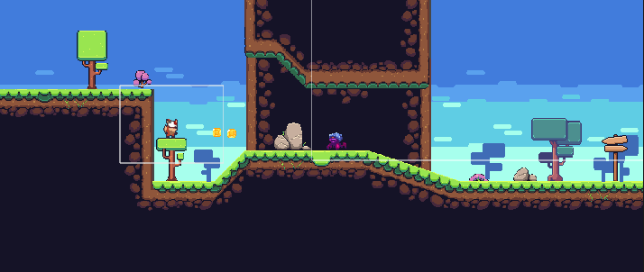

As shown in the picture, I started by making a player, an environment and an enemy. The player is able to move and jump around the environment. The enemy was not able to move however. I tested out the different layers (background, foreground), and finally I created coins to make the player collect them and add to a score counter.

## 3.1.2 Development and testing

1 – Creating the menus:

1.1: Main Menu

When running the game, the player will immediately see the main menu. Here, the player can choose to click on three buttons: Play, Options and Quit. The play button will start the game, the options button will remind the player of the controls and allow the player to control the volume. Finally, the quit button will allow the player to end the program. Here is how I created the main menu:

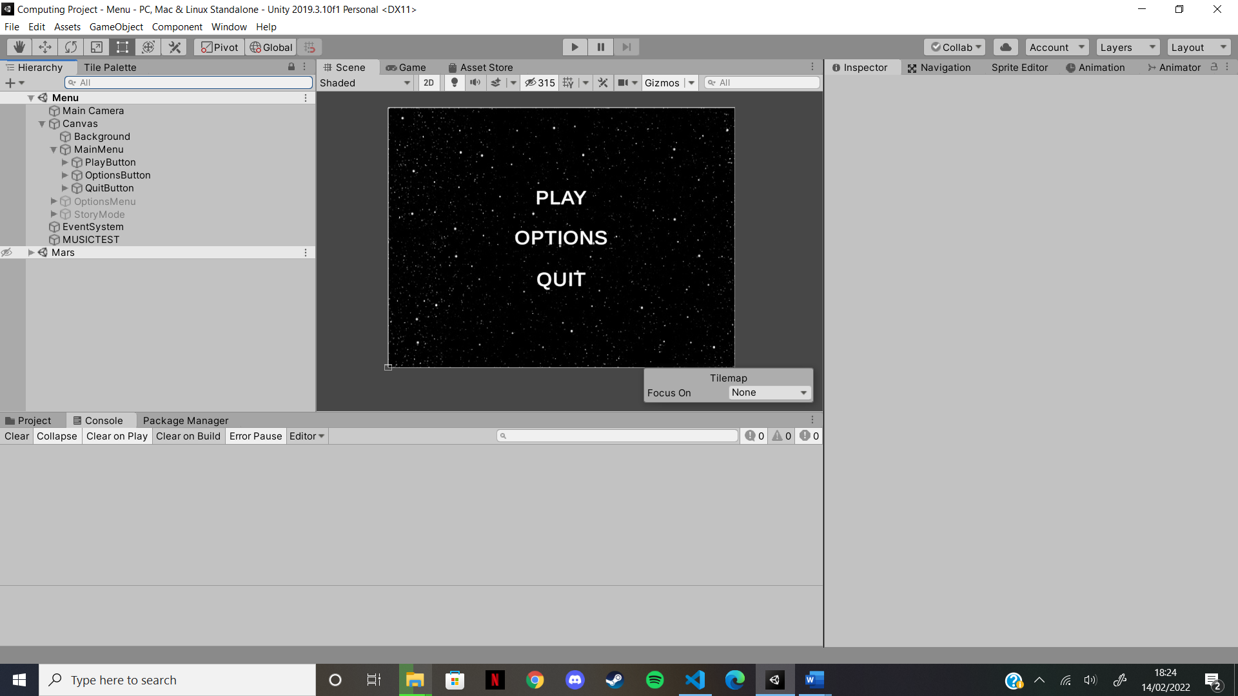

I started by creating a canvas. Within a canvas, I am able to put a number of things including a background, text, and buttons, which is all that will be necessary for the menu. In my canvas, I added a background and gave it a black stary image to fit the theme for the game. Then I added an overall object, which will hold all of the buttons, as seen in Figure 1.1. Inside each of the buttons is a text object, which allows me to give text to the buttons. These buttons now need functionality. For the first two buttons, no code is needed as I am able to set other canvas items as active and set the menu as inactive to show the required text. But for the quit button, I simply need a few lines of code:

public void **QuitGame** () // function to quit the game

{

      Debug.**Break**(); // breaking the debug quits the game

}

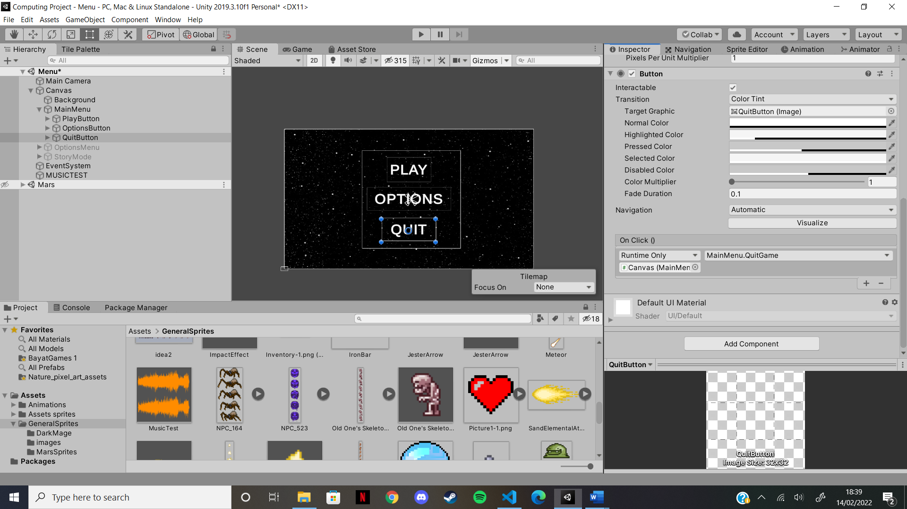I create a function that, when run, will “break the debug” which, essentially, will stop the game from running. In order to call this function, I use a Unity function called “OnClick()” inside the engine:

This OnClick() function will be called when the Quit button is pressed. To allow this, I add the Canvas object into the bottom left box as the script is held in there. Then, in the top right box, I find the script, and then the function QuitGame() from above.

Now I have to link the other two buttons, which, as previously said, don’t need any code as I can just use the Unity active features. Upon pressing the play button, the menu will dissapear and the Story menu will appear. To do this, I once again use the OnClick function:

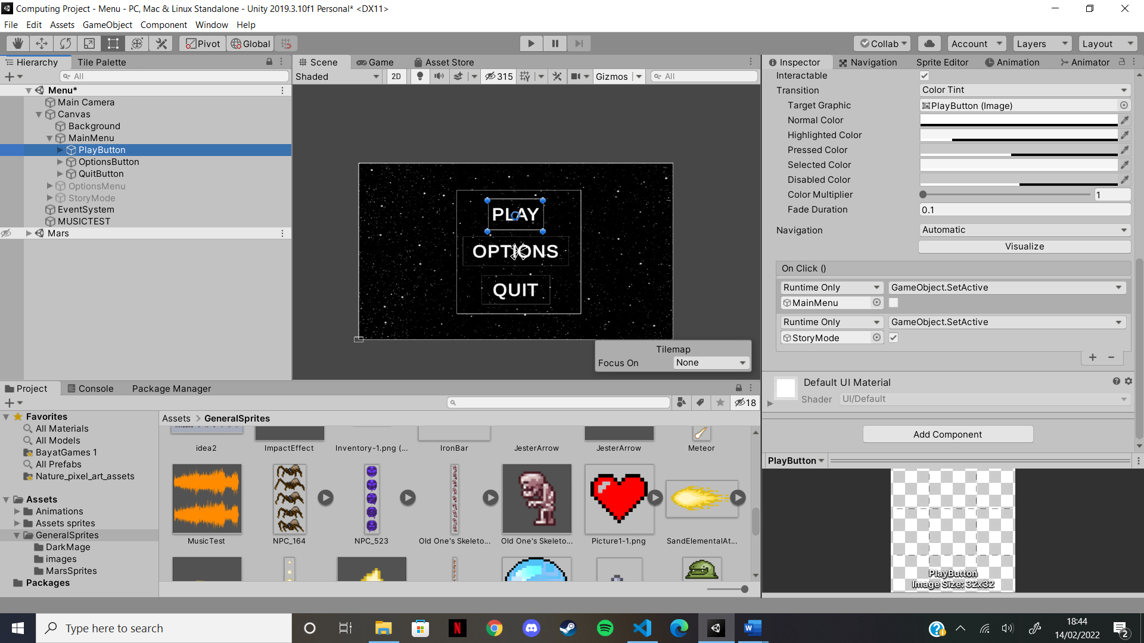In this instance, it is different than the Quit button as I have no function to call. I can simply move the menus into the boxes and select the SetActive feature. Then, I can check the box for StoryMode to tell the program that one the Play button is clicked, the StoryMode menu will have to be set as active. And as I have not checked the MainMenu box, it will be set as inactive once the button is pressed.

1.2: Story Mode Menu

Once the Play button is pressed, the Story mode menu appears. It is built in a similar way to the main menu:

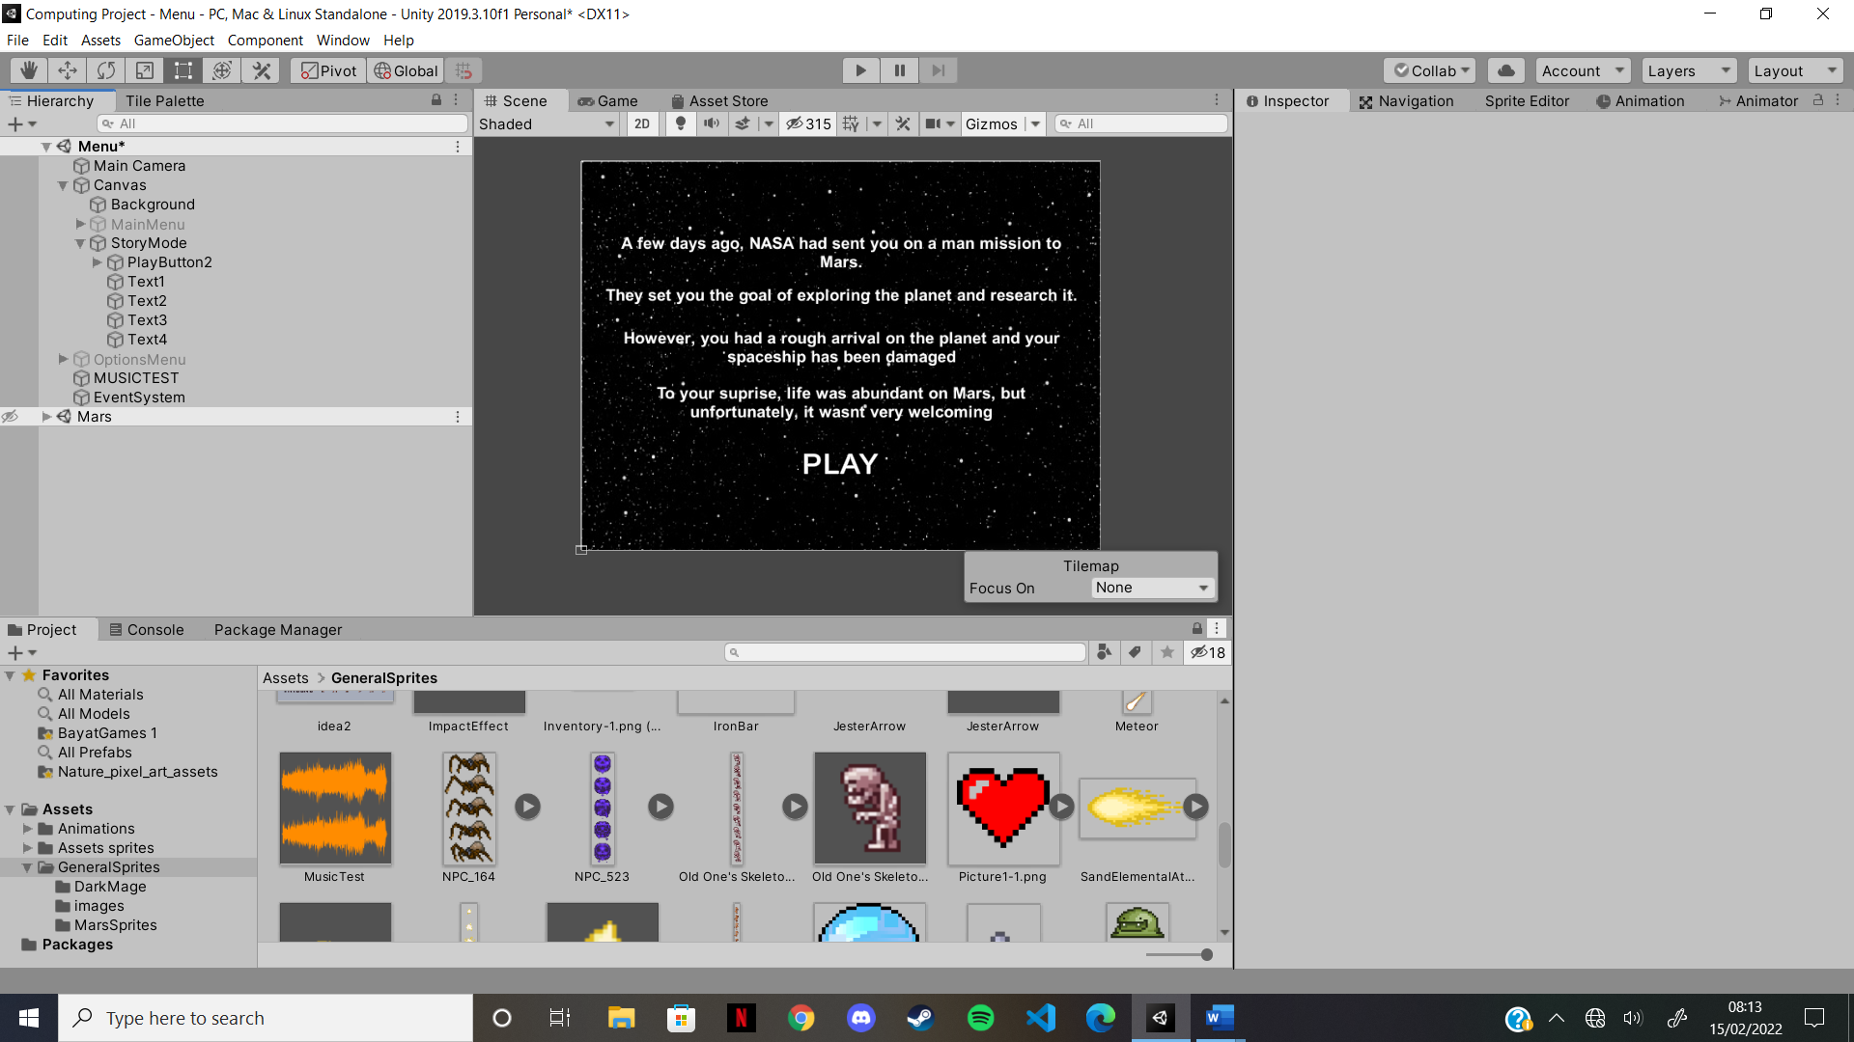

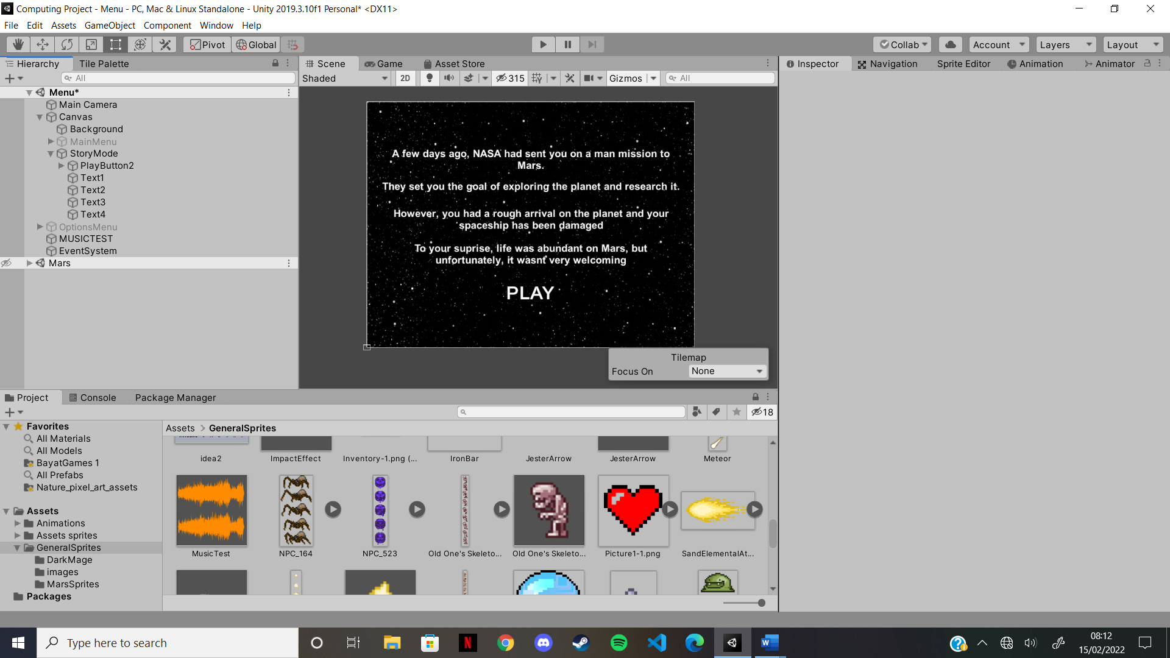

The Story Mode menu contains 4 pieces of text and one button. The texts will appear one at a time, after 5 seconds, to give time for the player to read the text on the screen. Then, the play button will appear last and will allow the player to start the game. The first part is to define our text and button. As there are 4 pieces os text, I will need to define 4 objects, and of course, the play button. By defining these it allows me to make them appear on screen when I want:

public **GameObject** Text1;

public **GameObject** Text2;

public **GameObject** Text3;

public **GameObject** Text4;

public **GameObject** PlayButton;

And here is the code for the menu:

void **Update**() // update functions is called once per frame

{

      if (gameObject.active) // if the menu is active, then do this

      {

          Text1.**SetActive**(true); // activate first text

**Invoke**("ActivateSecondText", 5); // invoke function to activate text

      }

}

void **ActivateSecondText**()

{

     Text2.**SetActive**(true);

**Invoke**("ActivateThirdText", 5);

}

void **ActivateThirdText**()

{

      Text3.**SetActive**(true);

**Invoke**("ActivateFourthText", 5);

}

void **ActivateFourthText**()

{

      Text4.**SetActive**(true);

**Invoke**("ActivatePlayButton", 5);

}

void **ActivatePlayButton**()

{

      PlayButton.**SetActive**(true);

}

This is the code that controls the appearance of the text and play button. To make sure this only happens when the story mode menu is on screen, I check if it is active (line 17). If it is, I set the first text as active. Then, I invoke the next function to activate the second text, but only after 5 seconds, as shown on line 20. Once all the text is activated, I just have to acitvate the button to allow the player to start the game.

Unlike the first Play button, this one requires coding as I need to change scenes. The first scene, the one the menus are on, needs to change to the second scene where the game is located. To do this, I need a few lines of code:

using **System**.**Collections**;

using **System**.**Collections**.**Generic**;

using **UnityEngine**;

using **UnityEngine**.**SceneManagement**;

public class **MainMenu** : **MonoBehaviour**

{

    public void **PlayGame** () // PlayGame function

    {

        SceneManager.**LoadScene**(1); // scene with index one will be loaded

    }

The libraries shown on lines 1-3 are automatically imported upon creation of the script file. To work with scenes, I require to import an extra library, seen on line 4.

When the second Play button is pressed, it will call the function PlayGame(), in the same manner the quit button called the QuitGame() function. The function only requires one line of code as I am able to call the scene manager and program it to load scene with index 1. I am able to set the index of a scene in the build settings:

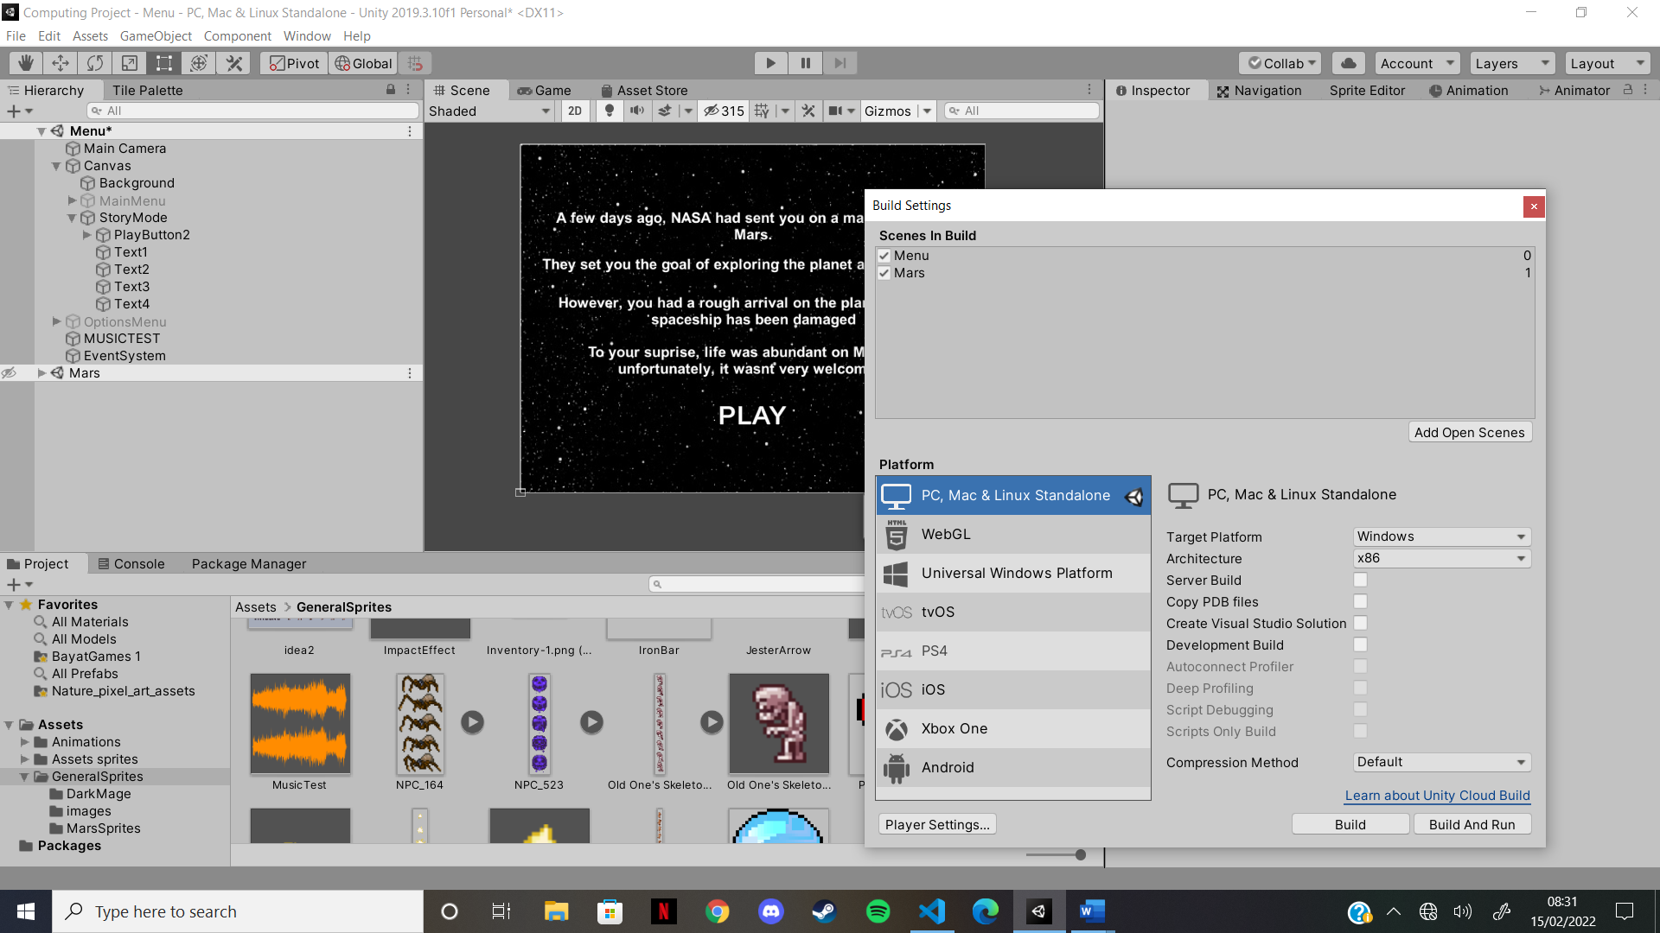As you can see, the Mars scene has index 1 and will be loaded when pressing the button

1.3: Options Menu

There is now only one more button to link with its menu, and that is the Options button. To link it to the options menu, we use the same method as the first Play button. We set the main menu as inactive and set the options menu as active. So now, once the Options button is pressed, the options menu will appear, which is built like so:

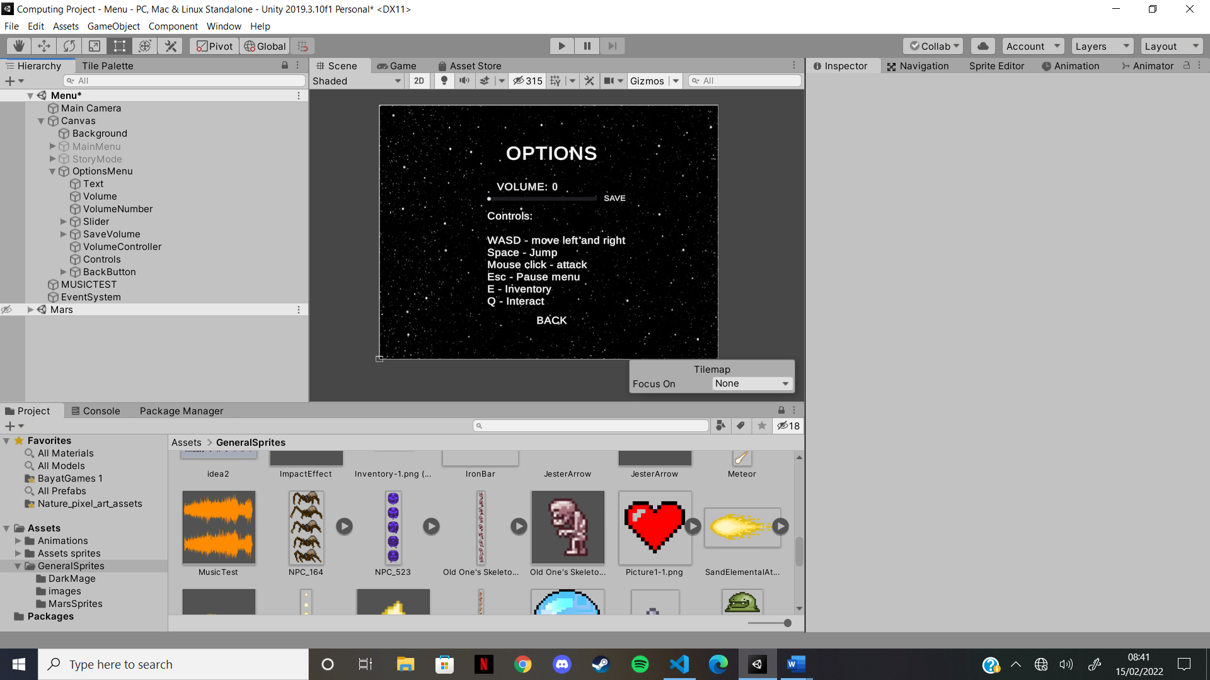



The options menu requires more objects than the other menus, however, it is simply a few more pieces of text and buttons. This menu does include a slider, which allows the player to control the overall volume of the game. This will be looked at the end. It is quite clear that the menu displays the controls to the player, and this will help the player if they need to be reminded on how to play. The menu also features a Back button, to allow the player to go back to the main menu. This is done in the opposite way the Options button in the main menu. I set the options menu as inactive and set the main menu as active.

Finallly, there is the volume control. This part includes two pieces of text, one to show the volume number and the other to display the text “VOLUME”, one button, labbelled “SAVE” that will save the volume when pressed, and one slider, that will allow the player to change the volume. Here is the code that controls the volume:

using **System**.**Collections**;

using **System**.**Collections**.**Generic**;

using **UnityEngine**;

using **UnityEngine**.**UI**;

public class **VolumeController** : **MonoBehaviour**

{

    [**SerializeField**] private **Slider** volumeSlider = null;

    [**SerializeField**] private **Text** volumeTextUI = null;

    public void **Start**(){ // load previous value at the beginning

**LoadValues**();

    }

    public void **VolumeSlider**(float volume){

        volumeTextUI.text = volume.**ToString**("0.0"); // set the slider’s text

    }

    public void **SaveVolume**(){

        float volumeValue = volumeSlider.value; // set to slider’s value

        PlayerPrefs.**SetFloat**("VolumeValue", volumeValue);

**LoadValues**(); // load values again

    }

    public void **LoadValues**(){

        float volumeValue = PlayerPrefs.**GetFloat**("VolumeValue");

        volumeSlider.value = volumeValue;

        AudioListener.volume = volumeValue; // change volume accordingly

    }

}

Once again, I am required to import a new librabry (line 4) that allows me to control the UI. With this, I am able to change text in the game. To start the program, I must define the variables I will use. I define “volumeSlider” as the Slider and “volumeTextUI” as the text. In the Start function, I call the LoadValues function. This will mean the game will automatically load the values saved the last time the player set the volume. The VolumeSlider function takes the volume as a parameter and sets the volume text as the volume value (but as a float as the slider value is from 0 to 1). In the SaveVolume function, the volume value is set as the slider’s value (again, must be a float) and we set the PlayerPrefs as this valye (PlayerPrefs is a Unity class that stores Player preferences between game sessions). Finally, we call the LoadValues function. In this function, we set the volume value as the PlayerPrefs’ value, we set the slider’s value as the volume value and we actually change the gam volume by changing Unity’s audio listener’s volume. Wth this code, the player will be able to change the volume using the slider. However, not all is finished as I have no way of calling the SaveVolume and the VolumeSlider functions. To do this, I simply connect the SaveVolume function to the Save button and the VolumeSlider function to the Sldier, the same way I did for the Quit and Play buttons.

And with that, the main menu, options menu and story mode menun are finished, and I am to start development on the game itself, including the player, which we will look at next.

2 – Creating the Player

2.1: Player basics

The player is the main character of the game. It is controlled by the WASD keys and others. I have already found my sprites and animations for the player, but I will have to implement them into the game. I will then have to code the movement, attacks, abilities, and more. The player will just be an object like all the others, and so I will need to add components to it, to give it some of its abilities:

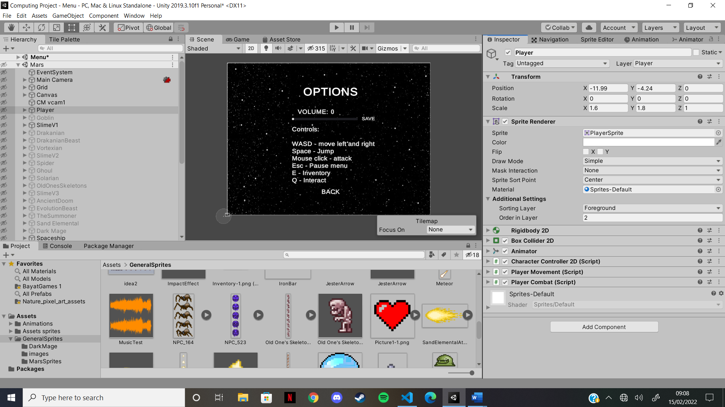These components will control the position and sprite for the player. As it stands, the player has position -11.99 in the x direction and -4,24 in the y. As it is a 2D game, the z direction will always stay at 0. The scale determines how big the player is, and I have it set at 1.8 on both the x and y. In the sprite renderer, there is a sprite box, which contains the player’s sprite. This will change whenever the players sprite changes. The other important feature is the sorting layer. This allows me to tell the game where the player is in the game compared to other objects.

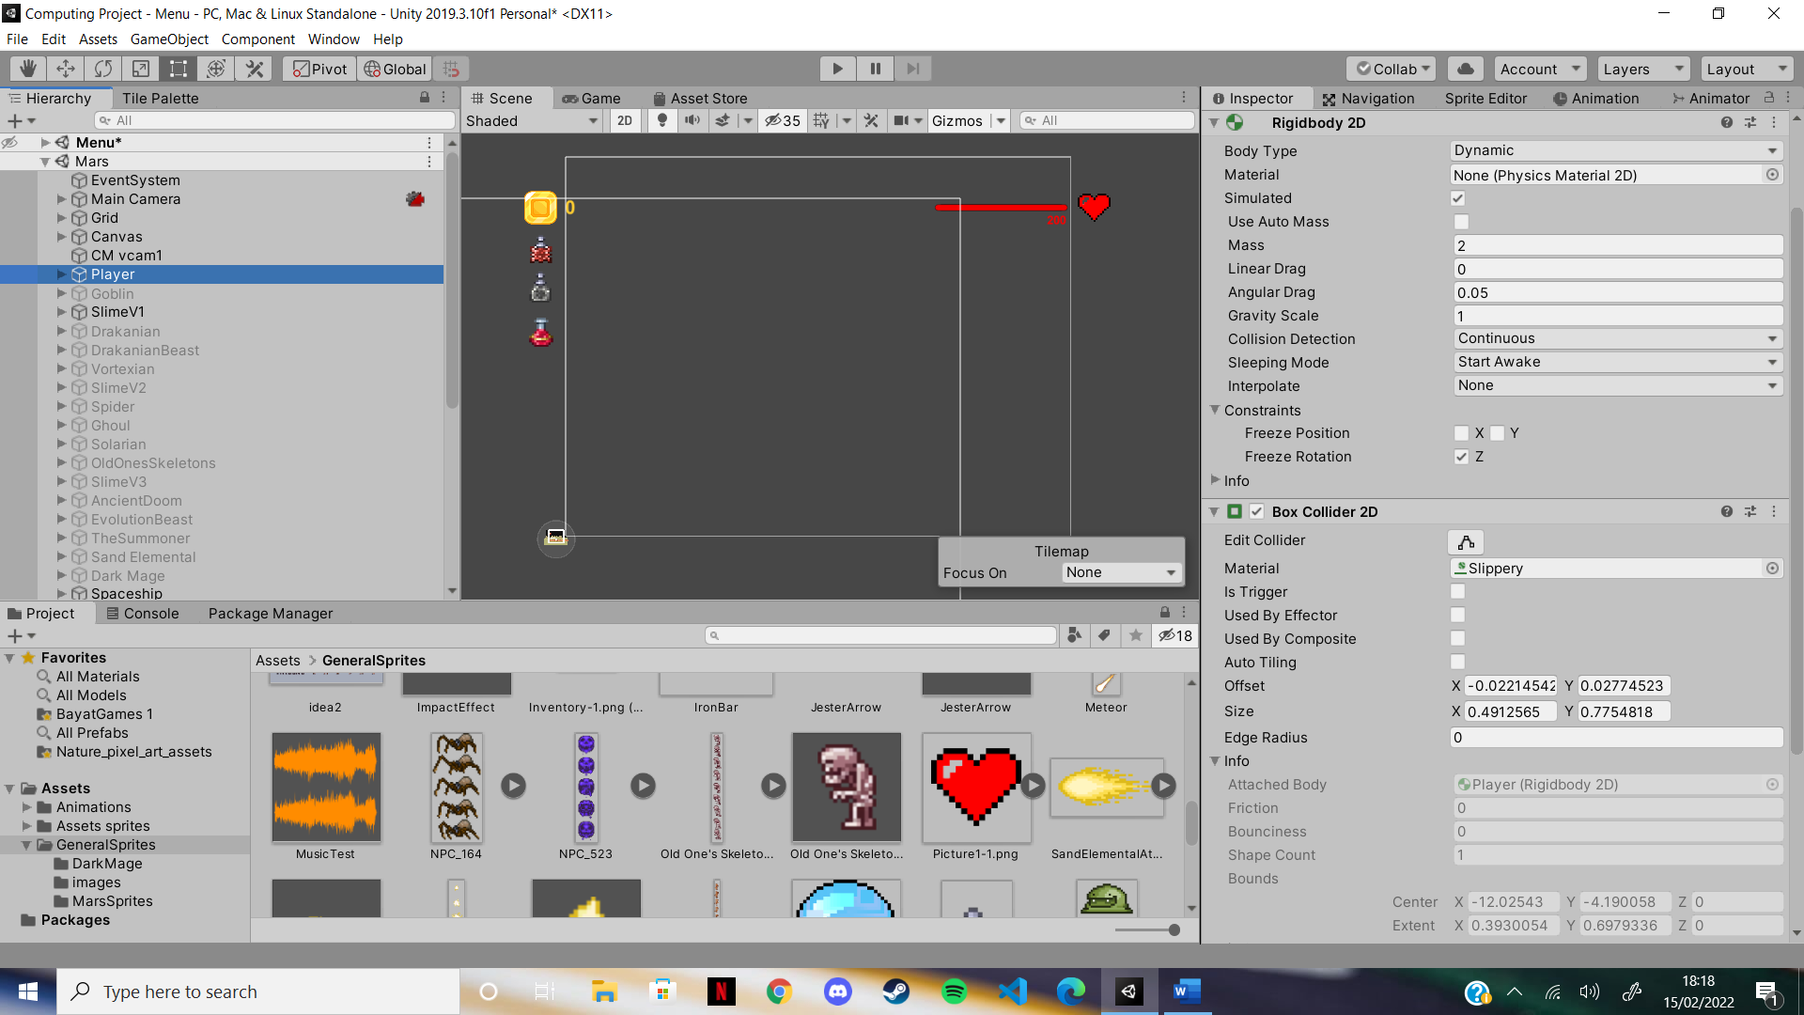  
These two next components control the collider and the rigidbody of the player. The rigidbody allows me to set a gravity scale for the player. Here, I have set the gravity to 1. In there, I can also give it a material for any extra physical abilities I want to give the player. There is also linear drag, which will restrict the speed of the player. In the program, I will only need to use the gravity scale.

The next component is the box collider (here set to 2D as the player is 2D). This creates a box around the object, which I can edit using the “Edit Collider” feature. Once again, I can give it a material to add more physical features. Here, I have a slippery feature, which makes it so the player will fall off a platform instead of standing on the edge of it. The next feature is the “IsTrigger” feature. Putting this as true will allow the box collider to record the collisions as triggers and I am then able to code with this.

The final component is the animator that will control all the animations of the player.

2.2: Player Movement

Now that the player has been built, I now have to code the movement and abilities, according to the algorithms previously written. Firstly, I need to acquire a character controller script. This script will give the basis of what I need to then code the rest of the movement and jumping for the player.

- Disclaimer: I did not write this script

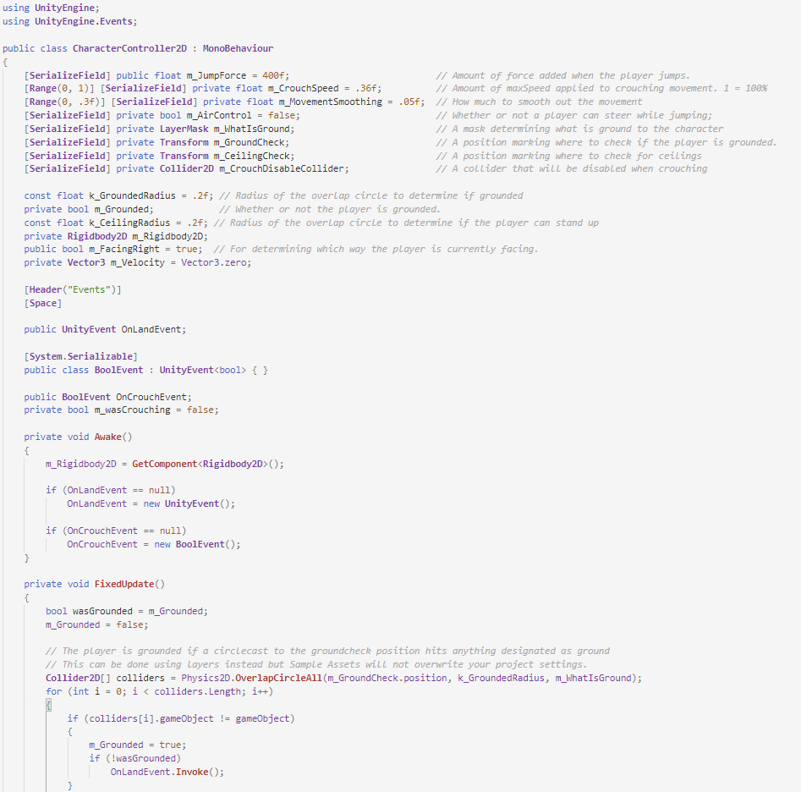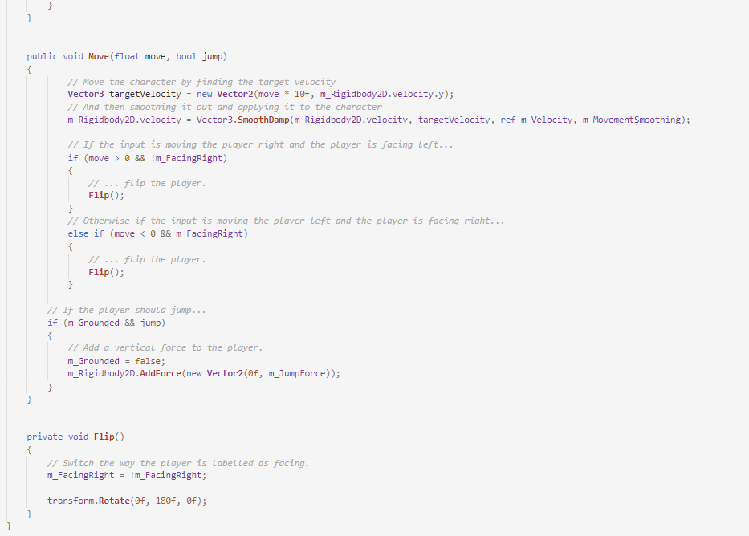

This script has the move function that I will be using in my movement script to make my character move and jump. It takes both move and jump parameters so it can do both in one function. It also has the flip function which will flip the player when facing the other side. In this function is a very useful variable “m_FacingRight” that I will use for the sword skills so they can track down enemies in front of the player.

To make my character move and jump, I will need to call the function Move from the CharacterController script and pass it the necessary values as parameters. I will do so in a separate class, the PlayerMovement one, which will control when the player moves, the dashing ability and the jumping. Before diving into the code, here are the variables I will be referring to:

public float runSpeed = 40f;

float horizontalMove = 0f;

public bool jump = false;

First off, I need to make the layer move left and right according to the key the player presses. There are a few ways to do this, and for left/right movement I will use a built-in unity feature, called the Input Manager:

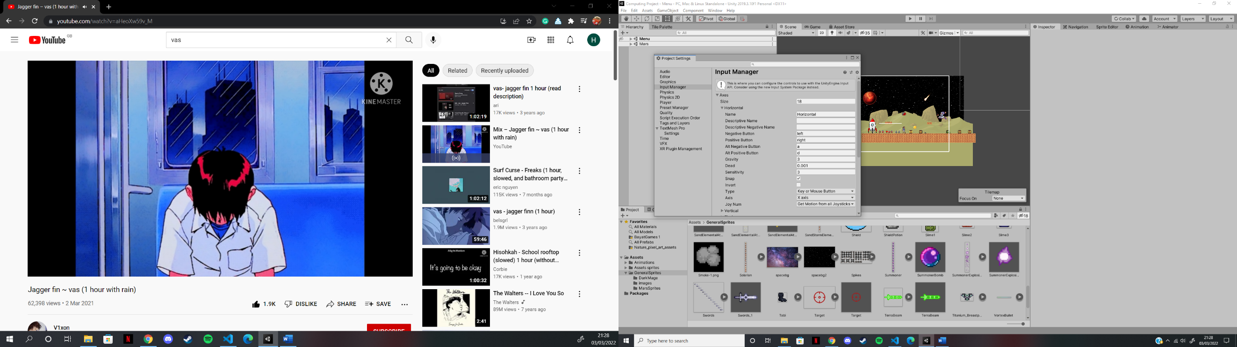

The main reason for me to use the input manager is that there is a positive and negative button for an action, here called ‘horizontal’. And so, I can then set the positive button as the left arrow or the a key, and the negative button as the right arrow or the d key. Then, I just have to refer to this in the code to determine the way the player will move. If the player presses a, the horizontal value will be positive (1), but will be negative if the player presses d (-1). The, we times the value buy the speed to give the player a bigger force and make them move faster. And this is done with a simple line of code:

void **Update**()

{

      horizontalMove = Input.**GetAxisRaw**("Horizontal") * runSpeed;

Now that the horizontal move variable has been set to a value, we need to call the move function and give it the value stored in the variable, like so:

controller.**Move**(horizontalMove * Time.fixedDeltaTime, jump);

This line of code will be placed inside the FixedUpdate function. This function is called every fixed frame-rate frame and is necessary when working with the rigidbody, as I am now as I am moving the player. Normally, we would not be able to use the function Move() as it is located in another class, but with this line of code, everything is made accessible from the CharacterController script:

public **CharacterController2D** controller; // allows the use of the script

The word controller is the name given to the script and is used for calling the function in the line code at the top of the page. Now, I have a working system to make my player move left and right. The move function will add a force to the rigidbody and the player will move. But now the player must jump, and to do this, we could either use the input manager, but as there is no negative button for a jump, we can use a different method called the Input.GetKeyDown() method shown here:

if (Input.**GetKeyDown**(KeyCode.Space)) // if the player presses ‘space’ key

        {

            jump = true; // set variable to true

This is an example of selection and it will occur in the Update function. It will only be processed when the player hits the space bar, as indicated by the key code. All we need to do is simply the Boolean variable jump as true, and when the Move function is called after a fixed framerate, the player will jump, simply by adding a jumping force to the y axis, as seen on line 89 of the CharacterController script. And now, the movement for my player is finished. I will refer back to this class when creating the dash skill for the player. But now, I must create the player’s attack code, so it can defend itself from the enemies.

2.3: Player attack

To create the player’s combat abilities, I must create a new class, the PlayerCombat class. In it, I will put all the player’s skills and potion abilities. First thing to do is to code the basic combat of the player. The main idea is that when an enemy gets close enough to the player, they will take damage, but only if the player has intended to attack them. Here are the variables I will refer to:

public **Transform** attackPoint;

public **LayerMask** enemyLayers;

public float attackRange = 0.5f;

public int attackDamage = 20;

public float attackRate = 4;

float nextAttackTime = 0;

To check if the enemy is in range of the player, so it can take damage, I create a gizmos, which in Unity, are used to give visual debugging and setup aids. In this instance, I will draw a sphere around the player which will determine the range at which an enemy can be attacked. This is the code needed to create it:

void **OnDrawGizmosSelected**()

{

     if (attackPoint == null) // if the attack point does not exist

         return; // return nothing (allows for no errors)

     Gizmos.**DrawWireSphere**(attackPoint.position, attackRange); // gizmos drawn

}

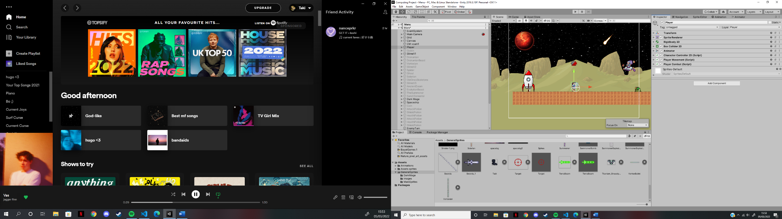As shown, the gizmos drawn will be a sphere (in the game it will be a circle as it is 2D) with its Centre located at the attack point’s position and its radius will be the attack range. Here is a screenshot of it in game:

Now the range is in place, but the player cannot attack the enemy, whether it is located in or out of the range. To do this, I must firstly create an attack function that will be called whenever the player uses the left click on the mouse. This call will be located in the Update function as the player will be able to attack at any given frame:

if (Time.time >= nextAttackTime) // if the time passed is greater

{

         if(Input.**GetKeyDown**(KeyCode.Mouse0)) // and player uses left click

         {

**Attack**(); // call attack function

              nextAttackTime = Time.time + 1f / attackRate; // reset variable

         }

}

To make sure the player cannot hit and enemy every single frame, I must make use of the Time feature. Time.time refers to the time at the beginning of the frame. The player will only be able to attack when that is greater or equal to nextAttackTime. To check if the left click has been used, I use the same function as for the jump, Input.GetKeyDown(). Once both conditions are true, the attack function is called, and nextAttackTime is updated for when the player wishes to attack again. The player should now be able to attack, but the enemies won’t take any damage, or are they checked against the attack range. This is done in the attack function, which has just been called:

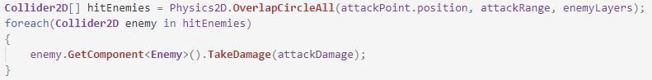

I create an array, named hitEnemies, which will store all game objects which collide with the Gizmos created before. Then, I check for any enemies that are in the array, and for each of those, I call the TakeDamage() function from the Enemy class to allow the player to inflict the set attackDamage onto the enemy. Now, I have a fully functional attacking system for the player. A similar system will be use when the enemies attack the player, and this will be looked at in section 3 when creating the enemies.

2.4: Player Health

The player’s health is the next feature to implement. The player cannot take damage without having a set amount of health, nor can they die, which would make the game very uninteresting. This section will also involve coding for the health bar slider, and the text alongside it. Here are the variables that I will be referring to:

public **Slider** slider;

public **GameObject** sliderObject;

static public float maxHealth = 200;

static public float currentHealthPlayer;

public **Text** HealthText;

The first thing to do is to set the player’s current health to their max health, and this will be done at the start of the program, therefore, in the start function:

void **Start**()

{

        currentHealthPlayer =  maxHealth; // set health to max health

Then, the health must be decreased whenever the player takes damages. This will be done in the TakeDamage function which is called whenever an enemy hits the player. The damage the player takes will depend on some factors, which are the orb and the shield potion. However, this will be looked at in their sections. For now, to decrease the health, I only need one line of code:

currentHealthPlayer -= damage; // reduce health accordingly

The health must also increase whenever the player picks up a heart from any enemies. The function to do so will be a Boolean function (meaning it will return either true or false) as if the health is equal, I don’t want it to do anything, and therefore, I want it to return false. Here is the function:

public bool **UpdateHealth**(int health)

{

      if (currentHealthPlayer == maxHealth) // if the player’s health is max

      {

          return false; // health is not updated (therefore false)

      }

      if (currentHealthPlayer + health > maxHealth) // if it will go above max

      {

          currentHealthPlayer = maxHealth; // set it to max

      }

      else

      {

          currentHealthPlayer += health; // else, add health

      }

      return true; // health has been updated, therefore true

}

The health parameter will be passed on whenever the heart is picked up. Whenever the health changes, the text and the slider both change. To change the text, I create a function that will set the text tot eh currentHealthPlayer variable:

private void **SetHealthText**()

{

     HealthText.text = currentHealthPlayer.**ToString**(); // change the text

}

I refer to the text variable, HealthText and set it as the currentHealthPlayer variable, as a string. To change the slider, it is a little more difficult, as the slider only takes values from 0 to 1. First off, it must be set to 1 at the start of the program so that it appears full to the player (Of course, I do the same for the text):

slider.value = **GetHealth**(); // change slider value

**SetHealthText**(); // change the text

The GetHealth function will get the ratio of the player’s health and will therefore allow the slider to be set to a value between 0 and 1. These two lines in the code above will be repeated in the Update function so that the text and slider value can be changed anytime during the program.

Here is the GetHealth function:

float **GetHealth**() // function to return a ratio of the health

{

     return currentHealthPlayer / maxHealth;

}

The function is set as a float as I require it to return the value as a float. When returned, the slider will change its value to the ratio and show the player how close they are to dying.

When the health reaches 0 (or less than 0), the player is dead and it must disappear. To do so, I created a selection in the TakeDamage function, shown here:

if (currentHealthPlayer <= 0) // if the player’s health is less than zero

{

         sliderObject.**SetActive**(false); // remove slider

         gameObject.**SetActive**(false); // remove player

         DeathScene.**SetActive**(true); // activate death message

}

When this if statement is processed, the slider is turned off, and so is the player. At the same time, a death scene is activated, which looks like this:

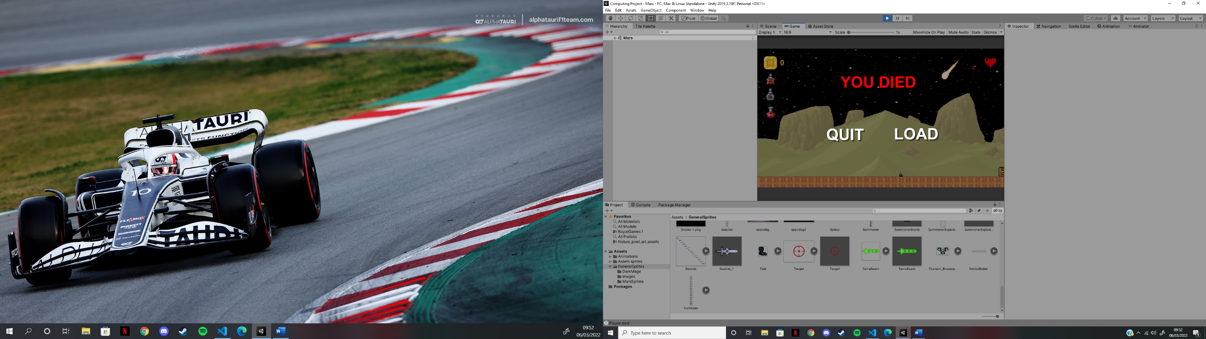

This was created in the same way as the menus seen previously. As shown the slider has disappeared and so has the player, as they have died. The player now has the option of loading a previously saved moment or quitting the game. These buttons are linked to a function in the same way the previous ones were. At this time, the load button doesn’t do anything as I have not create the save feature.

2.5: Player abilities

2.5.1: The black belt

The black belt is a player skill that allows the player to dodge any attacks from any enemy, with a 1/10 chance. Since it can only be activated with a 1 in 10 chance, I will need to code a random number generator between 0 and 9. Here is how I will do that;

**System**.**Random** rnd = new **System**.**Random**(); // create a variable for random num

int num = rnd.**Next**(10); // set it to number between 0 and 10

The variable num, set as an integer, will store a random value between 0 and 9 (the 10 is the limit, and is non inclusive. Then, all that is required to do is to program a selection to determine what will happen if the player dodges the attack:

if(num == 1)

{

       Debug.**Log**("Dodged attack"); // inform player they have dodged an attack

} else {

       currentHealthPlayer -= damage; // player hasn’t dodged an attack

}

If the player dodges the attack, a message is shown in the console to inform them they have successfully dodged an attack. Otherwise, the player takes damage like normal. All the code above will only be processed if the skill has been activated, but this will be looked at in the Chest section, as that is where the player will select the skill.

2.5.2: The Orb

The Orb is a player skill that, when activated, will surround the player with a blue orb that will negate any incoming damage from enemies and other sources. Here is what it looks like in the game:

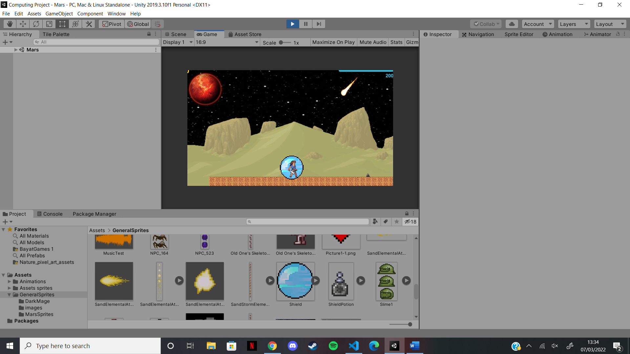

When the orb is activated, all damage needs to be negated. This now gets complicated as the TakeDamage function will not account for the damage being 0. Therefore, it leads me to create a second function, which will change the damage based on the state of the player. This function will be called whenever the player is set to take damage. This means that in the code above, the line to change the damage will be changed to the function’s name, along with the damage. Here are the variables I will be referring to:

public **GameObject** Orb;

int Orbtimer = 40;

public **GameObject** OrbTimerObject;

public **Text** OrbTimerText;

public bool OrbCanBeActivated = false;

public bool OrbIsActivated = false;

And here is the ChangeDamage function:

void **ChangeDamage**(int damage)

{

     if (OrbIsActivated) // if the orb is activated

     {

          damage = 0; // damage is set to zero

     } else if {

           currentHealthPlayer -= damage; // otherwise, take damage as normal

     }

}

Later on, I will add the shield potion effect to this function to further change the damage when the potion is taken. When the orb is activated, it will stay activated for 10 seconds before disappearing. Here is the code to make to do this:

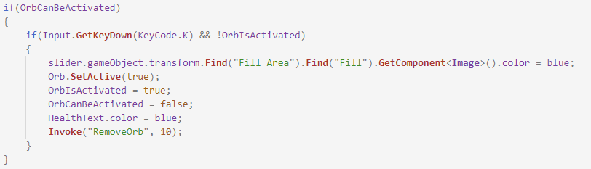

This function can only be called if the player presses the k key and if the orb is not activated. Once both these conditions are true, the orb is set as active and the variables are set to their correct values, to prevent the player from activating the orb again. In terms of UI, the slider’s colour is changed to blue, and the health text is also changed to blue. Then, after 10 seconds, the RemoveOrb function is called. Using the Invoke function allows me to control the time for which the orb stays active. After 10 seconds, this code is processed:

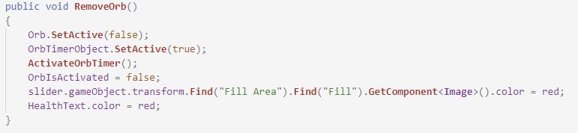

The orb is deactivated, and the variables are set to their correct values. However, the Boolean variable OrbCanBeActivated will be changed after 40 seconds, as that is the cooldown for the orb. The slider and the health text are set back to their correct colour, and finally, the ActivateOrbTimer() function is called, which controls the timer for the orb.

The timer is used to display to the player how much time left there is before the orb can be activated again. The code to do so is:

public void **ActivateOrbTimer**()

{

      Orbtimer -= 1; // timer decreases by one

      OrbTimerText.text = Orbtimer.**ToString**(); // set text to the timer

      if (Orbtimer == 0) // when timer is zero

      {

          OrbTimerObject.**SetActive**(false); // remove the timer

          OrbCanBeActivated = true; // player can use orb again

          Orbtimer = 40; // set timer back to original value

          OrbTimerText.text = "40"; // set text back to original value

      } else

      {

**Invoke**("ActivateOrbTimer", 1); // use recursion to decrease timer

      }

}

In each iteration of the function, the timer is decreased by one, and the text for the timer is set to the timer’s value. For each iteration where the timer does not equal zero, the function is called again, after one second. This means the timer will decrease by one every second until it is equal to zero. Once it is equal to zero, the timer is set back to 40 and disappears. Only now is the player able to re-use the orb, and therefore the Boolean variable OrbCanBeActivated is set as true.

2.5.3: The Tabi

The Tabi skill will allow the player to perform a dash by double tapping the left or right keys. Here are the variables I will be referring to:

public bool CanPlayerDash = false;

public float DashDistance = 15f;

public bool isDashing;

float doubleTaptime;

**KeyCode** lastKeycode;

[**SerializeField**] **Rigidbody2D** rb;

The dash skill is split in two pieces of code. The code for the player dash will only be called if CanPlayerDash is true, but the dash function itself will be called if the conditions are met. The conditions are that if the player presses the a or d key, the same key must be pressed again in a fixed amount of time so that the dash is performed. This is shown here:

*// Dashing left*

if(Input.**GetKeyDown**(KeyCode.A)) // if player presses ‘a’ key

{

if(doubleTaptime > Time.time && lastKeycode == KeyCode.A) {

**StartCoroutine**(**Dash**(-1f)); // call function if allowed

} else {

      doubleTaptime = Time.time + 0.5f; // set the time to double tap

}

lastKeycode = KeyCode.A; // set last key pressed as ‘a’

}

*// Dashing right*

if(Input.**GetKeyDown**(KeyCode.D)) // if player presses ‘d’ key

{

if(doubleTaptime > Time.time && lastKeycode == KeyCode.D) {

**StartCoroutine**(**Dash**(1f)); // call function if allowed

} else {

      doubleTaptime = Time.time + 0.5f; // set the time to double tap

}

lastKeycode = KeyCode.D; // set last key pressed as ‘d’

}

If the player presses either the a or d key, the respective selection will be processsed. Then, I must check if the time for double tapping is bigger than the time passed and if the player has pressed the respective key again. If they have done so, the player can dash. I use Start  
Coroutine as I will need to add a delay in the Dash function, and I am not able to use the Invoke function as I need to pass a parameter, the direction (1 for right, -1 for left). If the conditions are not met, then that must mean it is the first time the player has pressed the key, and therefore, we set the double tap time to a value based on the time passed. Finally, I set the last key as the key pressed, to allow the payer to dash if they press that key again the time required. Now that the conditions are set, the player needs to be able to dash, and this can be done like so:

**IEnumerator** **Dash**(float direction)

{

  isDashing = true; // player is now dashing

  rb.velocity = new **Vector2** (rb.velocity.x, 0f); // set velocity in y to be 0

  rb.**AddForce**(new **Vector2**(DashDistance * direction, 0f), ForceMode2D.Impulse);

  rb.gravityScale = 0f; // set gravity to 0

  yield return new **WaitForSeconds**(0.4f); // wait for 0.4 seconds

  isDashing = false; // player no longer dashing

  rb.gravityScale = 1; // set gravity back to 1

}

This is the Dash function, which will be processed when the conditions above are true. It has a parameter, direction, which is either 1 or -1, as previously shown. Once the function is called, the player is dashing, and therefore isDashing is set as true. Then, we call the rigidbody and set the velocity in the y-drection as 0 so that the player does not move up or down during the dash (setting the gravity as 0 further helps this). To make the player dash, we add a force in the x-direction, which is equal to the dash distance multiplied by the direction (to set the direction the player will dash). After 0.4 seconds, the player is able to dash again. There are two new features in this function, IENumerator and WaitForSeconds, both of which work with the StartCoroutine, and hence why I had to use it. Now the player is able to dash in both directions for 2/5of a second.

2.5.4: The Hermes boots

The Hermes boots skill will allow for faster movement speed for the player. This is the easiest skill to code as it only requires a chance in the run speed of the player, which can be done like so:

if(FasterRunning) // if player can run faster

{

       runSpeed = 60f; // set speed to 60

}

The Boolean variable FasterRunning will be set as true when the skill is clicked, in the same way as all the other skills will be set as true. This is all the code needed for this skill as once the speed has been changed this way, it will not be changed anywhere else.

2.5.5: The Chestplate

The Chestplate is a skill that will spawn a jester arrow at the nearest enemy whenever the player is hit. Here are the variables I will be referring to:

public **GameObject** JesterArrow;

public bool JesterArrowToEnemy = false;

Once again, the Boolean variable will be set as true when the skill is chosen in the second skills chest. Once it is set as true, and the player gets hit, this code is processed:

if(JesterArrowToEnemy) // if skill is selected

{

**Instantiate**(JesterArrow, transform.position, transform.rotation);

}

When this code is processed, the game object set as JesterArrow will be instantiated at the player’s position and rotation. The code for the jester arrow will be looked at in section 2.6.2.

2.5.6: The Heart

The heart is the final player skill that will be coded into my game. It will allow the payer to regenerate 1 health point every 2 seconds. Here are the variables I will be referring to:

public bool CanPlayerRegenerate = false;

public bool IsRegenerating = false;

The Boolean variable CanPlayerRegenerate will be set as true once the player selects the skill. Then, the player will be eligible to regenerate health. However, there will be two other conditions which are the IsRegenerating variable which must be false and the currentHealthPlayer which cannot equal to the maxHealth. Once all these conditions are true, the RegenerateHealth function will be called, as shown below:

if(CanPlayerRegenerate && !IsRegenerating && currentHealthPlayer != maxHealth)

{

**RegenerateHealth**(); // call the appropriate function

}

The RegenerateHealth function will work similarly to the orb timer function as it will use recursion to call itself every two seconds to add to the heath, as shown below:

public void **RegenerateHealth**()

{

    if(currentHealthPlayer == maxHealth) // if player is at max health, stop

    {

          IsRegenerating = false; // player is no longer regenerating

    } else {

          IsRegenerating = true; // player is now regenerating

          currentHealthPlayer += 1; // add one to the player’s health

**Invoke**("RegenerateHealth", 2); // use recursion to add health again

}

As previously said, the function calls itself every two seconds to add 1 health point to the current health, and the Boolean variable IsRegenerating is set as true, until the current health is equal to the max health. At that point, the variable is set to false and the function cannot be called again as the health is equal to the max health. And that is how the heart skill works.

2.6: Player projectiles

There are 3 player projectiles, the Terra beam, the Swords and the Jester arrow. Each will have the same code for movement. Once shot, they will go towards the nearest enemy, with a constant velocity, and will not change direction from then. Here are the variables I will be referring to:

float moveSpeed = 7f;

public **GameObject** impactEffect;

**Rigidbody2D** rb;

**Enemy** target;

**Vector2** moveDirection;

bool FacingEnemy;

**PlayerCombat** player;

The code for the projectile’s movement will be in the Start function as its direction and angle must be determined from the moment it is instantiated. To figure out where the projectile should be facing, I must figure out whether the player is facing an enemy or not. To do so, I compare the x position of the player to an enemy, and check whether the player is facing it using the previous variable, m_FacingRight from the CharacterController2D script. The code to do so is shown below:

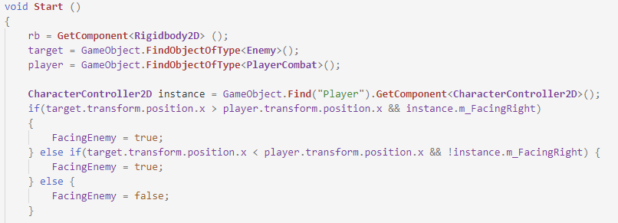

I must set the target as any enemy that is in the game, and the player as the player itself. This will be used to compare their x positions. To sue the varibale m_FacingRighy, I take the instance of the CharacterController2D script and clal it instance. Then, I start to compare. If the enemy’s x position is bigger than the player’s x position, then it is to the right of the enmy. If the player is facing the right, then the player is facing an enemy. The same is done for the left, nd is done by changing the sign to “<” and checking that m_FacingRight is false, as it should be. If both of these are not true, then the player cannot be facing an enemy. By doing these compraisions, the FacingEnemy variable will alwys be set to the correct value and will be ready to use in the next section, where I must adjust the movement based on the enemy’s position. The code is shown below:

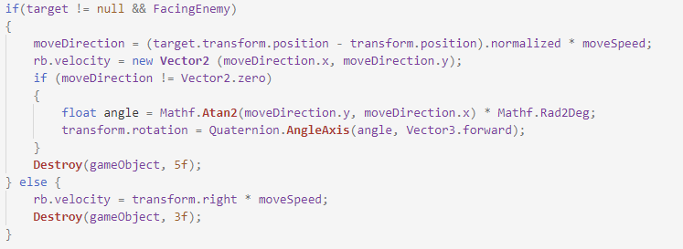

To adjust the movement of the projectile, I must firstly check if there is an enemy and If the player is facing one, using the FacingEnemy Boolean from before. If so, I must set the move direction to the difference between the enemy’s position and player’s position (as the projectile is summoned at the player’s position, its start position is the player’s position) and then multiply it by the move speed. Next, I must add that direction to a vector and change the velocity of the projectile based on that vector. The next few lines of code will change the angle of the projectile so if seems as if it is chasing after the enemy. To do so, we must check if the enemy isn’t right in front, as if it was, there would be no use to this. If it isn’t, I must figure out the angle at which the enemy is, and I can do using the moveDirection variable as it is the difference between the player’s position and the enemy’s. I then use Maths built-in functions to find the tangent between the two values and then change it to degrees. Once the angle is determined, I can rotate the projectile based on it using Quaternion.AngleAxis which creates a rotation which rotates an object ‘x’ degrees along an axis. Lastly, I must destroy the object after a set number of seconds, which is 5 seconds, in this case. However, there is another case. If the player isn’t facing an enemy, the projectile will move straight on and also disappear but only after 3 seconds, as with less enemies, it does not need to appear for too long. Now that I have the code for the projectiles’ movement, I will code their difference attacks, as all 3 projectiles have unique attacks to one another.

2.6.1: The Terra beam

The terra beam is one of the two weapon skills the player picks up before the first boss, the Sand Elemental. It will shoot towards the closest enemy and will pierce through any enemies behind them. To do so, I only have to not destroy the beam upon hitting an enemy:

void **OnTriggerEnter2D** (**Collider2D** hitInfo)

{

   if(hitInfo.gameObject.layer == 9) // if it hits an enemy

   {

         hitInfo.**GetComponent**<**Enemy**>().**TakeDamage**(20); // enemy takes damage

**Instantiate**(impactEffect, transform.position, transform.rotation);

   } else if(hitInfo.gameObject.layer == 10){ // if it hits the floor

**Instantiate**(impactEffect, transform.position, transform.rotation);

**Destroy**(gameObject); // destroy the projectile

   }

}

The function above is a Unity built-in function, similar to Start() and Update(), and it will be called whenever the box collider of the beam collides with another collider, and that collider will eb passed as hitInfo. Then, I check the layer of the collider. If it is (, which will be set as enemies in the game, then the enemy who corresponds to the hit collider will take 20 damage and an impact effect will be player. However, if the layer if 10, which is the ground, then the beam is destroyed and another impact effect will be played.

2.6.2: The Jester arrow

The jester arrow is the final player projectile. It will be shot whenever the player takes damage and only if the chestplate skill was chosen. This one is the simplest of the three as it will simply destroy on impact, without any other abilities:

void **OnTriggerEnter2D** (**Collider2D** hitInfo)

{

    if(hitInfo.gameObject.layer == 9) // if it hits an enemy

    {

         hitInfo.**GetComponent**<**Enemy**>().**TakeDamage**(20); // enemy takes damage

**Instantiate**(impactEffect, transform.position, transform.rotation);

**Destroy**(gameObject); // destroy projectile

    }

    else if(hitInfo.gameObject.layer == 10){ // if it hits the floor

**Instantiate**(impactEffect, transform.position, transform.rotation);

**Destroy**(gameObject); // destroy projectile

    }

}

Unlike the Terra beam, if the jest arrow hits an enemy, it will be destroyed, as it does not have the ability to pierce through them. That is the only difference to the code for the Terra beam.

2.6.3: The Swords

The swords is the second weapon skill the player picks up before the first boss. When used, a barrage of 5 swords will shoot towards the nearest enemy and will be destroyed on impact. However, when hitting an enemy, the enemy is then debuffed for 10 seconds, and for each sword hit, the timer is reset:

void **OnTriggerEnter2D** (**Collider2D** hitInfo)

{

    if(hitInfo.gameObject.layer == 9) // if it hits an enemy

    {

         hitInfo.**GetComponent**<**Enemy**>().**TakeDamage**(5); // enemy takes damage

         if(hitInfo.**GetComponent**<**Enemy**>().EnemyIsDebuffed) // enemy debuffed

         {

             hitInfo.**GetComponent**<**Enemy**>().**ResetDebuffTimer**(); // reset timer

         } else { // enemy not debuffed

             hitInfo.**GetComponent**<**Enemy**>().**DebuffEnemy**(); // debuff enemy

         }

**Instantiate**(impactEffect, transform.position, transform.rotation);

**Destroy**(gameObject); // destroy projectile

     }

     else if(hitInfo.gameObject.layer == 10){ // if it hits the floor

**Instantiate**(impactEffect, transform.position, transform.rotation);

**Destroy**(gameObject); // destroy projectile

     }

}

The swords have the ability to debuff the enemy. To do so, whenever the enemy is hit, I check if it already is debuffed. If it is, then I reset the debuff timer, but if it isn’t, then I inflict the debuff on it. Just like the jester arrow, the swords do not have the ability to pierce and therefore they must be destroyed upon hitting one.

2.7: Player freeze and debuff

When the player is hit by a spider’s cobweb, they are frozen for 2 seconds, unable to move or jump. They will be very vulnerable during that time and so the player must act quickly to not get hit by the cobweb. Here are the variables I will be referring to:

public **Sprite** WebbedPlayer;

Once the cobweb hits the player, the FreezePlayer function will be processed, shown below:

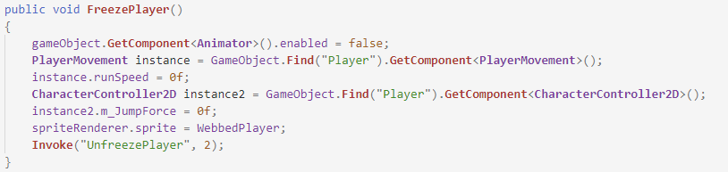

To disable the player’s movement, I must first access the player movement script. Then, I can set the run speed to zero which means the player will not move if the a or d key was pressed. Then, to disable the jumping, I must access the character controller script, and then set the jump force to zero which will make the player unable to jump. Finally, to make the player aware that they are frozen, I change the sprite to the webbed player sprite which adds cobwebs to the feet of the player, as if they were stuck to the ground.

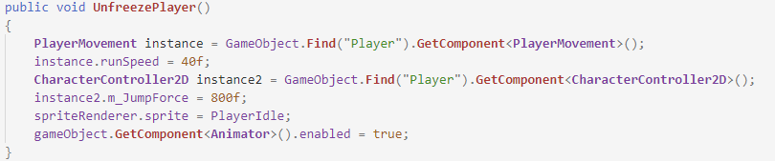To then unfreeze the player, I must wait 2 seconds. That is done as it has been done before, using the invoke function, and invoking the Unfreeze Player function. This function will simply do the same thing as the FreezePlayer function, but will restore the values to their original state instead of setting them as 0:

The player can also be debuffed by different sources. This means the player will take one damage per second for 10 seconds. A timer will appear to inform the player the time left of the debuff. Here are the variables I will be referring to:

int Debufftimer = 10;

public **Text** DebuffTimerText;

public **GameObject** DebuffTimerObject;

public bool PlayerIsDebuffed;

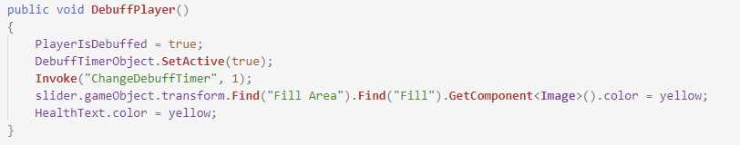Once the player is debuffed, an icon will show up and the slider color will change to yellow, as well as the player taking damage:

As shown, the variables are changed to their correct values, and the slider and text are changed to their respective colors. Now, the timer has appeared, and so I must make it work. This will be done in the same way the orb timer was done:

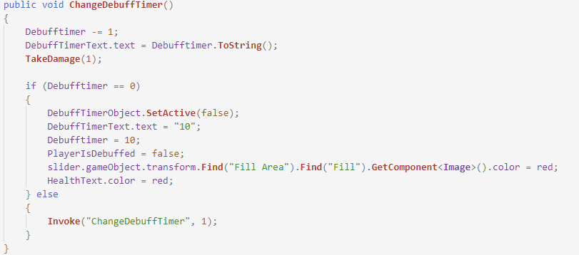

After each iteration, the player takes one hit of damage and then the function is called again, leaving the player taking 10 damage when debuffed, as required. Once the timer reaches 0, the slider and text are set back to their respective colors, and the variables are changed back to their original values.

End of module testing; Player:

|  |  |  |  |
| --- | --- | --- | --- |
| Feature Being Tested | Testing Method | Expected Outcome | Testing Results |
| Player moving to the right | Hold down the “a” key while in the game | The player will move to the right | passed – see video 1 |
| Player moving to the left | Hold down the “d” key while in the game | The player will move to the left | passed – see video 1 |
| Player attacking | Left click while in the game to test | The player will inflict damage upon an enemy | passed – see video 3 |
| Player jumping | Press the “space” key in the game | The player will jump into the air and fall back down | FAILED |
| Player taking damage | Add an enemy in game and make them hit the player for the test | The player’s health points will decrease by the damage dealt | passed – see video 3 |
| Player dying | Get the player’s health to zero | The player will die and a death message will appear | passed |
| Player taking damage when debuffed | Add enemy with debuff ability and make them hit the player | Once debuffed, the player will take 1 hit point of damage for 10 seconds | passed – see video 8 |
| Player not moving when frozen | Make the player get hit by  a cobweb | The player is unable to move and jump for 2 seconds | passed – see video 7 |
| Player dashing (dashing skill must be acquired) | Press the “a” or “d” key in quick succession | The player will launch forwards for a short time | passed |
| Player regenerating (regeneration skill must be acquired) | Activate the skill and test 1 health point comes back every 2 seconds | The health amount will increase by 1 point every 2 seconds | passed |
| Player activating orb (orb skill must be acquired) | Activate orb skill and press “k” when in game | The orb will be activated around the player. | passed |

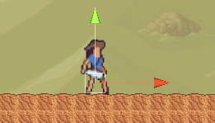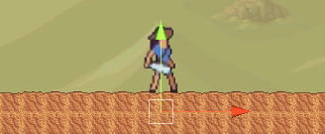When I tested the player’s jump. It seemed like they weren’t jumping at all, but the animation was playing. Through investigation, I figured out that the GroundCheck GameObject that is referenced in the CharcterClontroller2D class was in the ground and was not allowing the player to jump. By moving it further upwards, the player can now jump, and the test has passed. Here are screenshots demonstrating this:

after

before

3: Potions

Potions will help the player advance in the game by increasing damage, decreasing damage taken or recovering health. The player will grab the potions from chests and they will be stored in the inventory, where the enemy will be able to use them.

To grab a potion, the player will have to interact with its collider. Once they have done so, a function in the PlayerCombat class will be called, to update the number of potions the player has. Taking the Shield potion as an example, here is what it will look like:

(Note, the code for the other 2 potions only differ in the function called)

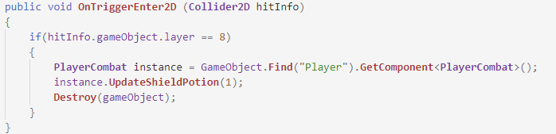

And here is the function called:

(Again, the functions for the other 2 potions only differ with the variables)

public void **UpdateShieldPotion**(int number)

{

     numberOfShieldPotions += number; // update number of potions acquired

     ShieldPotionNumber.text = numberOfShieldPotions.**ToString**();

}

As well as updating the number of potions the plyer has, I must update the text which will be shown in the inventory. At the moment, that text is kept as inactive in the scene as the inventory isn’t yet coded.

For testing purposes, I will call the function as the game begins to test the timer and the potion abilities

3.1: Health potion

The health potion will allow the player to gain 100 health points when used. From then, the player will not be able to take another potion for 60 seconds and a timer a will appear on screen to inform the player of the time left before they are able to take another potion. Here are the variables I will be using:

int numberOfHealthPotions = 0;

int Healthtimer = 60;

public **Text** HealthPotionNumber;

public **Text** HealthTimerText;

public **GameObject** HealthTimerObject;

public bool CanTakeHealthPotion = true;

When changing the health, I must make sure it does not exceed over the maximum health as otherwise, the game will be broken. Just as the other update health function, this one will also require to be a Boolean.

public bool **UpdateHealthViaPotion**(int health)

{

     if (currentHealthPlayer == maxHealth) // if player at max, return false

     {

         return false;

     }

     if (currentHealthPlayer + health > maxHealth) // if it will go above max

     {

         currentHealthPlayer = maxHealth; // set as max

         CanTakeHealthPotion = false; // player cannot take potion anymore

         HealthTimerObject.**SetActive**(true); // activate timer

**Invoke**("ChangeHealthTimer", 1); // start timer

     }

     else

     {

         currentHealthPlayer += health; // add health

         CanTakeHealthPotion = false; // player cannot take potion anymore

         HealthTimerObject.**SetActive**(true); // activate timer

**Invoke**("ChangeHealthTimer", 1); // start timer

     }

     return true; // health changed, return true

}

Similarly, to the other function, if the current health is equal to the max health, then the function will return false. If not, then the health must be added correctly. If the current health and the health parameter added together is bigger than the max health then I must set the current health as the max health. Otherwise, the current health is equal to the current health added to health parameter. Then in both cases, the rest is the same. I change the variable to false as the player is not able to take another potion for 60 seconds and then I activate the health ui as the timer has begun. As the timer has begun, I must start it, after a second, therefore I invoke the ChangeHealthTimer function after a second, which looks like so:

public void **ChangeHealthTimer**()

{

     Healthtimer -= 1; // timer decreases by one

     HealthTimerText.text = Healthtimer.**ToString**(); // set text to the timer

     if (Healthtimer == 0) // if timer is zero

     {

         HealthTimerObject.**SetActive**(false); // deactivate timer

         HealthTimerText.text = "60"; // set text back to original value

         CanTakeHealthPotion = true; // player can now take a potion again

         Healthtimer = 60; // set timer back to original value

     } else {

**Invoke**("ChangeHealthTimer", 1); // use recursion to decrease timer

     }

}

This function uses the same logic as the debuff timer did, as all the potion timers will do as well. The only difference is the variables. Here, the timer is 60 seconds, and not 10, and once finished, a different Boolean variable is changed. Here, CanTakeHealthPotion is set as true as the player is now able to take a potion if they wish to.

3.2: Attack potion

The attack potion will allow the player to increase their damage by 20 points. The potion will also have a timer of 60 seconds, and during this time, the player will not be able to take another potion. The increase in damage will be active throughout the duration of the timer. Once the timer reaches zero, the increase in damage will be taken away, and the player will be able to take another potion. Here are the variables I will be referring to:

int numberOfAttackPotions = 0;

int Attacktimer = 60;

public **Text** AttackPotionNumber;

public **Text** AttackTimerText;

public **GameObject** AttackTimerObject;

public bool CanTakeAttackPotion = true;

Just like the health potion, the attack potion will be used from the inventory and the function UpdateDamage will be called from there. This function will change the damage, activate the timer, and disable the ability to take another potion, as shown below:

public void **UpdateDamage** ()

{

     attackDamage += 20; // add 20 to the damage

     AttackTimerObject.**SetActive**(true); // activate the timer

     CanTakeAttackPotion = false; // player cannot take potion again

**Invoke**("ChangeAttackTimer", 1); // start the timer

}

Once the changes have been made, I must work on the timer, which will count down to zero, using the same recursion technique as the two previous timers:

public void **ChangeAttackTimer**()

{

     Attacktimer -= 1; // timer decreases by one

     AttackTimerText.text = Attacktimer.**ToString**(); // set text to the timer

     if (Attacktimer == 0) // if timer is zero

     {

         AttackTimerObject.**SetActive**(false); // deactivate timer

        AttackTimerText.text = "60"; // set text back to the original value

         attackDamage -= 20; // change damage back

         CanTakeAttackPotion = true; // player can now take a potion

         Attacktimer = 60; // set timer back to original value

     } else {

**Invoke**("ChangeAttackTimer", 1); // use recursion to decrease timer

     }

}

Once the timer reaches zero, the attack damage is set back to its original value, by subtracting 20 off of it. Then the player is able to take a potion again and therefore the Boolean variable CanTakeAttackPotion is set as true.

3.3: Shield potion

The final potion that will be programmed into the game is the shield potion. It will reduce the damage taken of the player by 10 points. It works similarly to the attack potion, as it will be active for 60 seconds before the payer can take another one again. To change the damage according to the enemy’s damage, I will expand on the ChangeDamage function and add a new if statement that will allow to change the damage if the shield potion is activated. First, I must tell the program that a shield potion has been activated, and I will need these variables to do so:

int Shieldtimer = 60;

int numberOfShieldPotions = 0;

public **Text** ShieldPotionNumber;

public **Text** ShieldTimerText;

public **GameObject** ShieldTimerObject;

public bool CanTakeShieldPotion = true;

Once the potion is used from the inventory, the program must be aware it has been used to them change the damage according to the enemy’s damage. To do so, I need this function:

public void **ShieldPotion**()

{

     ShieldTimerObject.**SetActive**(true); // activate timer

     CanTakeShieldPotion = false; // player cannot take a potion

**Invoke**("ChangeShieldTimer", 1); // start the timer

}

Now that the player isn’t able to take a potion, that means the potion is under effect. Now, I can change the damage of the enemies based on this variable in the ChangeDamage function, as so:

else if (!CanTakeShieldPotion) { // if player cannot take a potion

        if(damage <= 10) // if the damage is less than or equal to 10

        {

              currentHealthPlayer -= 1; // player takes 1 damage

        } else{

              currentHealthPlayer -= (damage - 10); // damage is reduced by 10

}

There is one issue with reducing the damage by 10, as some enemies deal less than 10 damage. This means the player would take negative damage if they were to get hit by one of those enemies with the potion active. To counter this, the player will only take 1 damage if the enemy’s damage is less than or equal to 10. If that is not the case, then the player will take ten less damage points than normal, as that is the potion’s ability. The last thing to code for the shield potion is the timer, which just like the other potions, will use a recursion method:

public void **ChangeShieldTimer**()

{

     Shieldtimer -= 1; // timer decreases by one

     ShieldTimerText.text = Shieldtimer.**ToString**(); // set text to timer

     if (Shieldtimer == 0) // if timer is zero

     {

         ShieldTimerObject.**SetActive**(false); // deactivate timer

         ShieldTimerText.text = "60"; // set text back to original value

        CanTakeShieldPotion = true; // player can take potion again

         Shieldtimer = 60; // set timer back to original value

     } else {

**Invoke**("ChangeShieldTimer", 1); // use recursion to decrease timer

     }

}

Once the timer is over, the Boolean variable CanTakeShieldPotion is set as true, which now means the damage will no longer be altered and the player is able to take another potion.

End of module testing; Potions:

|  |  |  |  |
| --- | --- | --- | --- |
| Feature Being Tested | Testing Method | Expected Outcome | Testing results |
| Potion timer | Wait 60 seconds after using a potion | The player will not be able to take another potion for a minute | passed – see video 14 |
| Potion timer UI | Look at the screen after using a potion | A timer will show up on the screen to show the player the time left | passed – see video 14 |
| Attack potion | Attack an enemy with the potion active | The enemy should take 20 more damage | passed |
| Shield potion | Let an enemy attack the player | Th player should take 10 less damage | passed |
| Health potion | Take damage before taking the potion | The player’s health should increase by 100 | passed – see video 14 |

Overall, this module went well, and I am happy with the results. I didn’t encounter many problems when testing the potions and the timers.

4: Enemies

4.1: Enemy basics

There will be a range of enemies in my game, including two boss enemies. Most enemies will have the same movement but will range in attack patterns and abilities. I will first look at their basics, before moving onto their movement, and then move onto their different attacks, including their different types of projectiles.

Firstly, I must create the basics of the enemies, using the same components as I did for the player. The enemies will have the same structure as the player; however, they will have two features altered, their box collider and the rigidbody. The box collider will become a trigger, to allow it to trigger whenever it collides with another collider and rigidbody will have a gravity of 0 like so:

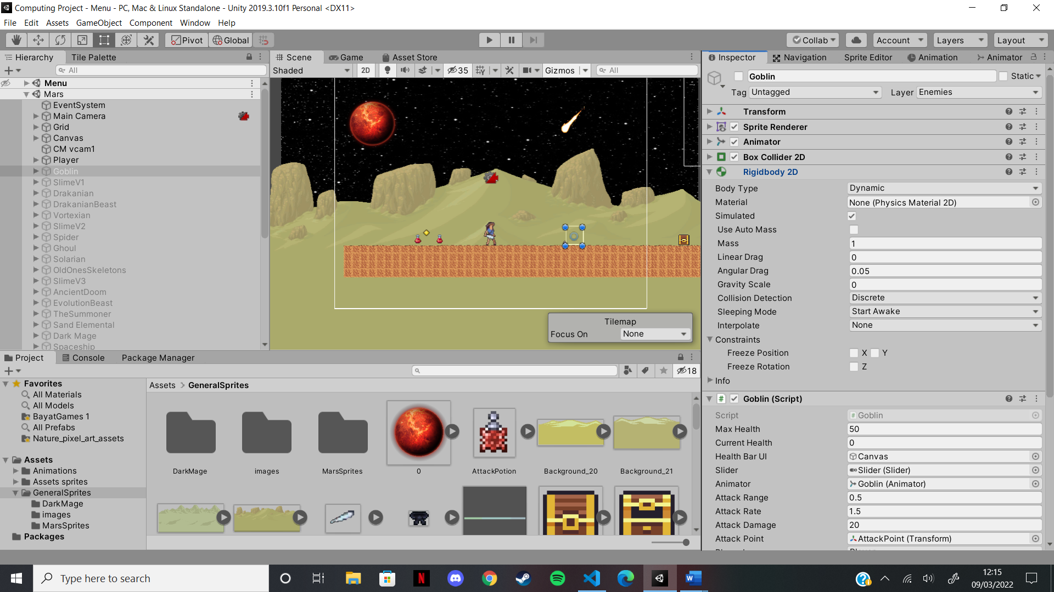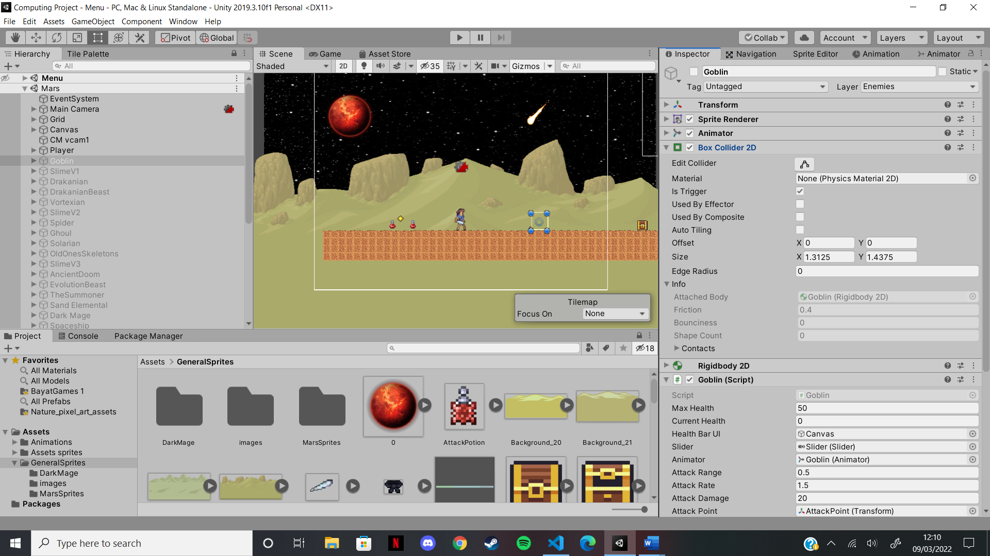

This is due to the enemy’s lack of jumping. The enemies will stay on the ground as it has a collider and therefore the enemies will not be able to fall. If they were to leave the ground, then their gravity will be set to 1 before being set back to 0 as they touch the ground:

4.2: Enemy movement

Most enemies will move left and right and will change directions when they hit an invisible game object. To make them move left and right, I will use a similar system to the player’s movement, however, the code will not depend on a key to be pressed anymore as the enemies move on their own. Here are the variables I will be referring to:

public float speed = 1f;

public bool moveRight;

The Boolean variable moveRight will be changed when the enemy collides with the invisible game object, as so:

void **OnTriggerEnter2D**(**Collider2D** trigger)

{

     if(trigger.gameObject.**CompareTag**("Turn")) // if collider hits the turn

     {

         if(moveRight) // if the enemy is moving right

         {

             moveRight = false; // it now moves left

        } else{ // enemy is moving left

            moveRight = true; // it now moves right

         }

     }

}

To detect the collisions, I will use the OnTriggerEnter2D function again. If the collider corresponds to a game object with tag turn, then the invisible game object was hit. Then, I must check if the enemy was initially moving right. If it was, then the enemy should now move left, and if it wasn’t, then it will now move right.

Now the enemy needs a force to be able to move in the required direction. Here is how I do so:

speed=1f;

if (moveRight) // if the enemy is moving right

{

        transform.**Translate**(2 * Time.deltaTime * speed, 0,0); // add force

        transform.localScale = new **Vector2** (-enemyScale[0], enemyScale[1]);

} else // enemy is moving left

{

        transform.**Translate**(-2 * Time.deltaTime * speed, 0,0); // add force

        transform.localScale = new **Vector2** (enemyScale[0], enemyScale[1]);

 }

I must first set the speed to a constant value, here 1. Then, if the enemy is moving right, then the force must be positive, hence the 2 (and -2 for moving left). The transform.Translate function will move the enemy in the required direction and multiplying by Time.deltaTime makes it move 1 unit per second, allowing for a nice flow. The other two lines will flip the enemy on its x scale axis when they change directions. The enemyScale array stores the scale of the enemy, as shown here:

enemyScale = new float[2]; // create array to store the scale

enemyScale[0] = gameObject.transform.localScale.x;

enemyScale[1] = gameObject.transform.localScale.y;

As the scale might be different for different enemies, I must grab it from the enemy’s transform component and add it to the array, so it can be changed later when the enemy changes direction.

This concludes the enemy’s movement (for most enemies). I will now look at how the different enemies attack.

4.3: Enemy attack

There are two ways an enemy can attack, melee and ranged. A melee enemy will have a small attack range and will attack the player up close. A ranged enemy will have a bigger attack range and will stop to shoot at the player when the player is in range. Here are the variables I will be referring to:

public float attackRange = 0.5f;

public float attackRate = 1.5f;

protected float nextAttackTime = 0;

public **Transform** attackPoint;

public **LayerMask** playerLayers;

For the enemy to attack, I use the same system that I did for the player. I create a gizmos circle that will determine the enemy’s attack range, like so;

void **OnDrawGizmosSelected**()

{

     if (attackPoint == null)

         return;

    Gizmos.**DrawWireSphere**(attackPoint.position, attackRange);

}

Then, I create an array that stores all of the objects with colliders that enter the circle. For every player in the array, the enemy will stop, and if it is allowed to attack, it will do so, as shown here:

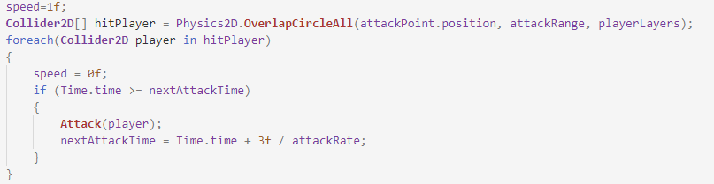

To check if the enemy is allowed to attack again, I check the variable nextAttackTime against the time, and once the enemy has attacked, I update it using the time. By increasing the value 3 shown above, I can increase the time before another attack. I will look at the attack function in the next two sections as they differ for melee and ranged enemies

4.3.1: Melee attack

A melee enemy will attack the player up close, and this is determined by the attackRange, which can be changed in the unity engine. Taking the goblin as an example, this is what its attack range looks like:

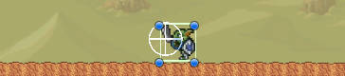

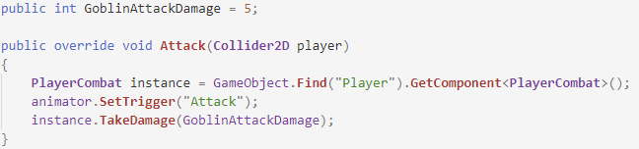Once the player is in range, the attack function will be called, as was shown previously. For a melee enemy, the attack function looks like so:

As each enemy is a subclass of the Enemy class, they inherit the attack function. However, since it is different for each enemy, I must override it so that when called, the right function is called. To access the player’s take damage function, I take instance of it, which I call instance, and I pass it the enemy’s attack damage as a parameter.

4.3.2: Ranged attack

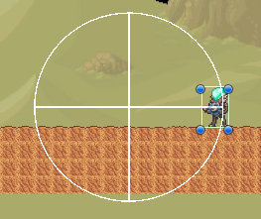A ranged enemy will attack the player from a much larger range, again controlled by the attackRange variable. Taking the Vortexian as an example, this is what its attack range looks like:

Once the player is in range, the attack function is called, which looks like so for a ranged enemy:

public override void **Attack**(**Collider2D** player) // attack function

{

**CheckIfFireBullet**();

}

The enemy will only be able to fire if the fireRate will allow it to, so I create a function to check if the enemy can fire or not. The code needed to do so is shown below:

public **GameObject** bullet;

public **GameObject** FirePoint;

float fireRate;

float nextFire;

void **Start**()

{

    base.**Start**(); // call start function from parent class

     fireRate = 3f;

     nextFire = Time.time;

}

void **CheckIfFireBullet**()

{

     if(Time.time > nextFire) // if time is bigger than the variable

     {

**Instantiate**(bullet, FirePoint.transform.position, transform.rotation);

        nextFire = Time.time + fireRate; // update variable

     }

}

If the enemy is able to fire (it will only be able to fire if the nextFire variable is smaller than the time, and if it is, then it is updated for the next fire), the game will instantiate the projectile at the fire point’s position (this will be different for all enemies). This covers the basics for the ranged enemies as their projectile will have a separate class.

4.4: Enemy projectiles

Most of the different enemy projectiles will have different abilities or move in different ways. All of them will be fired towards the player and will have a similar movement to the player projectiles. This section will focus on their movement, but all projectiles will be looked at individually, where I will focus on how they deal damage differently, and in some cases, how they move differently. For the movement, these are the variables I will be referring to:

public float moveSpeed = 7f;

public **GameObject** impactEffect;

public **Rigidbody2D** rb;

public **PlayerCombat** target;

public **Vector2** moveDirection;

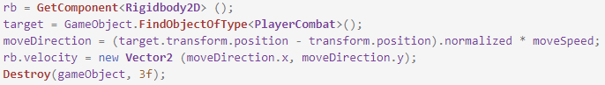Unlike the player projectiles, the player is now the target, and the projectile must move towards it. To do so, I find the difference in positions between the player and the projectile, and I make it move in that direction, by adding a force to the rigidbody’ s velocity:

If the projectile does not hit anything, it destroys itself after 3 seconds. It must also be destroyed if it was to hit a wall or the ground, and this can be done like so:

public virtual void **OnTriggerEnter2D** (**Collider2D** hitInfo)

{

     if(hitInfo.gameObject.layer == 10){ // if it hits the floor

**Instantiate**(impactEffect, transform.position, transform.rotation);

**Destroy**(gameObject); // destroy the object

     }

}

This is done in the exact same way as for the player projectiles. This now concludes the movement of the projectiles.

4.4.1: Bullet and Evolution beast projectile

Both of these projectiles are the most basic ones as they have no abilities. They will simply hurt the player when hitting them. Taking the bullet as an example, it is done like so:

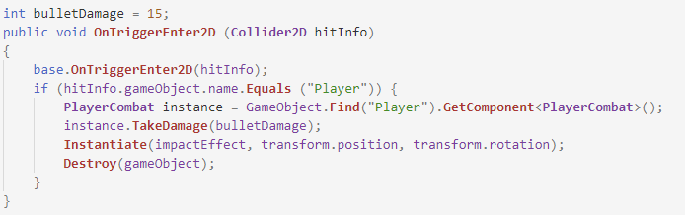

As soon as the bullet hits a collider, it will check to see if it belongs to an object of name ‘player’. If it does, then it has hit the player, and therefore, the player must be damaged, which is done by taking the instance of the player. Then, as it has hit the player, the bullet is destroyed. One final thing to mention is that as the bullet class is a subclass of the projectiles class, it inherits the second function on page 94. I must call that function within the sub-class. This could also be done in the update function; however, I thought this way was more efficient as it only requires one more line of code.

The function above will be the exact same in all the other projectile subclasses, with some lines added for some as they have extra abilities. An example of this will be shown below, for the cobweb.

4.4.2: Cobweb

The cobweb has the unique ability to freeze the player when it hits them. As I have already coded the function necessary to do so, I only need to call it now, whenever the cobweb hits the player, as shown below:

instance.**FreezePlayer**(); // call function from PlayerCombat class

This may only be one line; however, it is all that is required to freeze the player. As previously said, the cobweb class has a replica of the bullet function, with the line above added to it, hence where the instance variable comes from.

4.4.3: Demon scythe

The demon scythe will have its movement altered as it will have the ability to accelerate while it is moving. To do this, I will need this variable:

float acceleration = 0f;

The acceleration will initially start of at zero but will increase by one every frame. This will not be enough, as the speed will not have been updated and the scythe will not accelerate. The speed will also need to be updated at every frame, therefore I will need the update function to update these values, like so:

void **Update**()

{

     moveSpeed += acceleration; // update the speed

     acceleration += 1; // update the acceleration

}

Once the speed has been changed, the moveDirection variable will change in the parent class and therefore the scythe will start moving faster.

4.4.4: Summoner bomb

The summoner bomb will have its movement completely reworked. Upon being summoned, the bomb will stay above the summoner’s head for 1 seconds, before moving towards the player. Upon hitting the ground or the player, the bomb will not deal damage, but will explode. The explosion itself will deal damage and will have its own class.

For the movement, I will use StartCoroutine to delay the bomb’s movement by 1 seconds. It will have to called from the start function so that the 2 seconds begin as soon as the bomb is summoned into the game, like so:

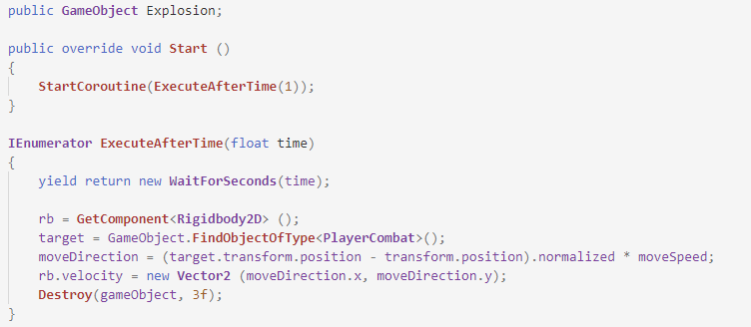

When calling the ExecuteAfterTime function, I pass it the time (1 second), and wait at the beginning of the function. Then, I copy the movement function from the projectiles class as it the bomb will now move towards the player, just like all the other projectiles do. Once it hits the ground or the player, the explosion will be instantiated, as shown below:

public override void **OnTriggerEnter2D** (**Collider2D** hitInfo)

{

     if(hitInfo.gameObject.layer == 8 || hitInfo.gameObject.layer == 10)

     {

**Instantiate**(Explosion, transform.position, transform.rotation);

**Destroy**(gameObject); // destroy the object

     }

}

That is all for the bomb, but now the explosion must hit the player if the player was to stand in front of it. This is how I do it:

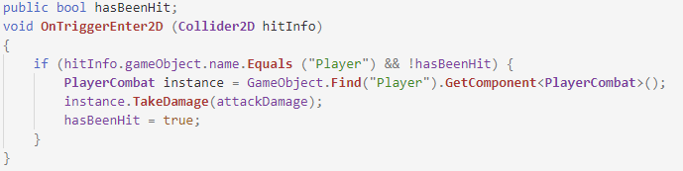

If the explosion collides with the player’s collider, then the plyer will take damage. However, a problem arises with this function. In unity, the collider will be constantly colliding with the player if they were to stand in front of the explosion. This will mean that this function will be called every frame, resulting in the player getting killed in second. To avoid this, I created the hasBeenHit variable which is set to true after the player is hit for the first time. If it is true, the function is unable to be processed and therefore the player only takes damage once.

The explosion must get destroyed so it doesn’t stay forever. To do this, I invoke a function to destroy the object after a second from the start function, like so:

void **Start**()

{

**Invoke**("Destroy", 1); // invoke function after a second

}

void **Destroy**()

{

**Destroy**(gameObject); // destroy the object

}

With this, the explosion will be destroyed after a second of being in the game.

4.5: Enemy health

All enemies will have a different amount of health, depending on when they appear in the game. The enemies that appear later on will have more health, to make them harder to kill. Without this, the player will be able to kill them to quickly due to their upgrades. However, all of the enemies’ health will be controlled in the same way. Here are the variables I will be referring to:

public float maxHealth;

public float currentHealth;

public **GameObject** healthBarUI;

public **Slider** slider;

Just like the player, all the enemies will have their own health bars. These will appear when the enemy first takes damage and will get shorter as the enemy takes damage. To begin with, I will set the correct values to the correct variables, as so:

currentHealth = maxHealth; // set health as the max health

slider.value = **GetHealth**(); // set slider to the health ratio

Then, whenever the enemy takes damage, the TakeDamage function will be processed, which looks like so:

public void **TakeDamage**(int damage) // enemy damage function

{

     currentHealth -= damage; // decrease health

     healthBarUI.**SetActive**(true); // activate health bar

When the enemy is hit, it’s health will decrease by the damage, and the slider will be activated. To update the slider, I use the same function that I did for the player’s slider:

protected virtual void **Update**()

{

     slider.value = **GetHealth**(); // change slider value

}

public float **GetHealth**()

{

     return currentHealth / maxHealth; // return health ratio

}

This will update the enemy’s health bar at every frame, making sure it is always up to date. If the enemy dies, then it will be destroyed, along with the enemy. The enemy is then able to drop a heart or a coin at their location. This will be done in the Die function, shown below:

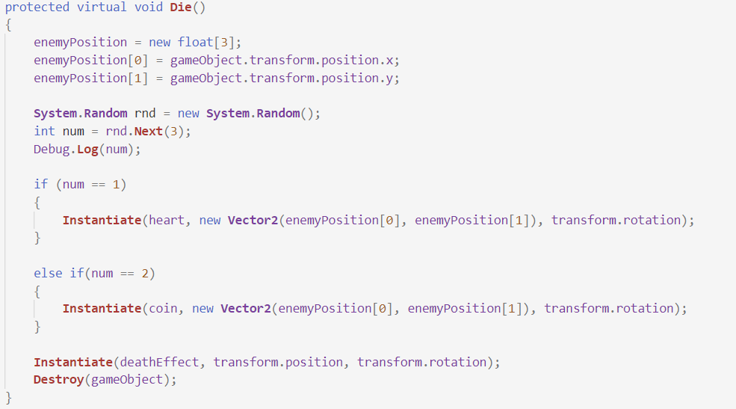

To make sure the heart or coin drops at the enemy’s death position, I create an array which will store the enemy’s death position inside it. Then, I randomly generate a number between 0 and 2 (inclusive). If it 1, a heart is instantiated at the correct position. If it is a 2, then a coin is dropped at the correct position. However, if it is 0, then nothing is dropped. Then the enemy is destroyed, and a death effect will play.

End of module testing; Enemies:

|  |  |  |  |
| --- | --- | --- | --- |
| Feature Being Tested | Testing Method | Expected Outcome | Testing result |
| Enemy movement | Watch the enemies move in the game | The enemy will not move down or jump, but only left or right | passed – see video 3 |
| Enemy changing direction | Watch the enemy when it hits the turn object | The enemy will change direction upon hitting it, and its sprite will flip | passed |
| Enemy taking damage | Use the player to attack the enemy | The enemy’s health bar will show up and its health will decrease | passed – see video 3 |
| Enemy death | Kill the enemy by attacking it with the player | The enemy will disappear completely | passed – see video 3 |
| Enemy attack when in range | Move the player towards the enemy | The enemy’s attack animation will play and the player will take damage | passed – see video 3 |
| Enemy drops | Kill the enemy by attacking it with the player and see | Either a heart or a coin will drop at the enemy’s location upon death | passed – see video 3 |
| Ranged enemy shooting | Move the player in the shooting range of a ranged enemy | The ranged enemy will instantiate the projectile upon the player being in that range | passed – see video 6 |

This module included all the enemies’ movement and attacks and therefore took a while to test. However, it all went well and no major problems were encountered.

4.6: The Slimes

The slime has the unique ability to jump towards the player. Once it has done that, it will wait for a second before jumping again. This means I will have to work with the gravity of the enemy and the rigidbody. Here are the variables I will be referring to:

int jumpHeight = 5;

public **Transform** groundEnemyCheck;

public float groundRange = 0.5f;

public bool isEnemyGrounded;

bool isJumping = false;

bool canJump = true;

public **LayerMask** groundLayers;

[**SerializeField**] **Rigidbody2D** rb;

To check if the slime is grounded, I will create a second gizmos for it, that will make the isEnemyGrounded variable true whenever the slime is touching the ground. The gizmos is created like so:

void **OnDrawGizmosSelected**()

{

     if (groundEnemyCheck == null)

         return;

     Gizmos.**DrawWireSphere**(groundEnemyCheck.position, groundRange);

}

<

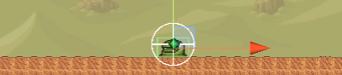And will look like so:

As shown, the gizmos collides with the ground whenever the slime is grounded. Now I have to set the variable as true whenever this occurs, like so:



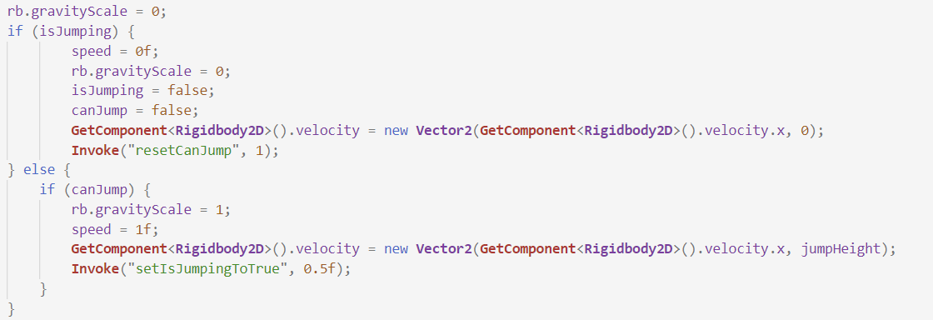When this is true, this section of code will be processed:

The gravity of the slime will be set to zero and if the slime can jump, it will be set as 1 to allow it to jump. Then, I add a force to the rigidbody to allow physically make the slime. Then, after half a second, I want it to come back down, and so I set the variable is jumping to true by invoking this function:

void **setIsJumpingToTrue**() {

     isJumping = true; // reset the variable

}

Once that is done, isJumping is true, and the other section is processed. The gravity is set back to zero and the variables are set to false. The force on the slime is set to zero, to prevent it from keeping its acceleration as it falls to the ground. At this point the slime is grounded, and so I invoke this function after a second:

void **resetCanJump**() {

     canJump = true; // reset the variable

}

This function will reset the variable canJump after a second to allow the slime to jump again.

End of module testing; Slimes:

|  |  |  |  |
| --- | --- | --- | --- |
| Feature Being Tested | Testing Method | Expected Outcome | Testing results |
| Slime jumping | Watch the slime jump in the game | The slime jumps in the air, but not too high up | passed – see video 4 |
| Slime falling to the ground | Watch the slime fall in the game | The slime will fall back down to the ground after jumping | passed – see video 4 |
| Slime hitting the ground and stopping | Watch the slime hit the ground in the game | The slime will stop and not go through the ground | passed – see video 4 |
| Slime staying stationary | Watch the slime in the game | The slime will not move or jump for a second | passed – see video 4 |

This module was quick to test and I didn’t encounter any major errors as the slime’s movement worked quickly

4.7: The Drakanian

When the Drakanian dies, the Drakanian beast will spawn at the Drakanian’s death position. To do so, I will need a function when the Drakanian dies, shown here:

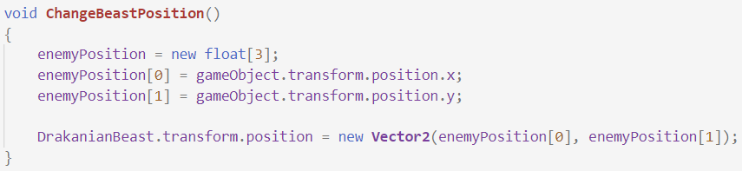

Once the Drakanian dies, I grab its position and change the Drakanian beast’s position according to it. Then, the Drakanian can die, and so I call the enemy class’s Die function. Putting all of it together gives:

public **GameObject** DrakanianBeast;

protected override void **Die**()

{

     DrakanianBeast.**SetActive**(true); // activate the Drakanian beast

**ChangeBeastPosition**(); // change its position

     base.**Die**(); // call Die function from parent class

}

This is all that is needed for the Drakanian. As the Drakanian beast has no abilities, it will have similar code to the Goblin’s.

End of module testing; Drakanian:

|  |  |  |  |
| --- | --- | --- | --- |
| Feature Being Tested | Testing Method | Expected Outcome | Testing results |
| Drakanian disappearing | Kill the Drakanian with the player in game | The Drakanian will disappear and drop a heart or coin | passed – see video 5 |
| Drakanian Beast appearing | Wait for the beast after the Drakanian dies | The Drakanian beast will spawn and act like all other enemies | passed |

The Drakanian module was the quickest and easiest to test and I am very happy with how it turned out.

4.8: The Ghoul

The ghoul will have the ability to debuff the player when they hit them. The chance to debuff the player will a 1 in 6 chance and will therefore mean I will use more random numbers. When the ghoul attacks the player, its main attack function is called, which was looked at on page 92. However, these lines of code are added:

**System**.**Random** rnd = new **System**.**Random**();

int num = rnd.**Next**(6); // random number between 1 and 6

if (num == 5)

{

       instance.**DebuffPlayer**(); // call the player’s debuff function

}

I generate a random number between 0 and 6 and if that number happens to be 5, then the player’s debuff function is called and therefore the player has now been debuffed.

End of module testing; Ghoul:

|  |  |  |  |
| --- | --- | --- | --- |
| Feature Being Tested | Testing Method | Expected Outcome | Testing results |
| Ghoul debuff ability | Let the Ghoul attack the player in game | The ghoul will be able to debuff the player when attacking | passed – see video 8 |
| Frequency of debuff ability | Record the ratio of hits to debuff hits | The number of hits is higher than debuff hits | passed – see video 8 |

The Ghoul was also a quick module to test and the coding went smoothly with no big problems to sort out.

4.9: The Solarian

The solarian is the most interesting enemy out of them all. It has the ability to roll towards the player, when the player is in a certain range of it. Here are the variables I will be referring to:

public bool isRolling = false;

public bool CanRoll = true;

public float RollRange = 0.5f;

public **Transform** RollPoint;

To determine the range at which the solarian can roll, I will create a gizmos. However, unlike all the other gizmos I have previously created, this one will be a rectangle, and not a sphere. This will allow the solarian to only roll when the player is directly in front of it, and not if the player if standing above it. Here is how I create it:

void **OnDrawGizmosSelected**()

{

     if (RollPoint == null)

         return;

     Gizmos.**DrawWireCube**(RollPoint.position, RollPoint.localScale);

}

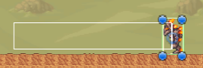And here is what it looks like in the unity engine:

Now that I have the range in place, the solarian must roll towards the player when they are inside of it. To do this, I will create an array, as I have done for all the other gizmos. However, this one will look a little bit differently due to the fact this gizmos is no longer a circle:



Once the player is in the Roll array, I must check if the solarian is already rolling, and if it is allowed to roll. If so, the variables get switched from true to false, or false to true. This is in place to make sure the solarian does not constantly re-start the roll if the player stays in the range. Then, I will invoke a function after 5 seconds to make the solarian stop rolling. This can be shown here:

foreach(**Collider2D** player in Roll)

{

     if(!isRolling && CanRoll) // if the Solarian is allowed to roll

     {

             isRolling = true; // Solarian is now rolling

             CanRoll = false; // Solarian cannot roll

**Invoke**("StopRolling", 5); // invoke function to stop rolling

             animator.**SetBool**("Roll", true); // start rolling animation

     }

}

Once the solarian has stopped rolling, it will not be able to roll again for 10 seconds, and this can be done in the StopRolling function by using the Invoke function, like so:

public void **StopRolling**()

{

    isRolling = false; // Solarian is no longer rolling

**Invoke**("ActivateRoll", 10); // invoke function to allow it to roll

    animator.**SetBool**("Roll", false); // stop rolling animation

}

During the 10 seconds, the Solarian will not be able to roll as the canRoll variable is still set as false. Once the ten seconds are up, the ActivateRoll function is called, which looks like so:

public void **ActivateRoll**()

{

     CanRoll = true; // reset the variable to allow the Solarian to roll

}

Now the Solarian is able to roll again if the player was to be in the range again.

If the Solarian was to hit the player when it is rolling, it will deal more damage, and it will also stop rolling. This means its attack function must be altered, and it can be done like so:

if (isRolling)

{

**StopRolling**(); // Solarian should stop rolling

         instance.**TakeDamage**(SolarianRollDamage); // player takes damage

} else {

         instance.**TakeDamage**(SolarianAttackDamage); // player takes damage

}

This function uses the same instance as the all the others do, which is the PlayerCombat instance.

End of module testing; Solarian:

|  |  |  |  |
| --- | --- | --- | --- |
| Feature Being Tested | Testing Method | Expected Outcome | Testing result |
| Solarian roll distance | Move the player inside in the roll range | The Solarian will change to tis rolling animation and roll towards the player | passed – see video 9 |
| Solarian stop rolling | Watch the Solarian roll in the game | The Solarian will switch back to its walking animation after a few seconds | passed – see video 9 |
| Solarian hitting player when rolling | Let the player get hit by the solarian while rolling | The Solarian will stop its rolling animation | passed – see video 9 |
| Solarian waiting to roll again | Watch the Solarian after rolling in the game | The Solarian will not be able to roll for a few seconds | passed – see video 9 |

The Solarian took some time to get just right, but the testing went smoothly. I was very happy in the end as it worked with no major problems.

4.10: Sand Elemental

The Sand elemental is the first boss in the game, which is fought at the end of the player’s journey through Mars. All the detail on this boss was previously covered in section 2.2, so I will only repeat the basics. The elemental will float in the air and move between the invisible game objects like all the other enemies. The only extra feature she has is the fact that she will always look and move towards the player. To do this, I will compare the elemental’s position in the x axis to the player’s position in the x axis. I will then flip the sprite and change the variables according to where the player is in comparison to the elemental. This is done like so:

public **Transform** target;

void **Update**()

{

    base.**Update**(); // call the parent class’s update function

    if(target.transform.position.x > gameObject.transform.position.x)

    {

          transform.localScale = new **Vector2** (-enemyScale[0], enemyScale[1]);

          moveRight = true; // player is to the right, therefore move right

    } else {

          transform.localScale = new **Vector2** (enemyScale[0], enemyScale[1]);

          moveRight = false; // player is to the left, therefore move left

    }

}

To begin with, the enemy’s update function must be called, otherwise the elemental will not move at all. Then, I compare the positions of the two objects. If the player is on the right of the elemental, then her sprite is flipped in the x direction, and the variable moveRight is set as true, to allow her to follow the player. If not, then the elemental is to the right of the player, and she must move left. Therefore, moveRight is set as false.

In this example, the target is set as a Transform, which is different to the projectiles, both enemy and player, as they were set as GameObject. This is due to the fact that the elemental is always present in the scene (until she dies) and not instantiated like all the projectiles are. Due to this, I am allowed to set the player as the target within the unity engine, like so:



With that, the player is automatically set as the target, and no extra lines of code are needed to do it.

The elemental now needs to attack the player, and she has two different ways of doing so. Therefore, in her attack function, I must choose the one she will use, and this will be done at a random chance, like so:

**System**.**Random** rnd = new **System**.**Random**();

int num = rnd.**Next**(2);

if (num == 0) { // attack 1

**CheckIfFireAttack1**();

} else { // attack 2

**CheckIfFireAttack2**();

}

If the number is 0, then the first attack is used, and if it is 1 (which is the only other possible outcome), then the second attack is used. To check if the elemental is allowed to attack, I will use the same logic as for the ranged enemies. This is demonstrated for the first attack here:

if(Time.time > nextFire) // if the elemental can fire

{

**Instantiate**(attack1, transform.position, transform.rotation);

       nextFire = Time.time + fireRate; // reset variable

}

This will make sure the elemental does not fire constantly, but only at limited rates.

4.10.1: Attack 1

The elemental’s first attack is a projectile, which will shoot towards the player and debuff them. I have already looked at projectile movement, and so I will only focus on its attack function. Firstly, the attack must be instantiated, which is shown in the code above. Secondly, the projectile must face the sand elemental as unlike other projectiles, it is not symmetrical in the x direction. This can be done like so:

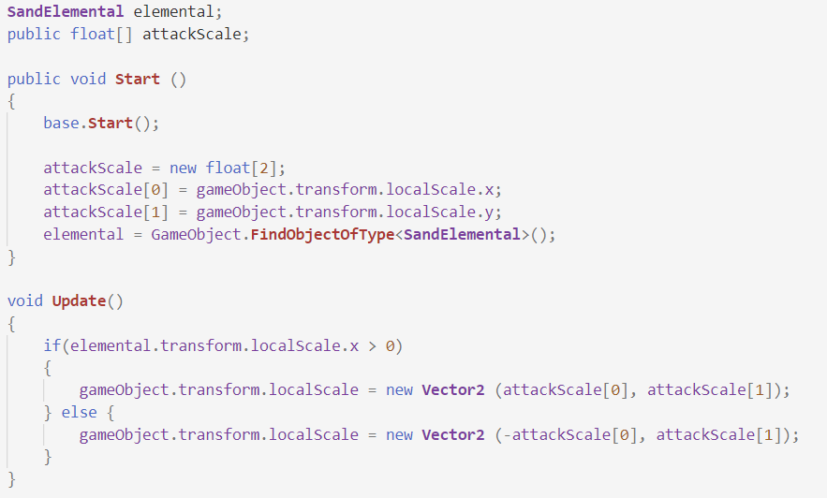

In the start function, I create an array to store the projectile’s scale. Then, I the update function, I check the elemental’s scale, and change the projectile’s scale accordingly. This will make sure the projectile is always facing the right way and, for example, will not move towards the player backwards.

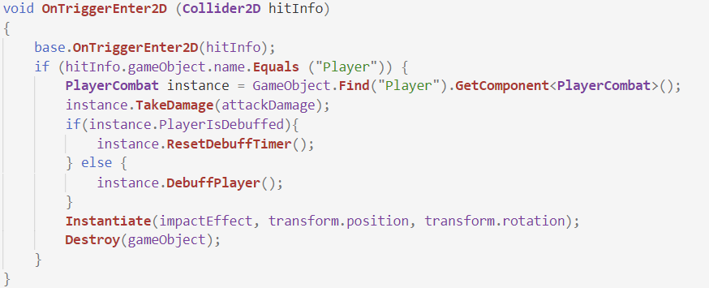

Now for the projectile’s attack function. The player takes damage and is debuffed simultaneously. If the player is already debuffed, then the timer is reset. Finally, the projectile is destroyed upon hitting the player and the impact effect is played.

4.10.2: Attack 2

The elemental’s second attack will warn the player that it is coming. Upon the elemental firing then attack, a target will appear at the player’s position, and this is shown here:

if(Time.time > nextFire) // if elemental can fire

{

     nextFire = Time.time + fireRate; // reset variable

**Instantiate**(attackTarget, target.transform.position, transform.rotation);

}

This target will then instantiate an explosion after a second of staying still. This is relatively simple, and is shown here:

public **GameObject** attack2;

void **Start**()

{

**Invoke**("Destroy", 1); // invoke function to destroy object after a second

}

public void **Destroy**()

{

**Destroy**(gameObject); // destroy the object

**Instantiate**(attack2, transform.position, transform.rotation);

}

This second for which the target is active will allow the player to move away before the explosion arrives. The explosion will be very similar to the Summoner bomb’s explosion. It will be destroyed after a second and can only hit the player once. To destroy the explosion after a second, this code is needed:

void **Start**()

{

**Invoke**("Destroy", 1); // invoke function to destroy object after a second

}

public void **Destroy**()

{

**Destroy**(gameObject); // destroy the object

}

And to hit the player, this code is needed:

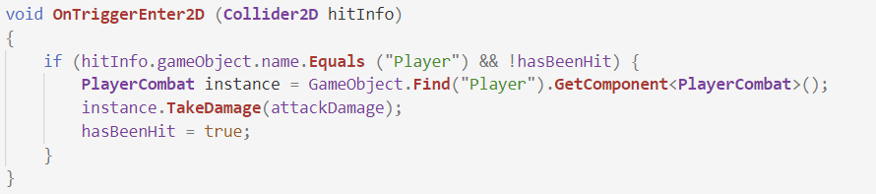

This now concludes the Sand elemental, and the final enemy to look at now is the final boss of the game, the Dark Mage.

End of module testing; Sand Elemental:

|  |  |  |  |
| --- | --- | --- | --- |
| Feature Being Tested | Testing Method | Expected Outcome | Testing results |
| Sand Elemental attacks | Let the Elemental attack the player in game | The Sand elemental will attack the player with two different attacks | passed – see video 12 |
| Frequency of attacks | Record the ratio of attack 1 to attack 2 | The attacks don’t play one after the other but the ratio is approximately 1:1 | Attacks were well distributed |
| Elemental’s debuff ability | Let the Elemental attack the player in game | The Elemental’s first attack will debuff the player on hit | passed – see video 12 |
| Elemental’s target before attack | Let the Elemental use the second attack in game | The explosion will play as second after the target shows | passed – see video 12 |

This module was simple to test; however it took some time to record a number of attacks to figure out their ratio. It was a crucial test to do, as if the attacks were not evenly distributed, it would ruin the boss fight for the player.

4.11: Dark Mage

The Dark Mage is the hardest and most toughest boss in the game. Evidently, he will have a lot of attacks and abilities, including teleportation. Just like the elemental, the mage will always face the player, however, he will never move towards them. This means his function will look like so:

public **Transform** target;

protected override void **Update**() // function is called once every frame

{

     if(target.transform.position.x > gameObject.transform.position.x)

     {

         transform.localScale = new **Vector2** (-enemyScale[0], enemyScale[1]);

     } else {

        transform.localScale = new **Vector2** (enemyScale[0], enemyScale[1]);

}

The Dark mage will attack constantly and will not use the gizmos. This is due to the fact that he does not move and if I was to use the gizmos, the player would be able to stand outside of it and cheat. So, the mage will use these variables instead:

public bool CanAttack = true;

public bool CanStartAttacking = true;

To avoid the mage attacking while the player isn’t present, I created the CanStartAttacking variable which will be set as true once the player enters the boss room. As the boss room has not been created, I will set it as true for testing purposes.

Once both these variables are true, the mage is able to attack. And since he has 4 different attacks, I must use a random number generator once again to determine which attack he will use:

**System**.**Random** rnd = new **System**.**Random**();

int num = rnd.**Next**(4);

if (num == 0) { // attack 1

**Attack1**();

} else if (num == 1) { // attack 2

**Attack2**();

} else if (num == 2 && !Attack3Active) { // attack 3

**Attack3**();

} else { // attack 4

**Attack4**();

}

There is one extra feature in this, and that is the Attack3Active variable. This is due to the fact that the mage is not allowed to use his 3rd attack if it is currently active.

Once the mage has selected an attack, he will not be able to attack again for 5 seconds and this will be done like so:

CanAttack = false; // dark mage cannot attack anymore

**Invoke**("ResetAttack", 5); // invoke function after 5 seconds

This will be located at the end of the code shown above. The ResetAttack function called above will look like this:

public void **ResetAttack**()

{

    CanAttack = true; // reset variable

}

Now all is set for the mage, and the attacks can now be programmed.

4.11.1: Attack 1

The first attack is a bomb that will fall to the ground before exploding into flames that will move left and right. To summon the bomb, this code is needed:



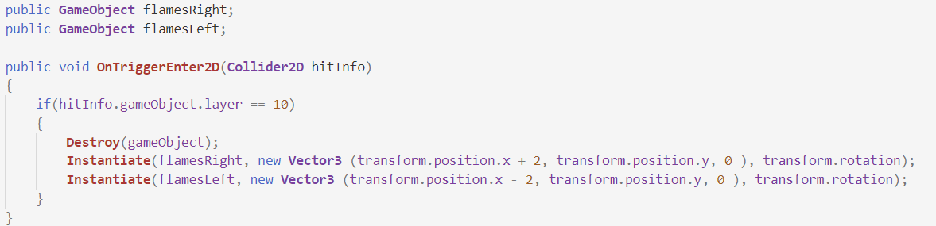The bomb is instantiated at the player’s x position, and 2 units above the dark mage’s y position. Once it is summoned, it will fall to the ground, as I have set its gravity to 1. It will now hit the ground, and the flames will appear. So, in a new class for the bomb, this occurs:

Upon hitting the ground, the two different flames are instantiated. I require two different game objects for the flames as they will have different directions.

These flames will move in a straight line and therefore, all code that is needed is:

transform.**Translate**(-2 * Time.deltaTime * speed, 0,0); // move the flames

<,

This is for the flames moving left, but for the ones moving right, the -2 is simply changed to a 2.

4.11.2: Attack 2

The mage’s second attack will be a summon attack. The mage will summon 4 of the old one’s skeletons. They will fall towards the ground and then chase the player around. I will want to summon the skeletons at even intervals from each other. If they were to be summoned in the same place, then it would seem as if there were only one skeleton, when in fact there are 4. I will do this like so;



The skeletons will firstly be summoned 1 unit below the mage, hence the -1 in the y position. For the x position, they are split in intervals of 0.6 units, which is enough for the player to notice that there are 4 different skeletons being summoned.

These skeletons will be summoned in the air and will need to fall to the ground before stopping on it. To do so, I will use a similar system to the slimes, but this will require less code as the skeletons don’t jump. Here are the variables I will be referring to:

[**SerializeField**] **Rigidbody2D** rb;

public bool isEnemyGrounded;

public **LayerMask** groundLayers;

public **Transform** groundEnemyCheck;

public float groundRange = 0.5f;

To check if the skeletons are touching the ground, I will create the same gizmos I used for the slimes, and use the same variable which will be set as true whenever they are on the ground, as shown below:

void **OnDrawGizmosSelected**()

{

     if (groundEnemyCheck == null)

         return;

     Gizmos.**DrawWireSphere**(groundEnemyCheck.position, groundRange);

}



Once the isEnemyGrounded variable is set as true, the skeletons have touched the ground and they must be stopped, to avoid them from falling through the ground. To do so, I will need to set the gravity to zero, and set their velocity to zero, to stop their acceleration as they fell :

if(isEnemyGrounded) // if the skeletons hit the ground

{

      rb.gravityScale = 0; // set gravity to zero

      rb.velocity = Vector2.zero; // set y velocity to 0

With this setup, the skeletons will stop as soon as they touch the ground, and then they can start to chase after the player

4.11.3: Attack 3

The third attack will be a shield of orbs that will be summoned around the mage. These will act as barrage, to prevent the mage from taking damage. The player will be able to destroy them, and once they have destoyred 5 (or more), the mage will be able to use the attack again. Here is how I will summon the orbs:

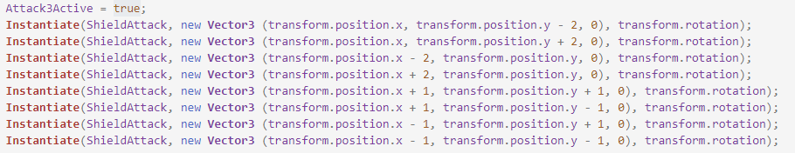

The changes in position will allow the orbs to be summoned in a circle around the mage. The orb class will inherit from the enemy class, as they are technically an enemy. However, they do not move, and so, I just have to set their speed as 0, like so:

public void **Update** ()

{

     speed = 0f; // set speed to 0 as they do not move

Now the orbs are set to protect the mage from any damage. However, that is not all. When one is destroyed, a counter will be increased by one, like so;

protected override void **Die**()

{

**Destroy**(gameObject); // destroy the object

     DarkMage.counter += 1; // add one to the counter

}

And when that counter is bigger than or equal to 5, then the attack can be used again:

if(counter >= 5)

{

       Attack3Active = false; // dark mage can now re-sue the attack

       counter = 0; // reset counter to 0

}

4.11.4: Attack 4

The mage’s fourth and final attack will be a barrage of 5 projectiles which will then shoot towards the player. They will be summoned towards the player, which means I will have to compare the player’s position to the mage’s position, like so:

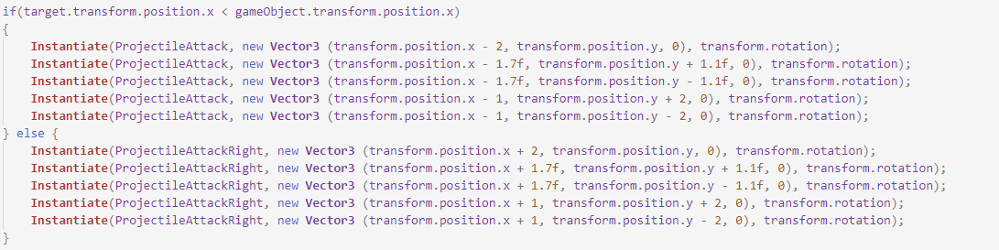

This way the projectiles will always be summoned towards the player.

These projectiles will now have to wait for 2 seconds before they shoot towards the player. To do so, I will use the same logic as I did for the summoner bomb, which will mean using the StartCoroutine function, like so:

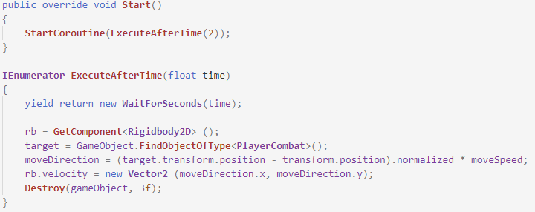

The time to wait will be 2 seconds, and after those 2 seconds, the projectiles will shoot towards the player. When they hit the player, the attack function will be called, which is the same as the other projectiles.

4.11.5: Teleportation

The dark mage will have the ability to teleport around the boss area. This will present a new challenge to the player as it will become harder for them to hit the boss. Here are the variables I will be referring to:

public float[] startPosition;

public bool canTeleport = false;

public static bool teleported = false;

public static int newPosistionX;

public static int newPosistionY;

Then, to teleport the mage, I first had to store his starting position, which is done by using the startPosition array, like so:

public void **Start**()

{

     base.**Start**(); // call the parent class’s start function

     startPosition = new float[2]; // create array to store start position

     startPosition[0] = gameObject.transform.position.x;

     startPosition[1] = gameObject.transform.position.y;

}

The reason for this is that I don’t want the mage to teleport out of the area, and so he will only be able to teleport a certain distance from his starting position. Then, I must create random coordinates to add to the starting position, which will teleport the mage. This is how I create them:

canTeleport = false; // mage can no longer teleport

**System**.**Random** rnd = new **System**.**Random**(); // create a random integer

newPosistionX = rnd.**Next**(9) + 5; // determines x teleportation

newPosistionY = rnd.**Next**(1) + 1; // determines y teleportation

int leftOrRight = rnd.**Next**(1); // determines left or right

int upOrDown = rnd.**Next**(1); // determines up or down

I want the mage to be able to teleport by a minimum of 5 units in the x direction (hence the +5), and by getting a random number between 0 and 8, a maximum of 13 units. For the y direction, I want a minimum of 1 unit, and a maximum of 2 units. The y direction is limited as the mage hovers over the floor and I do not want him to go through the floor. Then, I must find a way to decide if the mage goes left or right, and up or down. To do so, I create two new random integers, which will store either 0 or 1. If it is 0, the mage will go left and up, and if it is 1, he will go right and down. Here is how I then teleport the mage based on the integers:

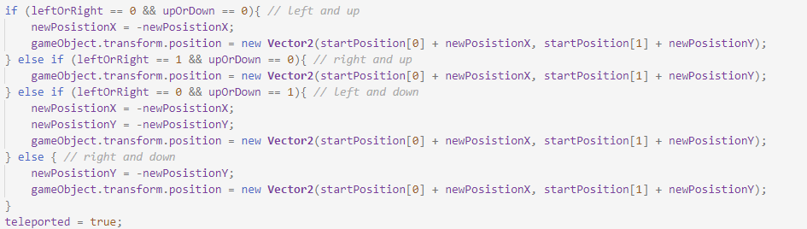

If the mage is set to go left, then the newPositionX has to be negative, and if he is set to go down, then the newPositionY also needs to be negative. Then, I update the mage’s position by adding the new position to his starting position, and with that, the mage has teleported.

As I don’t want him to teleport for another 5 seconds, I will invoke a function that will reset the canTeleport variable to true after seconds, like so;

**Invoke**("ResetTeleport", 5); // invoke function to reset the teleport

}

public void **ResetTeleport**()

{

     canTeleport = true; // reset variable

     teleported = false; // reset variable

}

Now the mage is able to teleport again.

One last thing to code with the teleportation is the orbs. The orbs must teleport along with the mage, otherwise their whole purpose is defeated, and the mage isn’t shielded any longer. The Boolean variable ‘teleported’ will come in handy, as I will change the orb’s position when that is set to true, like so:



The use of the variables from the Dark Mage class is made possible as they have been stated as static. With this, the orbs will follow the mage anytime he teleports.

End of module testing; Dark Mage:

|  |  |  |  |
| --- | --- | --- | --- |
| Feature Being Tested | Testing Method | Expected Outcome | Testing results |
| Dark Mage attacks | Let the Dark Mage attack the player in game | The Dark Mage will attack the player with the 4 different attacks | passed – see video 13 |
| Frequency of attacks | Record the ratio of attacks | The attacks will play randomly and all of them will be seen often | Attacks were well distributed |
| Dark Mage teleporting | Watch the Dark Mage in game | The Dark mage will teleport to a random location | passed – see video 13 |
| Frequency of teleports | Record the time between teleports | The time intervals will not be too high | Teleport time was not too high |

Just like the Sand Elemental, it took some time to record the attacks to see their distribution, but also watch the dark mage teleport to make sure it didn’t feel too fast, as that too would ruin the boss fight for the player.

5: Environments

5.1: Falling platform

The falling platform will be one of the two types of platforms. This one will disappear after 0.6 of a second once the player has stood on it. Her are the variable I will be referring to:

public **Transform** PlayerCheck;

public **LayerMask** PlayerLayers;

To check if the player has stood on it, I will create a box gizmos, that I will then use to create an array of all the colliders that come inside of it, like so:

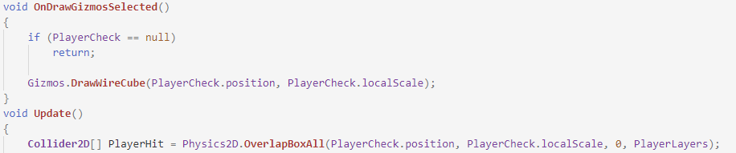

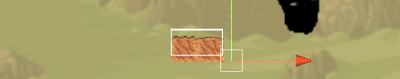The gizmos will look like this:

Once a player is detected in the array, the platform needs to destroy itself. This can be done by using the invoking function:

foreach(**Collider2D** player in PlayerHit)

{

**Invoke**("DestroyPlatform", 0.6f); // invoke after 0.6 seconds

In the DestroyPlatform function, I must first call the function to reset the platform, which will be located in the Grid class, as it oversees all platforms;

void **DestroyPlatform**()

{

**Grid** instance = GameObject.**Find**("Grid").**GetComponent**<**Grid**>();

    instance.**Wait**(gameObject); // call the Wait function

    gameObject.**SetActive**(false); // deactivate the platform

}

In the Wait function of the Grid class, I call another function, this time by using StartCoroutine in order to wait the 5 needed seconds, like so:

public void **Wait**(**GameObject** platformObject)

{

**GameObject** platform = platformObject; // set the platform as the variable

**StartCoroutine**(**ResetPlatform**(platform)); // call the function to reset

}

unfortunate, I was not able to directly call the ResetPlatform function with StartCoroutine in the falling platform class. But once the Wait function is called, the ResetPlatform is called, which looks like so:

**IEnumerator** **ResetPlatform**(**GameObject** platform)

{

     yield return new **WaitForSeconds**(5); // wait for 5 seconds

     platform.**SetActive**(true); // reactivate the platform

}

After 5 seconds, the platform is then set as true once more, and the player is able to use it again.

End of module testing; Falling platforms:

|  |  |  |  |
| --- | --- | --- | --- |
| Feature Being Tested | Testing Method | Expected Outcome | Testing results |
| The platform disappearing | Step on the platform with the player | The platform will disappear after a second | passed – see video 1 |
| The platform will only disappear if it is a player stepping on it. | Place an enemy on the platform | The platform will not disappear | passed – see video 1 |
| The platform re-appearing | Watch the platform after it has disappeared | The platform will come back 2 seconds after disappearing | passed – see video 1 |

This module was simple to test and I didn’t run into many errors. I was happy that this module worked well as it felt like a challenge to code and implement in the game.

5.2: Moving platform

A moving platform will move towards two different positions. The player will not be stuck to the platform and will have to move along with it to stay on top of it. Here are the variables I will be referring to:

public **Transform** position1;

public **Transform** position2;

public float speed;

public **Transform** startPosition;

**Vector3** nextPosition;

Whenever the platform reaches positon1 or position2, it must be directed to the opposite one, and to do so, I have to set the nextPosition variable as the opposite position, like so:

if(transform.position == position1.position)

{

       nextPosition = position2.position; // set the nextPosition

}

if(transform.position == position2.position)

{

       nextPosition = position1.position; // set the nextPosition

}

This is all that is needed when updating the nextPosition variable, however, the platform must now move towards the position marked as nextPosition, and this is done like so:



And now, the platform will move from one side to the other, and the player will be able to move long with it.

End of module testing; Moving platforms:

|  |  |  |  |
| --- | --- | --- | --- |
| Feature Being Tested | Testing Method | Expected Outcome | Testing results |
| The platform moving | Watch the platform moving | The platform will move from position1 to position2 | passed – see video 1 |
| The platform switching directions | Watch the platform moving | The platform will go back the other way when hitting the end | FAILED |
| The platform will not move the player | Use the player to stand on the platform | The player will fall off the platform if not moving | passed – see video 1 |

When observing the platform, it did not switch directions as it hit the left most position. This is because I did not link the game object’s position to the moving platform. After doing so, the platform did manage to switch directions and the test is now passed.

5.3: Spikes

Spikes will be dispersed around the world and will deal 5 damage every 2 seconds to the player if they stand on it. Her are the variables I will be referring to:

public bool PlayerHit;

First, I must determine the range at which the player will take damage from the spike. This will again require me to create a gizmos around the spike. After doing so, I create and array of all the colliders and check for the player. Once a player is detected in the array, they will take damage:

foreach(**Collider2D** player in hitplayers)

{

       if(!PlayerHit) // if the player hasn’t been hit

{

**HitPlayer**(); / /call the function

       }

}

The player can only be hit once every 2 seconds, and so the PlayerHit variable must be updated to make sure the player does not take any more damage:

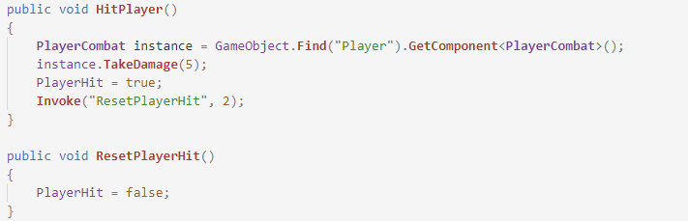

Then, once the player has taken damage, the PlayerHit variable is reset to false after 2 seconds. Now, the player can take damage again from the spike.

6: Chests

Chests are very important in the game as they allow the player to collect resources for their journey. There will be two different types of chests, the normal ones and the ones for the player and weapon skills. In this section I will be focusing on the opening and closing of the chests, and will be referring to these variables:

public **LayerMask** playerLayers;

public float chestRange = 0.5f;

public **Transform** chestPoint;

public static bool ChestIsOpen = false;

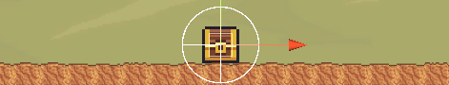To check if the player is close enough to the chest to open it, I will create a gizmos, that looks like this:

Whenever the player enters this area, it will be detected and added to an array. Then, the player is able to open the chest, by pressing the q key. This is shown below:

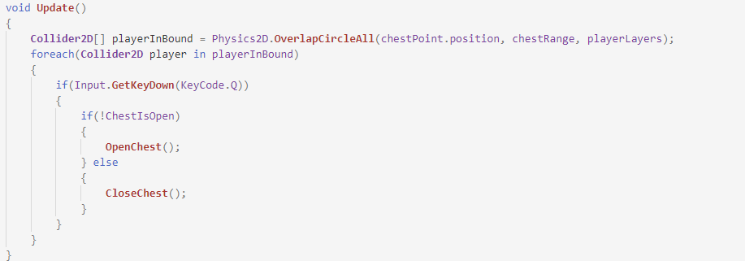

If the chest isn’t open, then it must open, and therefore the OpenChest function will be called:

public void **OpenChest**()

{

     ChestContentsUI.**SetActive**(true); // activate chest

     Time.timeScale = 0f; // freeze time

     ChestIsOpen = true; // reset variable

     spriteRenderer.sprite = OpenedChest; // change sprite

}

The game object containing the contents will be set as active, and the time will be frozen to let the player use the chest without worrying about what is happening around them. The ChestIsOpen variable is then set to true, and the chest sprite is changed to indicate to the player that they have opened the chest before if they were to come back to it. Below shows the ChestContentsUI:

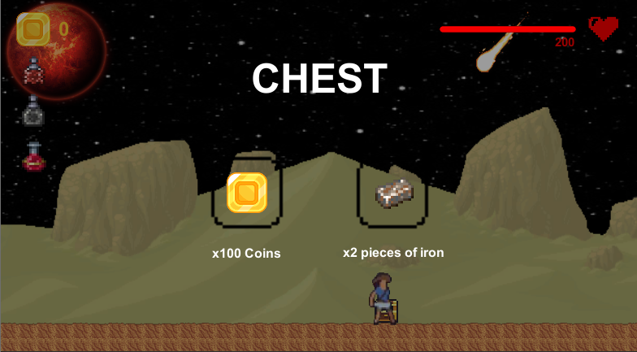

To close the chest, the player just has to press the q key again, and as the variable   
ChestIsOpen is set as true, the CloseChest function will be called. This function will deactivate the contents, and reset the time along with the ChestIsOpen variable:

public void **CloseChest**()

{

     ChestContentsUI.**SetActive**(false); // deactivate the chest

     Time.timeScale = 1f; // unfreeze time

     ChestIsOpen = false; // reset variable

}

Now, I am able to put function into these chests, as at the moment, the buttons shown above have no code to them.

6.1: Normal chests

Normal chests will contain coins in the first slot, and either iron bars or potions in the second. I will therefore need to create a function for all the contents possible. For the coins, I have not yet created the score manager, and therefore I will have to call a function that I have not coded yet. The same applies for the iron bars as I have not coded the inventory just yet, and they will be stored there. However, all 3 potions have functions I can call to update the numbers. All the functions are shown on the next page.

These must be called whenever a button is pressed, and I will link the buttons with the functions using the unity OnClick() feature I previously used on page 63.

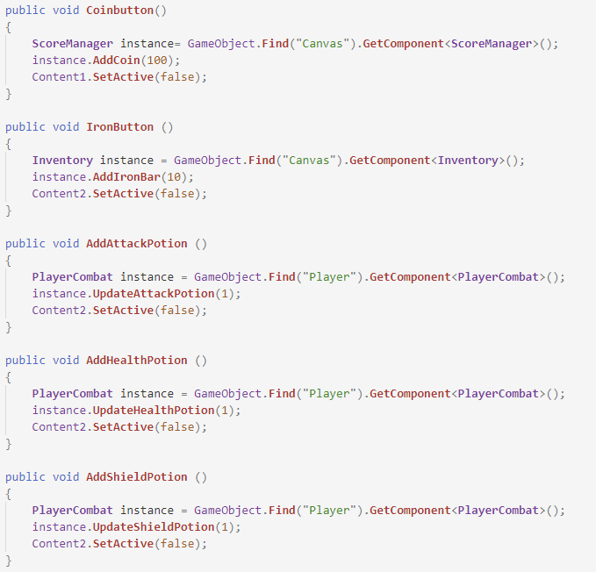

The functions called are the same ones used when the player picks up a potion. They were previously covered on page 86.

6.2: Player skills chests

There will be two player skills chests, and they will inherit from the parent chest class, meaning they inherit the gizmos, and the open and close functions. However, the functions that the buttons will be connected to will be different. In these functions, I must deactivate all contents when one is clicked on, to make sure the player only takes one. Then, the right variable in the PlayerCombat/PlayerMovement will be set as true to allow the player from using the skill:

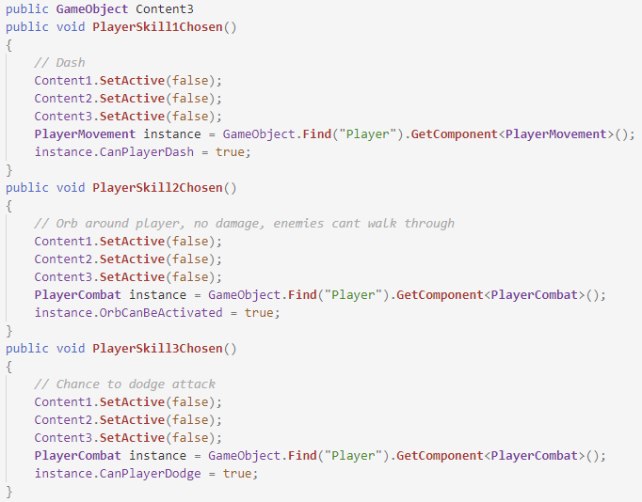

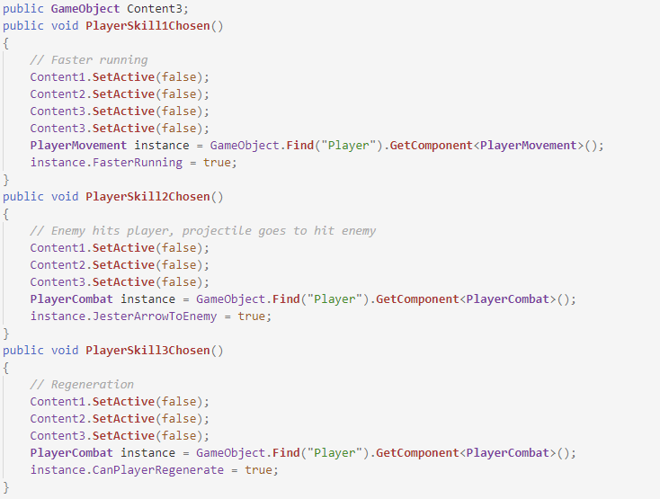These are the functions for the first skills chest. I had to add an extra variable for the 3rd content as the chest class only accounted for 2 contents. Below are the functions for the second skills chest:

6.3: Weapon skills chests

There will only be one skills chests, and it will also inherit from the chest parent class. The class will feature two functions, one for each skill, and they will each be linked to their respective buttons:

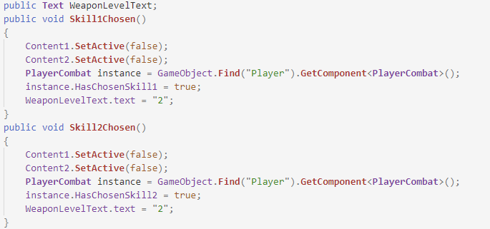

When one of skills is taken, they are both removed from the chest, and the weapon’s level is upgraded. To inform the player of that, a piece of text is changed from ‘1’ to ‘2’. Once again, this will be shown in the inventory, but is set inactive in the game until the inventory structure is made, which, coincidently, is the next major feature to create.

End of module testing; Chests:

|  |  |  |  |
| --- | --- | --- | --- |
| Feature Being Tested | Testing Method | Expected Outcome | Testing results |
| Chest opening | Press the “q” key in game | The chest will open | passed – see video 1 |
| Chest opening distance | Press the “q” key near a chest and away from a chest | The chest will not open when pressing the key away from it | passed |
| Chest contents | Look at the chest contents when opened | The contents will be shown | passed – see video 1 |
| Player can only take one skill (skills chests only) | Take a skill from a skills chest | The other skills will disappear to restrict the player to one skill only | passed |

I was very happy with the testing of the chest module as it took a while to code and I didn’t run into any major errors.

7: In-game menus

7.1: Inventory

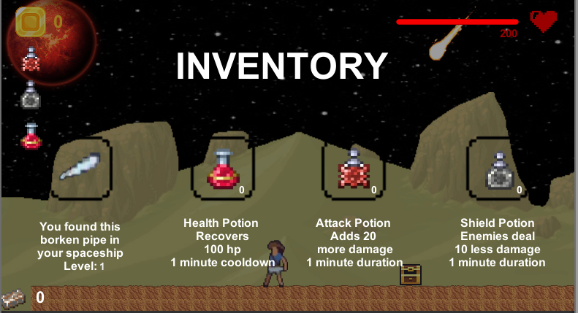The inventory will be very useful to the player, as it will allow them to use potions, but it will also give them information, including the number of potions and iron bars. Before coding anything, I must create a structure, which will look like so:

I was now able to add the potion numbers and weapon level texts which were previously inactive. Now, the player is able to see how many they have when they open the inventory. Now for the code, here are the variables I will be referring to:

public static bool InventoryOn = false;

public **GameObject** InventoryUI;

static int ironBars = 0;

public **Text** ironBarsText;

To open the inventory, the player must press the e key, and they can do so at any point in the game, like so:

void **Update**()

{

   if (Input.**GetKeyDown**(KeyCode.E))

   {

         if (InventoryOn) // if the inventory is on

         {

**InventoryFalse**(); // close it

          }

          else

          {

**InventroyTrue**(); // else, open it

          }

     }

}

Opening the inventory uses the same logic as the chest opening. If it is not currently open, then the InventroyTrue function is called, and the inventory opens, like so:

void **InventroyTrue** ()

{

     if (!Chest.ChestIsOpen) // if no chests are open

     {

        InventoryUI.**SetActive**(true); // activate the inventory

        Time.timeScale = 0f; // freeze time

        InventoryOn = true; // reset variable

     }

}

However, the inventory is not able to be opened if a chest is currently opened, so that adds an extra condition. At this stage, I realize the same will be done for the pause menu, and I will add the necessary code later on. To close the inventory, the player only has to press e again and the InventoryFalse function will be processed:

public void **InventoryFalse** ()

{

     InventoryUI.**SetActive**(false); // deactivate inventory

     Time.timeScale = 1f; // unfreeze time

     InventoryOn = false; // reset variable

}

Time is unfrozen and the inventory is set as inactive.

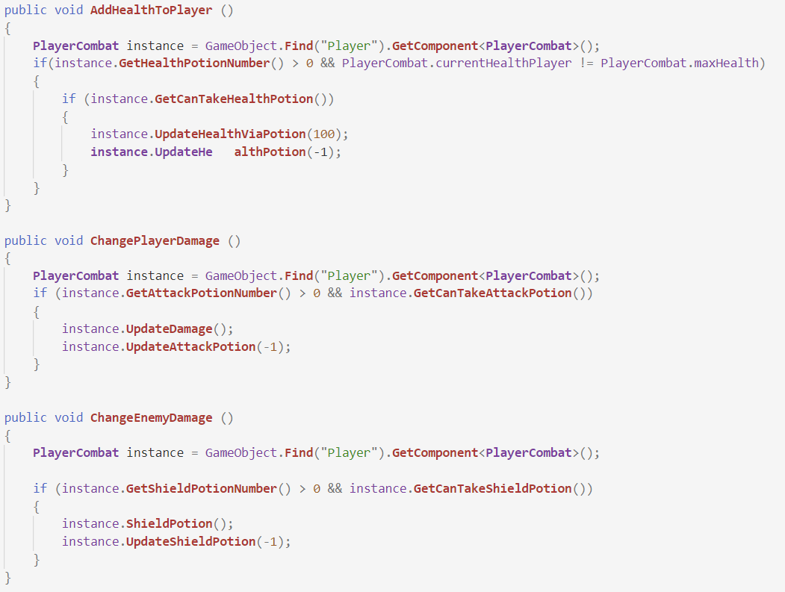Now the inventory needs functionality, If the player was to click on one of the potions, then the potion becomes active and the functions from the PlayerCombat class must be called. Not only that, but the number in the inventory must be changed to one less of what it was before, which means calling a second function. The 3 functions are shown on the next page.

Before actually calling the functions, I must check that the number of potions isn’t zero, and that the player is actually able to take one. Once both conditions are met, both respective functions are called, and the potions are active. These 3 functions will be linked to the respective buttons using the OnClick feature.

There is one more feature to the inventory, and that is the iron bars. These are available from chests, and the number must be updated in the inventory. This can be done like so:

public void **AddIronBar**(int number)

{

      ironBars += number; // add to the total of iron bars

      ironBarsText.text = ironBars.**ToString**(); // change the text

}

End of module testing; Inventory:

|  |  |  |  |
| --- | --- | --- | --- |
| Feature Being Tested | Testing Method | Expected Outcome | Testing results |
| Opening the inventory | Press the “e” key in the game | The inventory will open and the game will pause | passed – see video 14 |
| Contents of the inventory | Look at the inventory when opened | The number of potions and bars will be shown near their pictures, along with the weapon | passed – see video 14 |
| Ability to use a potion | Use a potion when the inventory is opened | The number of potions will decrease when taking one | passed – see video 14 |
| Closing the inventory | Press the “e” key again when the inventory is opened | The inventory will close and the game will un-pause | passed – see video 14 |

This module went through testing pretty smoothy and quickly, and no major errors were encountered.

7.2: Pause menu

The pause menu is the final in game menu for my game. It will allow the player to save, load and quit the game. Here is what the UI looks like:

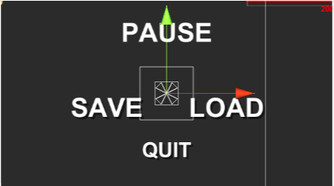

And here are the variables I will be referring to:

public static bool GameIsPaused = false;

public **GameObject** pauseMenuUI;

The menu will open when the player presses the escape key at any point in the game. To open, it will use the same logic as the other UIs:

void **Update**()

{

    if (Input.**GetKeyDown**(KeyCode.Escape))

     {

          if (GameIsPaused) // if the game is already paused

          {

**Resume**(); // close menu

          }

          else

          {

**Pause**(); // else, open menu

          }

    }

}

If the game isn’t paused, then the Pause function is called, which will activate the UI and freeze time:

void **Pause** ()

{

      if (!Inventory.InventoryOn && !Chest.ChestIsOpen) // if nothing is open

      {

          pauseMenuUI.**SetActive**(true); // activate menu

          Time.timeScale = 0f; // freeze time

          GameIsPaused = true; // reset variables

    }

}

As I have now coded the inventory, I can now check if it is open, along with any chests. If not, then the menu is activated. To close, the player only has to press escape again, and the Resume function will be called:

public void **Resume** ()

{

     pauseMenuUI.**SetActive**(false); // deactivate the menu

     Time.timeScale = 1f; // unfreeze time

     GameIsPaused = false; // reset variable

}

Time is unfrozen and the UI is deactivated.

The only button I will look at in the menu is the quit button, as I will look at the saving and loading buttons later on. When the quit button is pressed, this function is called (once again by using the OnClick feature):

public void **LoadMenu** ()

{

      Time.timeScale = 1f; // unfreeze time

      SceneManager.**LoadScene**(0); // load scene 0, the main menu

}

Time is unfrozen, and the main menu is loaded.

Now that I have a working pause menu, I will have to update the functions to open both the chests and the inventory, as they will not be able to be active if the pause menu is active. When updated, they look like this:

void **InventroyTrue** ()

{

     if (!PauseMenu.GameIsPaused && !Chest.ChestIsOpen)

     {

        InventoryUI.**SetActive**(true);

        Time.timeScale = 0f;

        InventoryOn = true;

     }

}

public void **OpenChest**()

{

if(!PauseMenu.GameIsPaused && !Inventory.InventoryOn)

{

     ChestContentsUI.**SetActive**(true);

     Time.timeScale = 0f;

     ChestIsOpen = true;

     spriteRenderer.sprite = OpenedChest;

}

}

8: Spaceship

The spaceship allows the player to travel the planets in the game. Upon arriving to Mars, the spaceship broke and the player has to fix it. Once it is fixed, then the player can interact with the spaceship and they will move on to Venus. The spaceship is fixed once the player has acquired a certain number of resources, and this will be controlled in the ScoreManager class. Once that is true, this code will be processed:

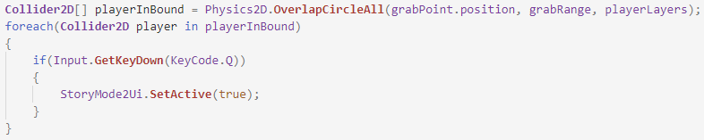

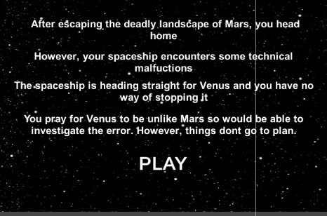After creating a gizmos, which will help detect if the player is close to the spaceship, I create an array, and for every player in the array, who press the q key, then the second story mode is set as active, and the player will be teleported to Venus. The second story mode menu will use the same class as the first, the only difference being the text. It will look like this:

9: Score system

When the player picks up a coin, their score has to update. To do this, I create a ScoreManager class. Here are the variables used in the class:

public **Text** CoinText;

public static int coins;

public **GameObject** finishedText;

public **GameObject** missionText;

public static bool isSpaceshipFixed = false;

public bool isMissionTextShown = false;

When the player firsts clicks play, an instruction will appear to inform them of the number of resources needed to fix the spaceship:

void **Start**()

{

     coins = 0;

     if(!isMissionTextShown) // if the text isn’t on

     {

          missionText.**SetActive**(true); // activate it

          isMissionTextShown = true; // reset variable

**Invoke**("ChangeMissionText", 5); // invoke function to remove it

     }

}

Then, after 5 seconds the text disappears:

void **ChangeMissionText**()

{

     missionText.**SetActive**(false); // remove the text

}

The player is now informed of their mission. They now need to able to grab coins that are spread across the planet. When a coin is grabbed, the AddCoin function is called, like so:

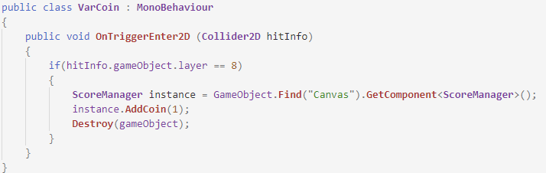

Of course, the coin is also destroyed in the processed. The AddCoin function is relatively simple, and will look like this:

public void **AddCoin**(int number)

{

      coins += number; // add to the total of coins

}

Once the coins variable has been changed, the text on screen must also change, and this will be done by calling a function in the update function, so that it is always up to date. The function is shown below:

private void **SetCoinText**()

{

     CoinText.text = coins.**ToString**(); // change text to the total of coins

}

Once the player has collected all the resources necessary, they have completed their mission. To inform them, another message will appear on screen:

void **Update**()

{

  if(coins >= 200 && Inventory.**GetIronBarNumber**() >= 10 && !isSpaceshipFixed)

  { // if player has gathered all that is required

         finishedText.**SetActive**(true); // activate text

         isSpaceshipFixed = true; // reset variable

**Invoke**("ChangeFinishedText", 5); // invoke function to remove it

    }

**SetCoinText**(); // change text

}

The number of coins and iron bars needed will change later on, they are set like so for testing purposes. Just like the first text, this one will also disappear after 5 seconds:

void **ChangeFinishedText**()

{

     finishedText.**SetActive**(false); // remove text

}

End of module testing; Score System:

|  |  |  |  |
| --- | --- | --- | --- |
| Feature Being Tested | Testing Method | Expected Outcome | Testing result |
| The coin counter | Look at the ui for the coin counter | The coin number will display on the screen | passed – see video 1 |
| Coin counter increasing | Grab a coin with the player | The coin number will increase after grabbing a coin | passed – see video 1 |
| Coin completion | Grab enough coins to complete the mission | The player will be informed when the score is high enough to fix the spaceship | passed |

I was happy with how this module ended up as it is a vital part to the game. Testing went smoothy with no errors.

10: Save system

When the player presses the save button in the pause menu, a function must be called to Save the players data, and this is shown below:

public void **SavePlayer**()

{

      SaveSystem.**SavePlayer**(this); // call the function

}

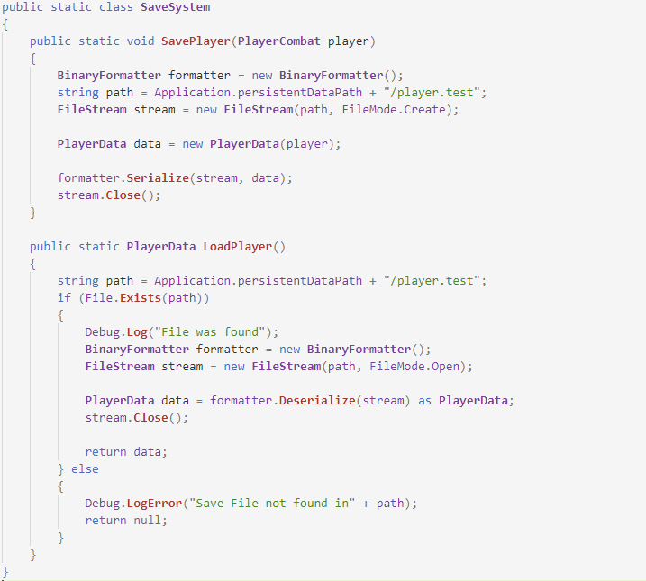This will call the SavePlayer function in the SaveSystem class and pass it the player (‘this’ means the game object). Below is the SaveSystem class:

- Disclaimer: I did not write this code myself

On one line of the SaveSystem class, it refers to the PlayerData class, and this one I did code myself. This class is used to tell the SaveSystem class what data it needs to store. For my game, I will store the player’s health, number of potions and their position, as shown below:

public class **PlayerData**

{

    public float playerHealth;

    public int amountOfAttackPotions;

    public int amountOfHealthPotions;

    public int amountOfShieldPotions;

    public float[] playerPosition; // define variables

    public **PlayerData**(**PlayerCombat** player)

    {

        playerHealth = PlayerCombat.currentHealthPlayer;

        amountOfAttackPotions = player.**GetAttackPotionNumber**();

        amountOfHealthPotions = player.**GetHealthPotionNumber**();

        amountOfShieldPotions = player.**GetShieldPotionNumber**();

        playerPosition = new float[3];

        playerPosition[0] = player.transform.position.x;

        playerPosition[1] = player.transform.position.y;

        playerPosition[2] = player.transform.position.z;

    }

}

With this class now in place, all this data will be stored in the binary file. Now the data must be loaded if the button is pressed, and this will require the use of the LoadPlayer function from the SaveSystem class. After calling it, I must set the player’s variables to the ones previously stored in the PlayerData class:

public void **LoadPlayer**()

{

      gameObject.**SetActive**(true); // activate player if dead

      DeathScene.**SetActive**(false);

**PlayerData** data = SaveSystem.**LoadPlayer**(); // call the function

      currentHealthPlayer = data.playerHealth;

      numberOfAttackPotions = data.amountOfAttackPotions;

      numberOfHealthPotions = data.amountOfHealthPotions;

      numberOfShieldPotions = data.amountOfShieldPotions;

      AttackPotionNumber.text = numberOfAttackPotions.**ToString**();

      HealthPotionNumber.text = numberOfHealthPotions.**ToString**();

      ShieldPotionNumber.text = numberOfShieldPotions.**ToString**();

**Vector3** newPosition;

      newPosition.x = data.playerPosition[0];

      newPosition.y = data.playerPosition[1];

      newPosition.z = data.playerPosition[2];

      transform.position = newPosition;

// set variables to what they were when saving

}

Now the player is able to save their data and load it whenever they wish. This will include when they die, which will allow them a second chance. This is why I included the first two lines in the function.

End of module testing; Save system:

|  |  |  |  |
| --- | --- | --- | --- |
| Feature Being Tested | Testing Method | Expected Outcome | Testing results |
| Data saving | Click on the save button in the pause menu | The data will be saved through the player data class when pressing the save button | passed |
| File created | Find the file after clicking the save button | The file will be created and the data saved in there | passed |
| Data loaded | Check variable components after pressing load button | The data will be correctly loaded when the load button is pressed | passed |
| Data loaded in game | Watch what happens in game | The game’s state will go back to the state it was when saving | passed – see video 14 |

Overall, this module went well, and I am happy with the results. I didn’t encounter many problems when testing the saving and the loading.

**Section Four: Evaluation**

**Max marks 20**

# 4.1 Testing to inform evaluation

## 4.1.1 Post development testing

In this section, I will look at the success criteria that I mentioned in section 2.6 and I will test all parts of it. This will allow me to have a big understanding of how much the game has been completed and to what extent it works. I will provide evidence of certain sections being tested and working in the forms of videos which should be attached to this word document.

|  |  |  |
| --- | --- | --- |
| Success Criteria | How I will know it has been met | How much has the criteria been met |
| The game will be a 2d platformer that obeys the laws of physics | I will play through the game. The perspective should match a 2D one, there should be gravity and platforms | The criteria has been fully met. Video number 1 shows a brief demonstration at how my game obeys the laws of physics and is 2D platformer |
| The game should feature a main menu and a pause menu | I will play the game and check a main menu appears. I will also attempt to pause the game to show the pause menu | This criteria has been fully met. Refer to video two for a demonstration |
| The character should be able to move left and right while also being able to jump | I will attempt to move the player left and right and also attempt to jump | This criteria has been fully met. A demonstration is shown on video 1 |
| The character should have a defined amount of life | Upon starting the game, I will look and see if the player’s health is displayed as a defined amount | This criteria has been fully met |
| The character health and coins collected should be displayed to the player | Once in game, I will look and see if the screen displays such information | This has been fully met and shown throughout section 3 |
| There should be different enemies, all with different amounts of health | I will let the player take damage from enemies to check they do different damage. I will also damage them to check for the different amounts of health | This criteria has been met. Refer to page 32 for the table of enemies, displaying their health and damage. |
| Different enemies will have different AI | I will play through the game and observe the enemies to check most have different AI | This criteria has been fully. Videos 3 to 11 show a demonstration of multiple enemies. |
| The character should have an inventory interface | Once In game, I will attempt to open the inventory interface to check | This criteria has been fully met and is shown throughout section 3. |
| Multiple levels that get harder as the game progresses | I will allow someone to play through the game and they shall inform me on the difficulty and challenge of these levels | This criteria has been met as the game does get progressively harder in terms of levels and enemies. |
| The character must be able to fight against enemies | I will play the game and attempt to kill as many enemies as I see | This criteria has been met and some of the videos show the player fighting with the enemies. |
| There will be a final boss at the end of the game | I will play the game until the end to check is a boss appears | This criteria has been met as it was talked about in section3. |
| The game will feature information about space | I will explore the game, look in chests to try and find the information | This criteria has not been met due to time constraints. |
| Enemies should be able to drop coins and drops | I will kill as many enemies as I can to check if they drop hearts and coins | This criteria has been met fully and some videos show the enemies dropping the hearts and coins. |
| The game should be able to run on a standard computer | I will test the game on multiple different computers with ranging quality and speed | This criteria has been met fully |

The next step into the testing is to get different people, mainly students, to play the game and give me feedback on it. This will allow me to get an understanding on what I may have done wrong, and what I have to improve to get it just right. To get their feedback, I will ask them about how they felt playing the game as a whole. Their responses will be listed in section 4.2.2. This will include usability testing as well.

# 4.2 Evaluation of the Solution

## 4.2.1 Evaluating against the Success Criteria

1. **The game will be a 2d platformer that obeys the laws of physics:**

I believe my game has met this criteria fully as it is a 2D platforming game, which obeys the laws of physics. The game includes a player, a range of enemies, two bosses and a variety of levels to test the player on their platforming, fighting and adventuring skills. All these features are key for a good platformer game and I believe I have all of the implemented in my game. The laws of physics have also been met. The player and the enemies fall to the ground and behave normally. This is also key to making a good platformer.

1. **The game should feature a main menu and a pause menu:**

This criteria has been fully met and I believe there are no more features to add to the menus. The start menu allows the player to customize how high or low they want the volume to be when they play the game. They are also reminded on how to play and how to move the player. Within the pause menu, the player is able to save their progress as they play the game. This will allow them to come back to the last spot at which they saved and try again. The pause menu also allows the player to quit the game if they wish to do so.

1. **The character should be able to move left and right while also being able to jump:**

This criteria has been met fully as the player is able to move around and jump onto platforms. This was a very important criteria to meet, as without it, the game would’ve been impossible to play and most importantly, it wouldn’t have been entertaining to anybody.

1. **The character should have a defined amount of life:**

This criteria has been met fully as I made sure the player is not able to exceed the max health points that have been assigned from the beginning. By doing so, it allows for a harder challenge as the player as they must be more careful when they fight enemies and bosses.

1. **The character health and coins collected should be displayed to the player:**

This was an important criteria and has been met fully. Its important as it keeps the player informed at all times of their current progress on their mission, and they are able to keep track of their health at all times.

1. **There should be different enemies, all with different amounts of health:**

Having this criteria is very important as it makes the game more entertaining, and I believe that I have met this criteria fully. The enemies I have create do range in health, with a maximum of 2000 for the dark mage. This criteria allows for a bigger challenge as the player advances through the game and will also test their fighting skills that will improve as they advance.

1. **Different enemies will have different AI:**

This is another very important criteria. Mostly all of my enemies have different AI, however, some share the same abilities (goblin and old one’s skeletons, Vortexian and evolution beast). Having most of the enemies have different AI is very important as it creates a big challenge for the player. They will not be able to meet a new enemy already knowing what their abilities are, and they will have to learn how to dodge them and the best ways to fight them. This feature is the main one that increases the difficulty of the game, and I believe I have met it to some extent. To meet it fully, I would need to change certain enemies so that they all have different AI.

1. **The character should have an inventory interface:**

An inventory is a very common feature in many games and is important for the player to advance in the game. I will allow them to use potions to help them progress. Overall, I think my inventory has all the features the player will require in their adventure, and the criteria has been met fully

1. **Multiple levels that get harder as the game progresses:**

Making the levels for the game required me to do some prototyping as I needed to plan out how I would structure them so that they could pose a challenge to the player. When testing the game, I found that the levels did include some difficult platforming and the player’s skills were put to the test. Therefore, I think the criteria has been met.

1. **The character must be able to fight against enemies:**

This criteria is important to the game, as without it, the game will be unplayable and unenjoyable for the player. The player will be able to collect certain skills and items that will help them to fight the enemies and the bosses. After doing some testing, I believe I have met this criteria completely.

1. **There will be a final boss at the end of the game:**

This criteria as been fully met as the player will face a boss at the end of the game. This will present a challenge to the player where they will be able to test their skills before beating the game, making them feel worthy enough to beat it.

1. **The game will feature information about space:**

This criteria has not been met due to time constraints. However, this will not affect the gameplay and should not decrease the enjoyment the player will feel when playing the game.

1. **Enemies should be able to drop coins and drops:**

This is criteria has been fully met in my program. The enemies have a random chance of either dropping a coin, or a heart to help the player in their adventure throughout both planets. The hearts will help them regain their lost health, and the coins will help them advance towards their goals.

1. **The game should be able to run on a standard computer:**

To test this criteria, I had to try and play the game on different types of computers. When testing on my laptop, the game ran smoothly with no problems. When testing on a school computer (I decided they would be best as they have poor performance), the game encountered some lag, but ran smoothly most of the time. Therefore, I believe this criteria has been met fully.

## 4.2.2 Evaluating usability features

The usability of my game is dependent a few factors. The first is the ease of use, which covers controls, menus and GUIs. Having easy controls will allow the player the play the game easily without any trouble. Another factor is the enjoyment the player feels when playing my game. If they enjoyed it, then the game must be well constructed and easy to use, as the player would not get frustrated when playing.

**Ease of use:**

When deciding the controls the player will use, I decided to use the controls that most platformer games use: A for left and D for right. Due to my game being 2D, I did not require the use of the W and S keys. For the other keys, I chose keys that are close to A and D so that the players did not have to ‘navigate’ the whole keyboard to find the key they wish to use. This could make the difference between the player saving themselves, or them dying from an enemy. After having people play and test my game, I asked them about their thoughts on the controls and how easy the game was to use. Here are the answers I received from them:

* I liked how the different keys were close to one another
* Similar to other platformer games I’ve played
* I managed to understand how to play with them pretty quickly
* I had no problems with the controls

Next, are the menus. When developing the menus, I wanted to put as many functions as possible for the player to use. But I also had to make them easy for the player to use and access. I asked the people who tested my game to give me feedback on the different menus and their features:

* I enjoyed being able to change the volume
* The menus were well laid out and easy to navigate
* I liked being able to save my progress from the options menu

Finally, there is the GUIs, which include the health bar, the coins, the timer and such. I decided to only activate the timers when the player uses a potion, so that the player does not have any unnecessary information displayed to them while playing the game. Again, I asked the people who tested my game to give me feedback on the GUIs and how they were useful to them:

* There was a lot of useful information displayed on screen
* I liked how the timer appears and disappears when using a potion
* I really liked the health bar that was displayed
* The GUIs were very easy to use

**Engagement:**

This section will help evaluate how much the players where engaged with the game, which include the enjoyment people receive from playing my game, and if they would like to play more. To help me evaluate the enjoyment in my game, I asked students to play my game and give me feedback on their experience, while encouraging them to give me at least one negative feedback, Below are the short and concise notes that I made based on the feedback given from the students that played the game.

**Michelle’s feedback:**

Michelle was the first student I received feedback from after she played through the game. She told me she **liked the environment and that it fits a nice theme**, and that she **thought the game was well paced, especially for someone who is new to video games**. She also enjoyed **the different enemies** and **the story line**. From this positive feedback, I concluded that my game was well structured and that had enjoyed playing it. When asked about negative feedback, Michelle pointed out that **some of the enemies were hard to kill at the beginning of the game**. This is an issue that I would be able to fix by increasing the player’s attack range. When doing so, the player will not have to get as up close to the enemy as before in order to hit them. This would allow the player to hit the enemies more easily, especially at the start of the game when the player does not any skills and is heavily vulnerable.

**Oliver’s feedback:**

Oliver was next to give me feedback on my game. Oliver had spent more than an hour playing the game, indicating to me that he was enjoying it and eager to continue to play it. The first bit of feedback Oliver gave to me was that he **enjoyed the fighting aspect of the game very much** and **the skills the player was able to use**. He did however point out that **the player skills seemed to make the game a bit easier, especially the regeneration skill**. This indicated to me that the regeneration skill was too powerful and was unbalanced for the game. This is not ideal as it wouldn’t encourage the player to use either of the other two skills available. To balance the skill out, I would only allow the player to regenerate their health up to 75 health points, and the player will have to find a way to regenerate the rest manually. This would most definitely reduce the skill’s power and hopefully make the game feel harder. Oliver also pointed out he enjoyed the **Dark mage and thought it was very challenging, but just right for a final boss**, which was greatly appreciated.

**Marie’s feedback:**

Third to give me feedback was Marie, who had also spent a large amount of time playing the game. She first told me that the liked **the exploration and adventuring** of the game but hope **there was more secrets** for her to find. This would be an easy improvement to my game, as I would only have to create the extra secrets, which could help the player in their adventure, and help them find more enjoyment from the game. She also mentioned she really **enjoyed seeing enemies having different AI and also enjoyed learning them**. I was very happy to hear this as I had spent a lot of time coming up with idea for the different Ais and id hoped that the students would enjoy the challenge of learning them when facing against a new enemy. Finally, Marie told me she enjoyed **the sound effects** especially the ones that play when the player and enemies attack. She said it made the game feel more **alive** and **immersive**.

**Ryan’s feedback:**

Finally, Ryan was the last person to give feedback after playing the game, and he had a lot of feedback for me. He firstly told me he **enjoyed playing with the controls** as they were space out well and it made playing the game smooth without any problems. He also pointed out that he enjoyed that **the levels got harder as he progressed through the game** with the new enemies increasing in health and with the different AI and abilities. He told me he enjoyed **progressing through the game and the platforming was fun and not too easy**, however **the platforming could do with some more features to make it more difficult**, as he felt It wasn’t too much of a challenge. To do this, I would take inspiration from Celeste and Hollow Knight again to see what type of different platforming features I could add to the game to make it more difficult. Finally, he told me that he **enjoyed the difficulty of the two bosses**, and felt they had good, interesting attacks that were sometime difficult to dodge, but the bosses were still killable.

After hearing back from all 4 students, I reflected on the feedback given. From the positive feedback, I believe I have created a fun and entertaining game for all audiences. Most of the positive feedback was about the fighting and theme of the game, including the different enemies, the Ais and the skills. I am glad to hear the students enjoyed that aspect of the game, as I spent a lot of time on making it just right. From this, I was also able to infer that the students enjoyed the challenge of fighting the enemies and did not get bored of fighting similar enemies throughout their adventure. To increase the enjoyment the students felt from the game, I could add extra enemies, with new Ai and abilities, for them to learn and fight. I was also able to infer that the students thought the theme fit the different enemies and the player, which is good to hear as I was not sure if the theme of the game would fit together with them.

The negative feedback I received was mostly based on the difficulty of the game. While Michelle told me that the enemies were too hard to kill at the beginning, Oliver told me they were sometimes too easy to kill near the end of the game, with the skills acquired along the way. Overcoming this will pose a challenge, as I will have to find a balance between the two. This will then balance the difficulty of the game, and hopefully increase the enjoyment any player would feel when playing the game. Ryan also told me that the platforming could use some work to increase the difficulty, and I think I will be able to use this to balance the difficulty to a higher extent.

Overall, I am very pleased with the feedback I was given, which have given me some good ideas on how to improve the game.

## 4.2.3 Maintenance issues

In the future, I will need to maintain my game, by completing certain areas of the game (more enemies, more platforming, etc…) and by fixing any errors that could arise in the future.

To be able to maintain any game, it is useful to have well structured code with use of comments, well named variables, sensibly named functions and methods which describe its purpose, and separate classes. I believe my code is well commented. The comments, (denoted by ‘//’ as I code in C#) perfectly describe what the line of code does. This is very useful, as it allows anyone that reads my code, or attempts to change it, to understand what each line does and how it functions. It will also allow me to understand the code if I was to come back to change an object or fix an error. It would then make it easier for me to change the code as I wouldn’t have to spend time trying to figure out what the code does and how I must change it.

My methods and variables are sensibly named (For example, the attack damage variable for an object is called attackDamage), and this is really useful when it comes to maintaining code. This is due to the fact that I will be aware of what the variable refers to in the code and wouldn’t have to spend time figuring out what the variable refers to. The methods being sensibly named is also useful for maintaining code as anyone looking at the code will be aware of the methods function and therefore know which one to use if they wish to change any code.

Separating the code into multiple classes is another useful method to use in maintenance. By doing so, the code is very organized and named properly. It also allows less memory to be used as there is less repeated code. For maintenance, it is useful to find the block of code needed for editing. If code is edited from a class, it reduces the errors that could arise. If one was to arise, then it would be easy to find where it is located, and debugging can be conducted. Separating the classes will mean I have to make use of inheritance for some classes. For example, all my enemy classes inherit from the parent enemy class. Inheritance is useful for maintenance as if an error occurs for a number of enemies, I can change the code in the parent class which will fix the error for all enemies.

One thing I used to make my code better structured was indentation and camel casing. Camel casing is where I capitalize the second word of a variable (e.g., attackRange). This makes it easer to tell which part of the variable is the second word. This makes it less confusing when looking through the code and makes it easier to spot which variables are which, as the capital letter stands out. Indenting the code will also make it easier to read as anyone looking through will be able to tell what code is part of which function, or what If/Else statement.

Finally, using different types of variables will also help maintain the code. By using local and global variables, I am able to keep some values constant by defining them in some functions (the random number integers), and the rest at the top of the code as global variables. This will be useful as it prevents some variables being overwritten and causing errors within the game.

## 4.2.4 Potential Improvements and changes

Now that my game has been tested by students, I can improve it based on the feedback given. I will reflect on the changes I can make to make to make it more interesting, and in general more fun for the players. The main limitation to the game that comes to mind is the attacking difficulty. There is a weak balance between the fighting and the platforming. From the feedback, I inferred the fighting was very difficult, especially at the beginning of the game, and the platforming was not very challenging. This is a big issue with the game as it leads into a non-consistent difficulty which will not encourage the players to keep playing the game. This will be my main focus for improvements and changes.

The first improvement I will therefore make is **reworking the player’s attack**. After hearing from the feedback, it seemed that it was too difficult to dodge the enemies will hitting them at the same in the early stages. Once the players had acquired the weapon skills, it seemed to become easier as the player did not have to stand right next to the enemy to hit them, reducing the chances of them getting hit. To improve the attacking at the beginning of the game, I will rework the player’s attack. To do that, I will increase the player’s attack range. This should help the player attack the enemies easier as they won’t have to get as up close as they do before, which should satisfy the players playing more than before. Another way I would be able to rework the attack system would be to add **knockback** into the game. This would mean whenever the player hits an enemy, the enemy would be pushed backwards. This may help the player survive more hits from the enemies as it means they wont get hit right after hitting the enemy, making them survive longer in general.

The second improvement I will need to make is to **increase the difficulty for the platforming** as the feedback suggested it wasn’t challenging enough. I have a few ideas on how to achieve this, with the main one being adding more platforming features. For example, I would some sort of wall jumping ability (that could come in the form of a skill) which would increase the difficulty, but also allow me to hide more secrets around the areas. If it was to be set as a skill, the players might have to go back on their journey to find the secrets. I believe this will increase the engagement the players will feel with the game. Other ideas I have to make the platforming harder include puzzles where the player has to jump to certain platforms in a certain order to activate something, which would a fun feature for the player. I could also include a platform that only appears when the player collects a certain item (or uses a switch of some sort) but disappears after a while. Finally, my last idea would be having to collect an item that the player will carry around the map to activate some kind of lever to then advance onto the next area.

A change I would make on the game would come in the form of a **skill tree**, with the main purpose of improving the way skills are collected and used. A skill tree would work as user interface, just like the inventory. It would include a bunch of skills, organized in the shape of a tree, that the player can then use. The main idea for this is to give the player a secondary goal as they advance through the map, which is to collect all the skills possible. It also gives me the opportunity to add more skills. It would work like so: The player opens the tree using a special key bind and will be presented with one skill (the root) in color, while all the other ones branching off will be black (to indicate they haven’t been unlocked yet). The player can then buy the first skill with coins (the first one might be free). Once it has been clicked on, the skills directly branching off of it will activate and the player will be able to buy those. As the player buys more and more skills, they get increasingly powerful. I have some ideas for new skills including: a wall jumping ability, a double ability, a second attack (using right click) which would be ranged, and perhaps a second life as the final obtainable kill. A feature I could add is to restrict the player to only having a few skills active at once, if the game becomes too easy with all of them active. As these will be bought with coins, I would make a change to the spaceship, only needing iron bars to fix it, to allow the player to only use their coins on skills. I believe this rework for the skills will be very important and useful to increase the engagement and enjoyment the player will feel when playing the game.

Another improvement I would like to make to my game would be to **add more enemies** to increase the difficulty, but also the enjoyment the players would feel as they would have to learn new AI and abilities. Once enemy I would like to add is a flying enemy with more complex flying than the sand elemental, ancient doom and the dark mage. It would fly towards the player and then fly back as soon as it hits the player, before coming in for another swoop. The main challenge with this enemy would be its movement as I would like to make it smooth and flow nicely. The problem with an enemy is that it would near to impossible to kill it without a ranged attack. Another enemy I would like to add is one that goes underground. It would go underground and peak back up behind the player. The player would then have to react quickly to hit the enemy. If the enemy if hit once, it becomes stunned for a second, before it goes back underground to start the routine again. The challenge with this enemy would be to make it move underground, and if it dies underground (with a debuff on it), the player will have no way of grabbing the heart or coin it will drop. A final enemy I would like to add would be some kind of mini boss, which would be optional for the player to fight. It would be a kind of big mummy, that will jump in the air, trying to land on the player. As the mummy is big, the landing causes a tiny earthquake that would move in both directions away from the mummy. This mummy would have a lot of health, and will have a new feature, defense. With its defense, the damage it takes will be less than the damage the player normally deals. This would be a hard miniboss for the player to fight, but it would be fun and optional challenge for them as well.

To balance the difficulty even further, I would like to improve the health system by adding **upgradable health**. To do this, I would introduce a new item, like a stronger version of the heart (I would so this simply by changing its color, maybe to green or purple). Upon using this item, the player’s max health would increase by maybe 50 or 100 health. This heart would act as a reward to the player after beating a difficult enemy. For example, the player would get one after killing the sand elemental and the dark mage. I could also make the mummy referred above drop one to give the player a reward for beating an optional miniboss. This would balance the difficulty as it means the player is able to endure more hits from enemies and die less often.

A change I would like to make to the game is to the **saving system**. I do not think it is fully completed and can be improved. At this point, only the plyer’s position, health and potion numbers are saved when the player hits the button. I would like to add a way to save the coins the player collects, especially with how important they become if I was to add a skill tree. The problem with this is what comes after. The player would be able to save, collect and then load. At this point, the player’s coin count may have decreased, but the coins they collected will not be here, meaning they cannot collect them again, and I am not sure how to add a system to make the coins re-appear. The same problem occurs with the potions. When the player loads, the potion count goes down, but the player is not able to collect the potions again. This is definitely an improvement I would like to make.

Another improvement I could make to my game would be **more potions**. This would give the player more choice on which ones to sue for a boss fight and encourage them to try and collect one of each. I have some ideas for new potions, including a potion that would make you run faster, a potion that would make the enemy take damage when the player takes damage, a potion that would make a fire circle appear around the player, and if any enemy was to pass through it, they would take fire damage (some kind of debuff). More potions include one that increases the player’s health by 50, one that would decrease the player’s health by 100 but allow the player to deal an extra 40 damage (note the player would be able to use the normal attack potion and the potion described before when this one is active), and finally a potion that would make the player immune to all debuffs inflicted on them.

A final improvement for the game would be to increase the ease of use of the game, by allowing the player to **customize the key binds**. Doing so will allow the player to choose which keys to use, as they may not be comfortable with the ones that I have assigned. This would be very good as it would increase the ease of use and it would make the player feel involved with the game. This will also introduce a type of validation into the game.